# A needs assessment into special educational needs and disability in children and young people in York.

Phase 2- Young people aged 16 and over.

Contents

A needs assessment into special educational needs and disability in children and young people in York. 1

Scope 2

Focus on 19+ cohort 2

Need type 2

Gender, and age bands (19-25) 3

Current provision type, funding types, work 3

Not in Education, Employment or Training 4

Attainment 8 5

Pathways and Timeliness 6

Age of first EHCP by need type 6

Trends in closed EHCP each year 7

Inclusive City 7

Health overlap and education need overlap 8

National prevalence of disability and long-term conditions in childhood 8

All CYP - Prevalence of health need by age groups – most common conditions 8

All CYP - Self-reported health and self-reported daily limitation 9

Social care and educational need overlap 10

Number of child protection plans with and without EHCP 10

Number of looked after children w/ and w/o EHCP 10

Number of children in need with and without EHCP 11

Need projections 12

Population projections for age 0-25 cohorts over the next ten years, 12

Increase in demand for EHC and S-support across decade (based on population growth) 12

Increased demand for EHC and SEN support across decade (based on pop. growth and prevalence) 13

# Scope

This report is an addendum to the 2020 CYC needs assessment into special educational needs and disability in children and young people in York and- should be read in conjunction with the earlier report.

This report supplements the 2020 report by bringing an additional focus to the older cohort young people with special educational needs and further analysis and projection of need.

# Focus on 19+ cohort

### Need type

The needs of those in the 19 and over cohort are comparable to those in younger age groups, figure 1shows the number of individuals by different need types.

Figure : Types of need in individuals >19 years old (local data)

The majority of individuals on support plans over the age of 19 have needs related to autism spectrum disorders or moderate learning difficulties. If considered together, the social, emotional and mental health categories of need are third most common, alongside severe learning difficulties.

### Gender, and age bands (19-25)

Figure : Demographics of >19 EHCP cohort by age and gender (local data)

Figure 2 shows the distribution by age and gender of EHCP individuals in December 2021. There is a clear downward trend in the total number of individuals on plans as age increases, and a greater proportion of males on plans at all ages.

Current provision type, funding types, work

Table 1: Provision and funding for Post 16 EHCP (local data)



Table 1 shows the current provision for individuals age 16 and over in the City of York, as is to be expected, the majority of year 12-14 young adults remain in education and further education. This trend however continues well in to adulthood; at age 21 68% of individuals remain in further education, and at age 24 59% remain in further education. Further review of individual cases would help to understand if these placements are supporting individuals to live as independently as they are able to.

|  |
| --- |
| Reccomendation:  Begin regular audits to assure suitability of placements maximise independance. |

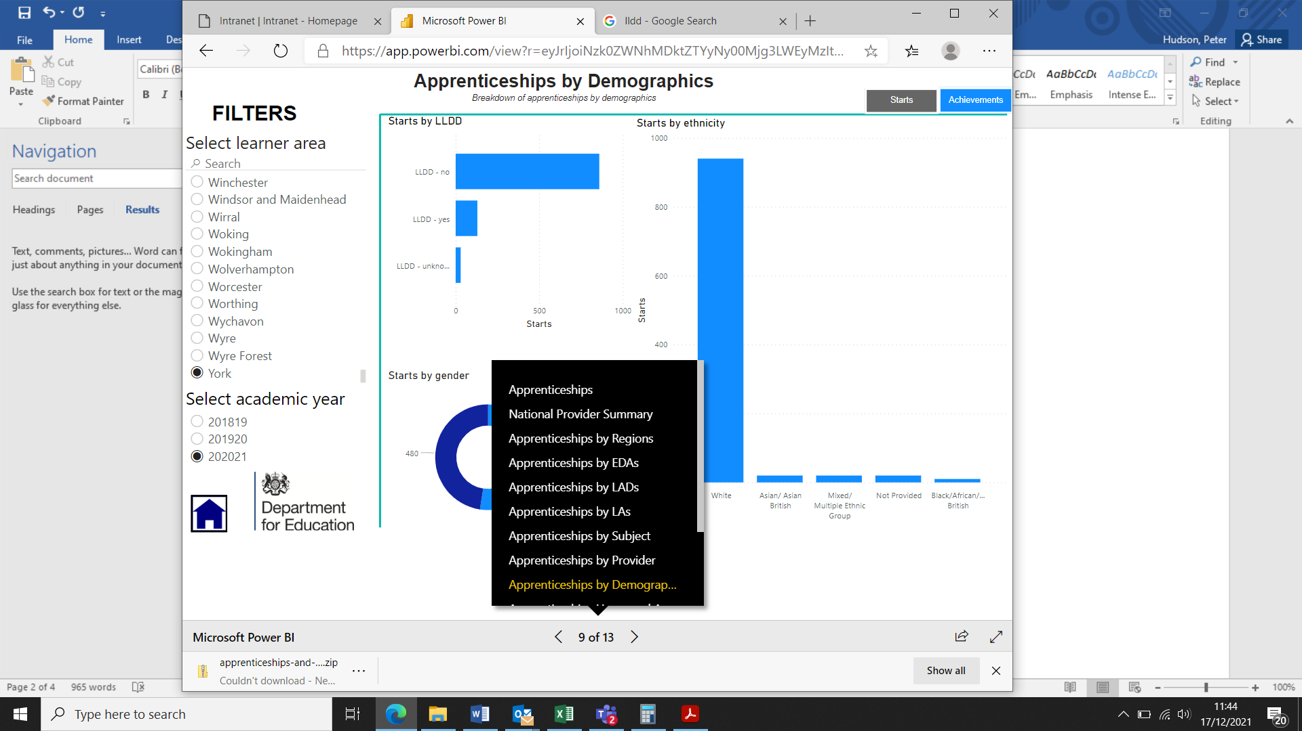

Figure : Apprenticeship starters in 2021, LLDD status (local data)

Apprenticeships are an attractive option for individuals leaving mainstream education at the age of 16. Across City of York around 1020 apprenticeship roles were offered in the academic year of 2020-21, of which 130 (12.7%) were started by people with LLDD (Learning difficulties or disabilities) (Figure 3). Proportionally individuals with learning difficulties and disabilities seem well represented in apprenticeship starters.

### Not in Education, Employment or Training

Monitoring and reducing the number of people Not in Education, Employment or Training (NEET) has been a priority to address social exclusion for nearly two decades. Recognising that SEND can be an additional barrier to employment and further education this is reported. Figure 4 shows the reducing trend in 16-17 year olds with EHCP or statement who are NEET. 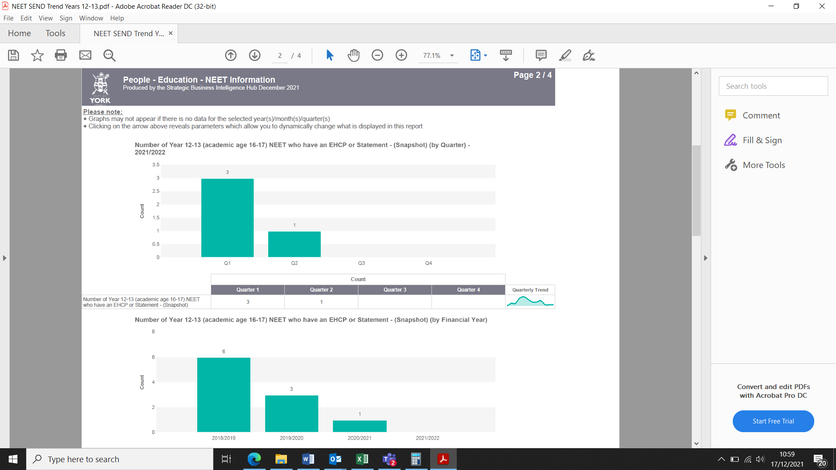

Figure : Number of year 12 and 13 aged individuals with an EHCP who are NEET (Local data)

A similar trend has been observed in the whole population of this age group in City of York, however both reflect favourably against the national and trends which have not demonstrated the same pronounced decrease over the last few years.

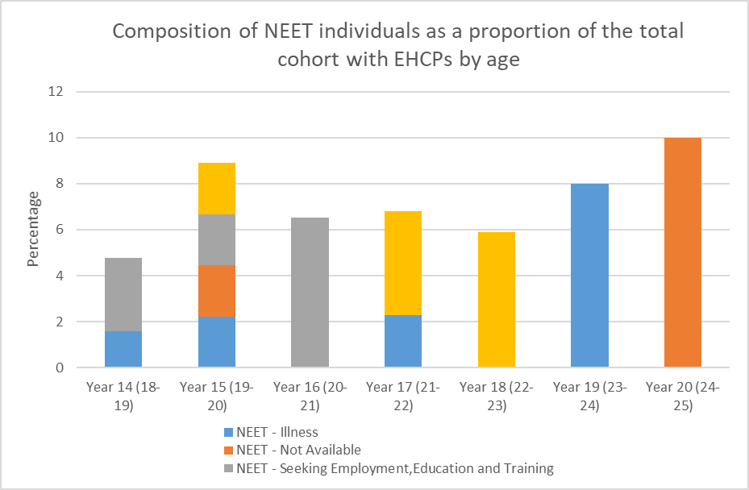

Figure : NEET status by age and composition (local data)

An analysis of locally held data for individuals with EHCPs who are identified as NEET (Figure 5) does not appear to show any substantial trend over the different age groups, nor does there seem to be any strong theme in cause for not participating in education, employment, or training.

### Attainment 8

Attainment 8 score is a benchmarking tool used across secondary schools in England, with the notable exception of independent schools. Attainment 8 calculates the average of each student’s top 8 GCSE result, with additional weighting to core subjects such as English and mathematics. Attainment 8 is usually considered in conjunction with Progress 8 which similarly uses 8 GCSE results, but instead reflects the relative improvement or deterioration of pupils against their standards on entry to secondary school.

York secondary schools typically compare well nationally, York KS4 students in 2021 achieving a mean attainment 8 of 5.6 versus 5.7 nationally. Progress 8, which can mitigate some of the beneficial demographic factors that York benefits from is also significantly above the national average 0.32 versus a national average of 0.

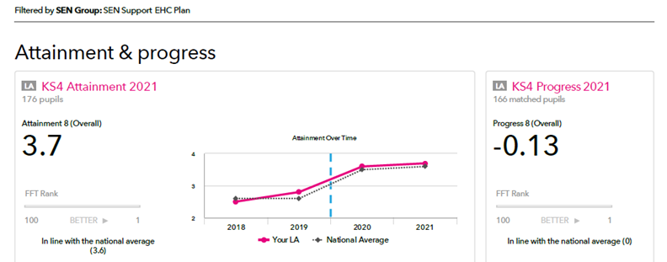

Figure : Attainment 8 in SEN group

Figure 6 is an extract from the 2021 Attainment 8 report benchmarking the results of Key Stage 4 students with SEN support or EHC plan in the City of York against those nationally; whilst a slight deterioration in Progress 8 was noted, this was not statistically significant. The overall Attainment 8 was statistically similar to the national average, 3.7 in York versus a national average of 3.6.

# Pathways and Timeliness

### Age of first EHCP by need type

Figure : New EHC plans in CYC by age 2015-2020 (local data)

The general trend since 2015 (Figure 7) has been a reduction in the proportion of new plans for children under 5; a greater proportion of new plans have started in the primary school age group. The proportion of new plans for people aged 16-19 is highly variable, in part due to the small number of new plans in that group.

### Trends in closed EHCP each year

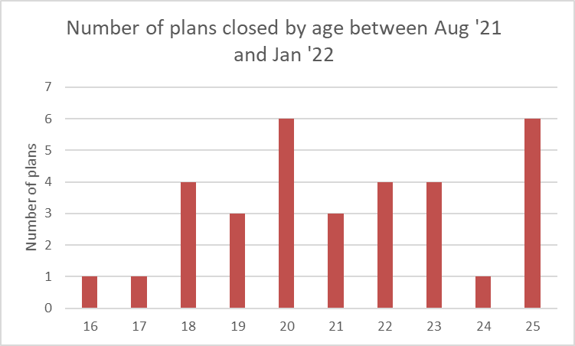

Figure 8: Number of EHCP plans recorded as closed, by age, between August 2021 and January 2022 (local data)

Data about closure of EHCP has not been routinely collected in the past. A review of recent closures (Figure 8) found that the majority of closures occur above the age of 18, with peaks at the age of 18, 20 and 25.

|  |
| --- |
| Recommendation:  Begin collecting and producing annual data on new plans by age and type, and age and type of plans closed. |

# Inclusive City

York’s Local Offer for SEND, a website supported by the Family Information Service is a repository of information regarding education, post-16 options, health services, SEN guidance, parent and carer support and more. The site is designed to be accessible to anybody who is involved with SEN. Furthermore, an officer is available to visit families and young people at home to help them with navigating the site.

The York Local Offer site includes a directory of external websites such as Changing Places and AccessAble who collate information on accessibility of venues and disabled access toilets, provides an application portal for the MAXCard and other helpful advice.

The Family Information Service monitors use of the Local Site; Figure 9 is produced by the service and shows a highly variable but increasing rate of traffic to the site.

Figure 9: City of York, local offer page views (local data)

Figure 10 shows the top pages accessed.

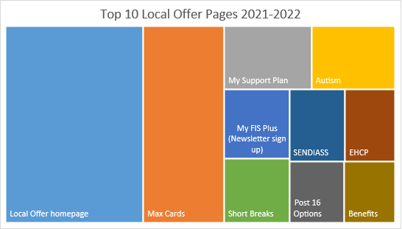

Figure 10: Top 10 site pages (local data)

The website is supported with social media promotion on Facebook and Twitter and it is frequently the source of traffic to the site. The FIS team’s own next steps following their analysis are:

* To improve communications around the Local Offer to continue rise in views and usage
* Continue use of social media to signpost – but link to specific pages that could be useful to families
* Identify with focus groups why families are not staying on the site once they have arrived and how we can reduce this bounce back data
* Continue to make accessibility improvements
* Continue to work with parent focus groups to make appropriate changes to navigation

|  |
| --- |
| Recommendation:  Support FIS to implement their actions. |

# Health overlap and education need overlap

### National prevalence of disability and long-term conditions in childhood

Across all ages, there are 14.3 million disabled people and 51.5 million non-disabled people in the UK (Table 2). This equates to 21.7% of the population as having a disability. Across young people aged 15-24, there are 1 million disabled people and 6.6 million non-disabled people, which means disabled people make up 13.2% of this age group. There is a slight variation between males and females, 12.8% of males and 13.5% of females being disabled in the 15-24 age range.

Table 2: Disability Prevalence by age and gender, average of 2018/19, 2019/20 and 2020/21, UK



Within York, 12% of 15-year-olds have been diagnosed with a long-term illness or a disability against a regional value of 13% and an England value of 14.1%.

### All CYP - Prevalence of health need by age groups – most common conditions

Many long-term conditions develop during childhood. Children who develop a long-term condition are more likely to develop mental health conditions, and therefore may require additional support as they move from paediatric to adult health services. Some of the most prevalent conditions include asthma, epilepsy, diabetes, and cancer(s).

Asthma is the most common long-term condition among children and young people and is one of the top ten reasons for emergency hospital admission in the UK. There were 15 admissions in under 19-year-olds in York in the 2020/2021 year (a rate of 38.4 per 100,000) which is among the lowest in the region. This is significantly lower than the previous year where there were 45 admissions and is likely a result of covid pandemic. There has been a downward trend in admissions since 2017/2018.

Epilepsy is the most common long term neurological condition of childhood, and it affects an estimated 112,000 children and young people in the UK, although diagnosis is not straightforward due to a lack of a specific diagnosis test. 37% of children with epilepsy have a co-existing mental health disorder, a higher prevalence than found in other long term childhood conditions. In 2020/2021 there were 25 hospital admissions in under 19-year-olds, a rate of 64 per 100,000 which is in line with the national average. However, this is down from the previous 5 years where there had been between 40-50 admissions per year, where rates were significantly higher than the England average.

Diabetes is increasingly common among children and young people in the UK; while 90% of diabetes cases are type 1, type 2 is increasing in prevalence. In 2019, there were an estimated 36,000 children in the UK with diabetes under the age of 19, up from 31,500 in 2015. In York, in 2020/2021 there were 20 hospital admissions in under 19-year-olds due to diabetes, a rate of 51.2 per 100,000 which is in line with regional and national averages. This rate has remained static over the last decade.

Cancer incidence in children is on average 1,838 new cases in the UK every year and an average of 240 deaths per year in the UK. The most common cancer diagnoses in children are leukaemia, brain/other central nervous system (CNS) and lymphomas. Incidence rates for childhood cancers have risen by 15% in the UK since the 1990s however more children are surviving longer from cancer. From the latest available data, approximately 84% of children survived five years after diagnosis, 80% survived ten years after diagnosis and 72% survived for 20 years or more after diagnosis.

### All CYP - Self-reported health and self-reported daily limitation

Probable mental disorder is not a diagnosis, but an indication of potential difficulties. It is measured using the Strengths and Difficulties Questionnaire (SDQ) which includes 25 questions on different aspects of behaviour related to emotional problems, conduct problems, hyperactivity/inattention (restlessness), peer relationship problems and positive prosocial behaviour. Figure 11 shows there was an increase in probable mental disorders between 2017 and 2021 among both SEND and non-SEND children and young people. Children aged 6-16 with SEND were more likely than those without SEND to have a probable mental disorder, both in 2017 (SEND = 43.9%, non-SEND = 8.2%), and 2021 (SEND = 56.7%, non-SEND = 12.5%).

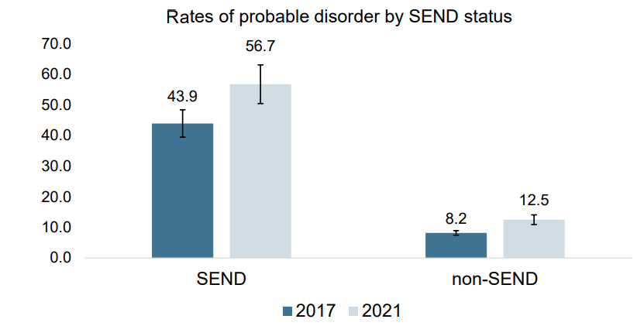

Figure 11: Rates of probable mental disorder by SEND status

# Social care and educational need overlap

### Number of child protection plans with and without EHCP

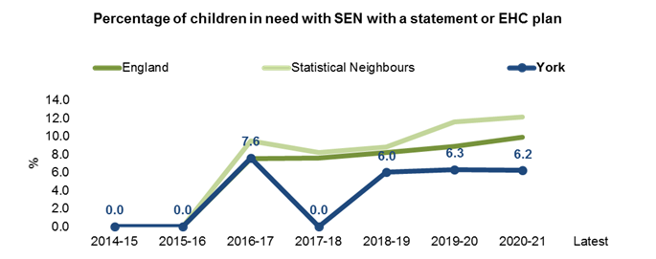

Figure 12: York, statistical neighbours and England, prevalence of SEN or EHCP within children with child protection plans (local data)

National data (Figure 12) shows that in York a slightly lower proportion of children with Child Protection Plans in place have a SEN or an EHCP, this has consistently been the case since 2016-17. Since 2018-19 the proportion has been steadily between 6% and 6.3%.

### Number of looked after children w/ and w/o EHCP

As of February 2022, 19% of City of York Looked after Children had an EHCP, as per Figure 13. This is a higher proportion than the general population.

Figure : Looked after children in Feb 2022, by EHCP status (local data)

### Number of children in need with and without EHCP

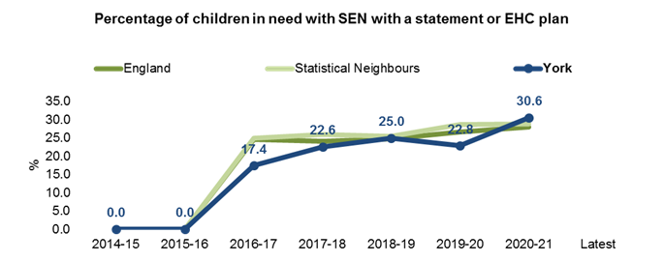

Figure 14: Proportion of children in need in York, similar neighbours, and England with statement or EHCP (local data)

The proportion of children in need with an EHCP in York has followed the national trend (Figure 14), the most recent figure for 20-21 has crept above both the National mean and the nearest neighbours mean, this will need monitoring to establish if this is natural variation within a small cohort or if it is the start of an upward trend.

|  |
| --- |
| Recommendation:  Routinely analyse intersection between Looked After children and Children In Need with LD, SEN and EHCP. |

# Need projections

### Population projections for age 0-25 cohorts over the next ten years,

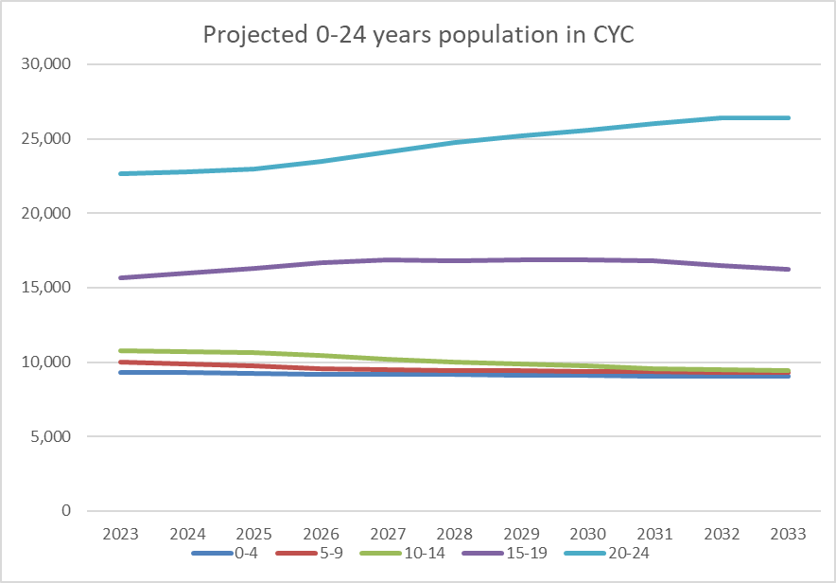

Figure 15: ONS population projections 2018

Figure 15 shows the general 15-19 years and 20-24 years cohort will remain largest for the next decade, with a substantial increase expected past 2025. This figure will be heavily influenced by the relatively large student population which resides in York. The younger age groups which will better reflect the native population of York is anticipated to exhibit a slight decline over the next 10 years

### Increase in demand for EHC and S-support across decade (based on population growth)

Using the PANSI tool it is possible to project future needs based on current prevalence rates and future anticipated demographic changes.

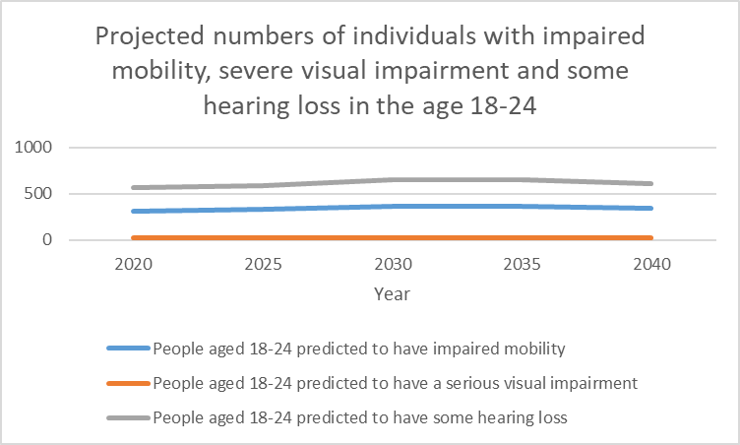

Figure 16: PANSI tool predictions of numbers of people with impaired mobility, hearing loss and visual impairment by age in City of York

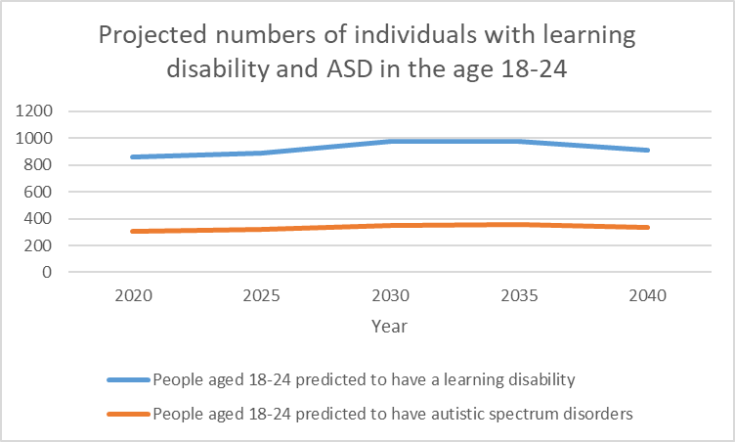

Figure 17:PANSI tool predictions of numbers of people with ASD and learning disability by age in City of York

Both the figures 16 and 17 indicate relatively small changes in total numbers of individuals aged 18-24 with a variety of needs. Numbers are expected to peak around 2030 to 2035 before falling again, following the anticipated demographic changes. Note that this is a blunt instrument and does not model the effect of new developments and other broader issues which may affect inward and outward migration.

### Increased demand for EHC and SEN support across decade (based on pop. growth and prevalence)

Figure 18: Historic trends in prevalence of SEN support and EHCP in City of York and England (Source SEN2 tool).

Figure 18 shows data obtained from the SEN2 tool for prevalence of SEN needs and EHCP in York and England. York’s SEN support rate trends below that of England, and follows a line of best fit where the prevalence increases 0.04% (2 d.p.) each year with an R2 of 0.102. The prevalence of EHCP similarly follows the shape of the national trend but below. A line of best fit sees and increase of 0.16% (2 d.p.) with a fit of R2=0.9131.

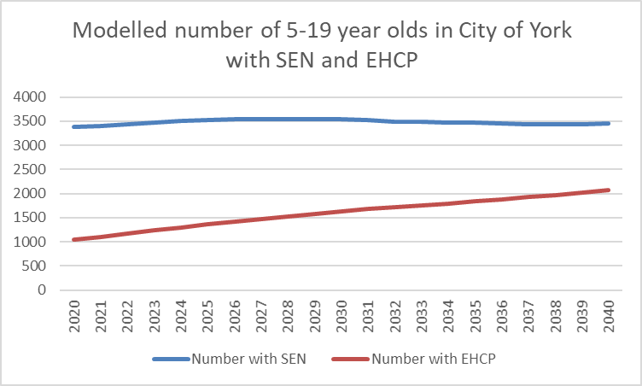

Figure 19: Modelled number of 5-19 year olds with EHCP and SEN

Figure 19 is devised from ONS published population predictions up to 2040 with the extrapolated increasing rates of SEN and EHCP observed in the City of York since 2015. Number 5-19 year olds with SEN is anticipated to remain fairly static up to 2040, the number of 5-19 year olds is expected to double by 2040 if the increase in prevalence over the last 5 years continues at the current rate. This simple projection becomes increasingly speculative the further from the present it is calculated, EHCP is more sensitive to change due to the relatively lower prevalence.

|  |
| --- |
| Recommendation:  Continue to benchmark proportion of pupils with SEN and EHCP against national data to refine future predications. |