York Health and Wellbeing Board

Pharmaceutical Needs Assessment
2022 - 2025

Table of Contents

Executive Summary 6
1. Introduction 7
1.1 Background 7
1.2 Purpose of the Pharmaceutical Needs Assessment 7
1.3 Pharmacy Market 8
1.4 National Context 9
1.5 Pharmacy Services NHS Overview 9
1.6 Community Pharmacy Contractual Framework 2019 - 2024 11
1.7 Pharmacy Integration Fund 11
1.8 Point of Care Testing 12
1.9 Working across City of York 12
1.10 City of York HWB strategic objectives 13
2. The York Health System 15
2.1 GP surgeries (including extended access) 15
2.2 GP enhanced services 18
2.3 Primary Care Networks 19
2.4 GP Out of Hours 20
2.5 Urgent Treatment Centre 20
2.6 Hospital Services 20
3. Pharmaceutical Needs Assessment process 21
3.1 PNA development group 21
3.2 Determination of localities 21
3.3 Assessing health needs 22
3.4 Current provision in York 22
3.5 Future provision 22
3.6 Stakeholder engagement 23
3.7 Statutory consultation 23
3.8 Recommendations and update from the previous PNA 2018 - 2021 24
4. York's Population 28
4.1 Overview of the City 28
4.2 Population profile and demography 30
4.3 Housing and Development Strategy 30
4.4 Car ownership 31
4.5 Life expectancy 31
4.6 Wider determinants of health 32
4.7 Index of Multiple Deprivation (IMD) 32
4.7.1 Income 35
4.7.2 Employment 35
4.7.3 Education, skills, qualifications 35
4.7.4 Housing and Homelessness 35
4.7.5 Crime 36
4.8 Health Needs 37
4.8.1 Smoking 37
4.8.2 Alcohol 38
4.8.3 Substance misuse 39
4.8.4 Obesity 39
4.8.5 Sexual Health 41
4.9 Cancers 42
4.10 Long-term conditions 43
4.11 Cardiovascular disease 43
4.12 Diabetes 44
4.13 Respiratory 45
4.14 Dementia 45
4.15 Mental Health and Mental Wellbeing 46
5. Current Provision of Pharmaceutical Services 47
5.1 Overview 47
5.2 Standard contract (40 hours) 48
5.2.1 Core hours 48
5.2.2 Supplementary hours 48
5.3 100 hour pharmacies 48
5.4 Pharmacy Access Scheme 49
5.5 Dispensing appliance contractors (DAC) 49
5.6 Distance selling pharmacies 50
5.7 Dispensing Doctors 50
5.8 Hospital Pharmacy Services 51
5.9 Out of area providers of pharmaceutical services 51
6. Access to Community Pharmacy services in York 53
6.1 Out of area dispensing activity 54
6.2 Access to pharmacies for older people 54
6.3 Access to pharmacies in areas of high deprivation 54
6.4 Access to pharmacies by opening hours 58
6.5 Ease of access to pharmacies 59
6.5.1 Weekday opening 59
6.5.2 Weekend opening 62
6.5.3 Opening during extended GP access, GP out of hours and Urgent Care Centre opening hours 66
6.6 Access to pharmacies by foot and by public transport 66
6.7 Access to pharmacy services out of the York area 72
6.8 Feedback from customers regarding access to pharmacies 74
6.9 Improving access 74
6.9.1 Electronic prescription service 74
6.9.2 Collection and delivery services 74
6.10 Disability access 75
7. York Pharmaceutical Services Overview 77
7.1 Essential services 77
7.1.1 Digital solutions 79
7.2 Advanced Services 79
7.2.1 Appliance Use Review (AUR) 81
7.2.2 Community Pharmacist Consultation Service (CPCS) 81
7.2.3 Hepatitis C Testing Service 82
7.2.4 Hypertension Case-Finding Service 85
7.2.5 New Medicine Service (NMS) 87
7.2.6 Stoma Appliance Customisation Service (SAC) 89
7.2.7 Flu Vaccination Service 89
7.2.8 Smoking Cessation Advanced Service 91
7.2.9 Additional Advanced services set up in response to the COVID-19 Pandemic 93
7.2.10 COVID-19 lateral flow device distribution service 93
7.2.11 Pandemic Delivery of Medicines Service 93
7.3 Local Enhanced services 93
7.3.1 COVID-19 vaccine administration (Local Enhanced Service) 93
8. York Locally Commissioned Services 95
8.1 York City Council Public Health commissioned services 95
8.1.1 Healthy Start Vitamins/Voucher Service 96
8.1.2 Needle Exchange Service 99
8.1.3 Supervised Consumption Service 101
8.2 Non-Commissioned Services 103
8.3 Collection and delivery services 103
8.4 Monitored Dosage Systems 103
9. Current and Future pharmacist role 105
10. Engagement and Consultation 107
10.1 Stakeholder engagement 107
10.1.1 Overview of responses to the Residents Survey 107
10.1.2 Overview of responses to the Pharmacies Survey 109
10.1.3 Overview of responses to the Stakeholder Survey 110
10.2 Formal consultation 110
10.2.1 Findings of consultation 111
11. Summary of findings 119
Appendix 1 - Dispensing GP practices and addresses 124
Appendix 2 - Membership of the Steering Committee 125
Appendix 3 - Residents Survey 126
Appendix 4 - Pharmacies Survey 159
Appendix 5 - Stakeholder Survey 179
Appendix 6 - Pharmacy addresses and opening times 190
Appendix 7 - Abbreviations used 192
Appendix 8 - References and Data Sources 194

Executive Summary

The Pharmaceutical Needs Assessment (PNA) is a statutory duty of the Health and Wellbeing Board. The purpose of the PNA is to consider the current and future need for pharmaceutical services in a geographical area, and to describe to what extent current pharmaceutical services meet that need. To do this it will consider the demography of the area and the differing needs across localities and population groups. It also considers whether the public has sufficient choice in accessing pharmaceutical services, the effect of provision provided by neighbouring areas, the effect of other NHS services, and finally whether the provision of further pharmaceutical services would secure improvements or better access.

To develop this iteration of the PNA, an independent subject matter expert organisation was commissioned; North of England Commissioning Support (NECS) and overseen by a partnership group comprising of representatives from organisations on the Health and Wellbeing Board in addition to the Local Pharmaceutical Committee and the Local Medical Committee. The aim being, to identify issues that affect the commissioning of community pharmacy services and to identify priorities for the future provision of community pharmacy services.

In order to inform the development of this document, a statutory consultation was undertaken from 1st July to 29th August 2022 in order to seek the views of statutory consultees, the public and other stakeholders, as to whether they agree with the contents of this pharmaceutical needs assessment. Any comments and feedback obtained from the consultation are reflected in this document. The PNA aligns closely with the health needs identified in the Joint Strategic Needs Assessment (JSNA) for York.

York Health and Wellbeing Board also wishes to acknowledge the contribution that community pharmacy services have made to the COVID-19 pandemic response since March 2020.

1. Introduction

1.1 Background

The Health Act 2009 ⁽¹⁾ introduced a legal requirement for all Primary Care Trusts (PCTs) to publish a pharmaceutical needs assessment (PNA) by 1st February 2011. The Health and Social Care Act 2012 ⁽²⁾ subsequently transferred the responsibility to Health and Wellbeing Boards.

Consequently, each Health and Wellbeing Board was required to produce and publish its first pharmaceutical needs assessment in April 2015 with a requirement that a revised assessment must then be published within three years, or sooner in response to significant changes to the availability of pharmaceutical services.

In May 2021, the Department of Health and Social Care (DHSC) initially determined that the requirement to publish renewed PNAs would be suspended for a year (to April 2022) in order to reduce unnecessary extra pressure on Local Authorities, Local Pharmaceutical Committees, pharmacy contractors and other stakeholders during the response to the COVID-19 pandemic.

Further to this, due to ongoing pressures across all sectors in managing the pandemic response, the requirement to publish renewed PNAs was suspended further until October 2022.

Therefore, in light of the announcement and following on from the publication of the PNA for York 2018 ⁽³⁾ the Health and Wellbeing Board has now produced an updated PNA for publication on 1st October 2022.

1.2 Purpose of the Pharmaceutical Needs Assessment

The PNA is a comprehensive assessment of the current and future pharmaceutical needs of the local population. It describes:

- The health needs of the population
- Current pharmaceutical services provision and any gaps in that provision
- Potential new services to meet health needs and help achieve the objectives of the Joint Health and Wellbeing Strategy ⁽⁴⁾

It takes account of the Joint Strategic Needs Assessment (JSNA) ⁽⁵⁾ and is a strategic commissioning document which will be used primarily by NHS England in its determination as to whether to approve applications to join the pharmaceutical list under the NHS (Pharmaceutical and Local Pharmaceutical Services) Regulations 2013 ⁽⁶⁾.

The PNA will also be used to:

- Ensure that decisions about applications for market entry for pharmaceutical services are based on robust and relevant information.
- Inform commissioning plans about pharmaceutical services that could be provided by community pharmacists and other providers to meet local need - these services can be commissioned by Local Authorities, NHS England, and Integrated Care Boards.
- Support commissioning of high-quality pharmaceutical services including locally enhanced services.
- Ensure that pharmaceutical and medicines optimisation services are commissioned to reflect the health needs and ambitions outlined within the Joint Health and Wellbeing Strategy.
- Facilitate opportunities for pharmacists to make a significant contribution to the health of the population of York.

Each Health and Wellbeing Board has a legal responsibility to produce a PNA. To deliver the PNA, City of York Council and North Yorkshire County Council (NYCC) decided to work in collaboration to share approaches and to facilitate partner involvement for those organisations that cover both council areas and work across boundaries. This has worked well in the past and both PNAs have the same lifetime expiry. Recognising these different geographical boundaries led to separate reports being produced for the respective Health and Wellbeing Boards.

As in previous PNAs, any comments and challenges from the public or stakeholders on the law and regulations surrounding market entry criteria and the implementation of controlled area designation and reserved localities were outside of the scope of this report. It was also agreed that business continuity was out of scope for the PNA where there might be access issues in the event of an unplanned event e.g., flooding. This is because it is difficult to predict when and where these events may occur, and organisations involved will have business continuity plans in place.

Hospital pharmacies do not provide services under the Community Pharmacy Contractual Framework and are therefore outside the scope of this PNA.

1.3 Pharmacy Market

Community pharmacies and appliance contractors are responsible for dispensing medications, appliances, and medical devices to NHS patients. They are not a direct part of the NHS but provide essential services on behalf of the NHS to the general public.

Under the NHS (Pharmaceutical and Local Pharmaceutical Services) Regulations 2013, ⁽⁶⁾ a person – i.e., a pharmacist, a dispenser of appliances or, in some rural areas, a GP – who wishes to provide NHS pharmaceutical services must apply to NHS England to be included on the relevant pharmaceutical list by proving they are able to meet a pharmaceutical need as set out in the relevant PNA. There are exceptions to this, such as applications to provide pharmaceutical services on a distance selling (i.e., internet or mail order only) basis.

There are five types of market entry application that can be made to be included on the NHS England Pharmaceutical List. These are:

- To meet a current need identified in the PNA
- To meet a future need identified in the PNA
- To improve current access
- To improve future access
- To fulfil an unforeseen benefit, where the applicant provides evidence of a need that was not foreseen when the PNA was published

1.4 National Context

Following publication of the NHS Five Year Forward View ⁽⁷⁾ in 2014 which set out a clear direction for the NHS over the period to 2020 – 21 the NHS Long-term Plan in 2019 ⁽⁸⁾ set out the ambition to accelerate the redesign of patient care to future proof the NHS for the decade ahead.

The NHS Long-term Plan ⁽⁸⁾ acknowledged the essential role pharmacists play within a health and care system with a commitment to community pharmacy:

- The NHS will work with government to make greater use of community pharmacists’ skills and opportunities to engage patients, while also exploring further efficiencies through reform of reimbursement and wider supply arrangements.

1.5 Pharmacy Services NHS Overview

There are more than 11,600 community pharmacies in England providing accessible healthcare alongside the dispensing of medicines. For a typical pharmacy, NHS income accounts for 85 - 95% of their total turnover.

Community pharmacies in England provide a range of services including:

- Dispensing and repeat dispensing
- Support for self-care
- Signposting patients to other healthcare professionals
- Participation in set public health campaigns (to promote healthy lifestyles)
- Disposal of unwanted medicines

Key findings of General Pharmaceutical Services in England 2015-16 – 2020-21 ⁽⁹⁾ indicated that:

- There were 11,600 active community pharmacies and 112 active appliance contractors in England during 2020-21. 236 new pharmacies opened during 2020-21, while 451 closed. This is the lowest number of active contractors since 2015-16.
- 1.03 billion prescription items were dispensed by community pharmacies and appliance contractors in England in 2020-21. This is a 1.79% decrease from the number of items dispensed in 2019-20 but still a 2.35% increase in items dispensed since 2015-16.
- 964 million prescription items were dispensed via the Electronic Prescription Service (EPS) in 2020-21, 93.9% of all items dispensed in the year by community pharmacies and appliance contractors. This is an increase of 58.6 percentage points from 2015-16.
- The cost of drugs and appliances reimbursed to community pharmacies and appliance contractors totalled £8.97 billion in 2020 - 21. This was an increase of 3.72% from £8.65 billion in 2019-20 and a six year high despite the reduction in dispensed items in 2020-21.
- 2.77 million seasonal influenza vaccines were administered by community pharmacies in 2020-21. This was a 60.9% increase from the 1.72 million vaccines administered in 2019-2020 and a 365% increase on the 595 thousand vaccines administered in 2015-16.

Over 95% of community pharmacies now have a private consultation room from which they can offer advice to patients and a range of nationally commissioned services such as vaccine administrations and private, personal discussions regarding medicines. Many pharmacies are also commissioned to offer public health services by Local Authorities and the NHS.

1.6 Community Pharmacy Contractual Framework 2019 - 2024

The Department of Health and Social Care (DHSC), NHS England, and the Pharmaceutical Services Negotiating Committee (PSNC) have agreed a five year plan, the Community Pharmacy Contractual Framework (CPCF) ⁽¹⁰⁾ which describes a vision for how community pharmacy will support delivery of the NHS Long-term Plan.

In August 2021, the Framework described how community pharmacy services would be more integrated in the NHS, provide more clinical services, be the first port of call for healthy living support as well as minor illnesses and to support managing demand in general practice and urgent care settings.

The Pharmacy Quality Scheme (PQS) replaced the Quality Payments Scheme with the gateway and quality criteria changed on an annual basis, with some becoming CPCF Terms of Service requirements during 2020 - 21. For the 2021-22 scheme, there was a focus on priorities supporting recovery from COVID-19 which officially began on 1st September 2021.

By 2023-24, as outlined in the CPCF, the NHS and PSNC’s vision that community pharmacies in England will:

- Be the preferred NHS location for treating minor health conditions
- Take pressure off urgent care, out of hours services and GPs, reducing waiting times and offering convenient care for patients, closer to their homes
- Become healthy living centres, helping local people and communities to stay healthy, identifying those at risk of disease and reducing health inequalities
- Provide diagnostic testing on-site related to minor illness
- Support key NHS targets such as tackling antimicrobial resistance; and
- Continue to ensure patients can safely and conveniently access the medicines they need as well as doing more to improve patient and medicines safety

1.7 Pharmacy Integration Fund

The Pharmacy Integration Fund (PhIF) was established in 2016 to accelerate the integration of:

- Pharmacy professionals across health and care systems to deliver medicines optimisation for patients as part of an integrated system
- Clinical pharmacy services into primary care networks building on the NHS Five Year Forward View and NHS Long-term Plan

The Community Pharmacy Contractual Framework (CPCF) agreement for 2019-24 sets out the ambition for developing new clinical services for community pharmacy as part of the five year commitment. The pharmacy integration programme will pilot and evaluate these services with the intention of incorporating them into the national framework depending on pilot evaluations.

1.8 Point of Care Testing

As part of the Community Pharmacy Contractual Framework agreement of 2019, NHS England committed to explore point of care testing (POCT) by community pharmacists to help in the drive to conserve the use of antibiotics. The impact of the COVID-19 pandemic and emergence of new POCT technologies that are more robust and less prone to error have now broadened the scope for the deployment of POCT in community pharmacies. This can help to improve the quality and efficiency of the delivery of diagnostic services closer to home and support the recovery of primary care. This drive also reflects the NHS Long-term Plan focus on prevention of ill-health, making the best use of the clinical skills of pharmacists and providing more clinical services in convenient and accessible locations in the community.

Examples of NHS commissioned POCT services that can now be delivered in community pharmacies are:

- Non-invasive blood pressure monitoring as part of the Hypertension Case-Finding and blood pressure checks
- Urinalysis for possible urinary tract infections
- Chlamydia screening for the under 25s
- Carbon monoxide monitoring as part of smoking cessation services
- COVID-19 rapid antigen testing
- Blood glucose measurements as part of diabetes prevention services
- Oxygen saturation using oximeters to assess people presenting with breathing difficulties
- Peak flow measurements for patients with asthma

1.9 Working across City of York

The NHS across England is changing with the creation of 42 Integrated Care Systems (ICS) designed to support better co-ordination of health and care services and improve overall health and outcomes and reduce inequalities. Since 2018, they have been deepening the relationship in many areas between the NHS, local councils and other important strategic partners such as the voluntary, community and social enterprise sector.

The Humber and North Yorkshire Health and Care Partnership covers a geographical area of some 4,800 square miles taking in cities, market towns and many different rural and coastal communities. The partnership is a collaboration of health and care organisations whose goal it is to ensure everyone living in the area can live a happy, healthy life. The partnership is striving to improve the health and wellbeing of the population as well as the quality and effectiveness of the services they provide ⁽¹¹⁾.

From 1st July 2022 statutory committees brought together the NHS and Local Authorities as partners to focus more widely on health, public health and social care. They now hold responsibility for developing an integrated care strategy to set out how the wider health and wellbeing needs of the local population will be met. From this point Clinical Commissioning Groups (CCGs) ceased to exist and Integrated Care Boards (ICBs) were established as statutory NHS organisations.

The ICBs will take over the responsibilities formerly held by the CCGs within the region as well as some of NHS England's commissioning functions which includes dental, community pharmacy and optometry services and will be accountable for NHS spend and performance within the system. ICBs will be required to develop plans, working with NHS England regional commissioning teams to take on effective delegated commissioning functions from 2023-24. Other functions of the ICB include promoting integration of health and care services, improving people's health and wellbeing and reducing health inequalities.

1.10 City of York HWB strategic objectives

The York Health and Wellbeing Board is a formal committee of City of York Council with representation from elected members of the council; local commissioners from health, public health and social care; and representation from Healthwatch and the voluntary sector.

It strengthens the democratic legitimacy of our health and wellbeing commissioning decisions and provides a platform for challenge, discussion and the involvement of local people, young and old, through our wide York health and wellbeing network and so over time it will make the health and wellbeing of our community everybody's business. It has a strong role in driving a genuinely collaborative approach to commissioning across health and social care.

The board is where leaders work in partnership to develop robust joint health and wellbeing strategies. These in turn set the York framework for commissioning of health care, social care and public health. The Health and Wellbeing Board produces a Joint Strategic Needs Assessment (JSNA) ⁽⁵⁾ which sets out to improve the public’s health and reduce inequalities across the whole City. The content of the JSNA is arranged into 4 themes:

Theme 1 Starting & Growing Well
Theme 2 Living & Working Well
Theme 3 Ageing Well
Theme 4 Mental Health

PNAs form an integral part of the JSNA, which informs the Joint Health and Wellbeing Strategy ⁽⁴⁾. The Strategy ⁽⁴⁾ provides a high-level framework for improving health and wellbeing in York with the following ambition:

Every resident of York to enjoy the best possible health and wellbeing throughout the course of their life:

- by promoting greater independence, choice and control
- building up community based support
- by supporting self-care and management
- with greater use of early help through targeted/short term intervention
- by imaginative use of new technology
- with fewer people using statutory services

Throughout the PNA, examples whereby community pharmacy can support the achievement of the key themes will be identified.

2. The York Health System

2.1 GP surgeries (including extended access)

There are 4 dispensing GP practices in York, details of their locations can be found in appendix 1.

Nimbuscare provides Improving Access hours in York weekday evenings 6.30pm – 8.00pm, and weekends 8.30am – 12.30pm alongside these member practices:

- Priory Medical Group
- York Medical Group
- Old School Medical Practice
- Front Street Surgery
- Haxby Group Practice
- Dalton Terrace Surgery
- Jorvik Gillygate
- Unity Health
- Elvington Medical Practice
- My Health

Priory Medical Group has multiple sites which offer the following extended access:
- Priory Medical Centre on Saturday from 8.30am – 11.15am.
- Heworth Green Surgery on Monday and Tuesday from 6.00pm – 8.00pm.

Dalton Terrace Surgery offer appointments up to 9.00pm on Wednesday evenings.

Jorvik Gillygate Practice - Monday up to 8.00pm, and Saturday from 8.00am – 12.00pm.

Unity Health – Kimberlow Hill Surgery from Monday to Thursday up to 8.00pm, and Saturday 9.00am – 1.00pm.

Elvington Medical Practice – Thursday up to 8.00pm, and Saturday 8.00am – 10.00am.

Currently extended access services are provided in two ways through PCNs under the Network Contract Directed Enhanced Service (DES) delivered mostly by member practices, and through ICB commissioned extended access services locally, across 7 days a week. The Network Contract DES states that from 1st April 2022 to 30th September 2022 a PCN must provide extended hours access which equates to a minimum of 30 minutes per 1,000 registered patients per week.

From 1st October 2022, PCNs will be required to provide enhanced access between the hours of 6.30pm and 8.00pm Mondays to Fridays and between 9.00am and 5.00pm on Saturdays in accordance with this Network Contract DES Specification and Enhanced Access Plan. Under the requirements, networks will have to provide 60 minutes’ worth of appointments per 1,000 population within the network, delivered within the hours stipulated.

PCNs will need to utilise population health management and capacity/demand tools as well as looking at local data together with seeking the views of patients as they develop their service.

In developing the service offer, PCNs need to agree with the commissioner what service mix would best meet the needs of their patient population, and they should be able to show how recent patient engagement has informed their proposals.

These changes may have some future requirements on pharmacies and commissioners will need to consider the availability of pharmaceutical services to support enhanced access.

The GP practice that responded to the survey felt the current local extended GP services opening hours matched the rota times/extended opening hours of local pharmacies which indicates that the current pharmacy hours provision is adequate.

Figure 1 - Map of Pharmacies, Dispensing GP practices, Urgent Treatment Centre and Hospital in York
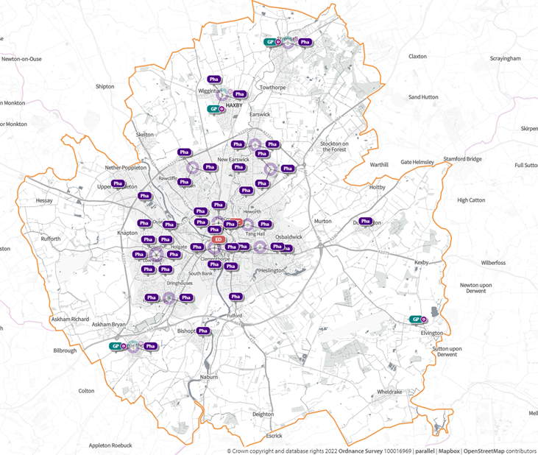
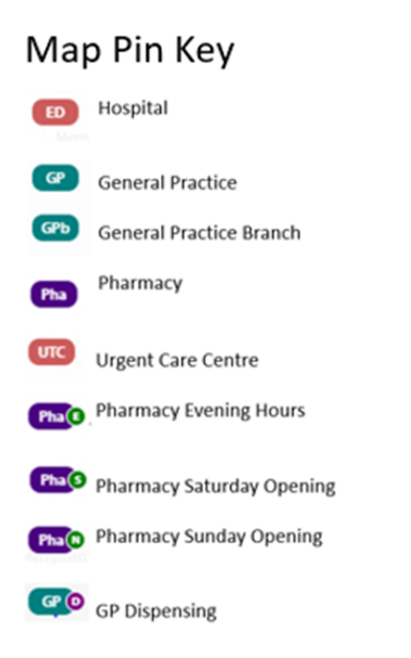

2.2 GP enhanced services

NHS England or ICBs may commission “enhanced services” from GP practices. These are primary medical services (other than essential services, additional services or out of hours services) that go beyond what is required through the GP core contract. These have previously been referred to as Directed Enhanced Services (DES) or National Enhanced Services (NES). Enhanced services that are currently available with national specifications produced by NHS England are as set out in Table 1. This includes highlighting the possible contribution that community pharmacies can make now or in the future.

Table 1 - Possible community pharmacy role in relation to GP enhanced services

Service | Description
Health checks for people with a learning disability | Allows GP practices to offer a medical to patients aged 14 years and over with a learning disability and produce a health action plan.  Community pharmacies could help to deliver elements of individual patients’ health action plans by supporting behaviour change, providing advice and support about prescribed medications, supporting the management of long-term conditions, help with self-care and signposting to other services.
Targeted immunisation programmes | Allows GP practices to provide the following targeted immunisation programmes:  - childhood ‘flu (2 and 3 year olds)  - meningitis ACWY (18 year olds and University Freshers)  - meningitis B (infants)  - pertussis (pregnant women)  - shingles (catch up)  - seasonal ‘flu and pneumococcal (adults aged 65 and over and clinical at risk groups)  Community pharmacies already make a significant contribution to improving access to seasonal ‘flu vaccine for adults aged 65 and over, adults in clinical at risk groups, adult carers and adult household contacts of people with a compromised immune system. For other immunisation programmes, community pharmacies can support uptake by promoting the benefits of immunisation and providing accurate information and advice.

2.3 Primary Care Networks

Primary Care Networks (PCNs) are geographically based teams, led by GP practices in the PCN area, delivering services to their registered population of between 30,000 and 50,000 patients. PCNs have a Clinical Director providing strategic leadership and oversight of service delivery of the PCN and representing the PCN as part of the wider health and social care system.

Every practice is a member of a PCN.

PCNs are expected to deliver the following NHS England specifications:

- Extended Hours Access
- Structured Medication Reviews and Optimisation
- Enhanced Health in Care Homes
- Anticipatory Care
- Personalised Care
- Supporting Early Cancer Diagnosis
- CVD Prevention and Diagnosis
- Tackling Neighbourhood Inequalities

The Primary Care Networks (PCNs) that cover York within the NHS Humber and North Yorkshire ICB are:

- Priory Medical Group
- West, Outer and North East York (WoNE York)
- York City Centre
- York East
- York Medical Group

2.4 GP Out of Hours

Yorkshire Doctors Urgent Care (YDUC) provide services across The Vale of York. The GP Out of Hours (OOH) service in The Vale of York operates 365 days a year, Monday-Friday 18:30-08:00 & Saturday/Sundays & Bank Holidays 08:00 - 00:00. The service is provided from GP OOH urgent care centres, one located at York Hospital and one at Selby War Memorial Hospital. Home visits are also provided where appropriate. It is worth noting that out of hours providers provide patients with their medication directly which reduces the need for pharmacies to open.

2.5 Urgent Treatment Centre

There is one urgent care centre in York located with the emergency department in York Hospital and is open 24 hours a day, 365 days a year.

Feedback from the residents survey indicated that 62% of respondents stated they would use a pharmacy for a minor health problem before going to A&E, 30% said they would go their GP, and 4% said they would use a walk-in centre before going to A&E.

2.6 Hospital Services

There is one hospital in the York area, provided by York and Scarborough Teaching Hospital NHS Foundation Trust. Scarborough Hospital is also within this hospital group providing acute hospital care. Community hospitals within the area, are accessible for York residents and provide rehabilitation, palliative care, outpatient services and elective care following surgery. These include Malton Hospital, Bridlington Hospital, Nelsons Court, St Monica's, New Selby War Memorial Hospital and White Cross Court.

3. Pharmaceutical Needs Assessment process

3.1 PNA development group

As set out within section 1 of this PNA, the legislation that describes the duties of the Health and Wellbeing Board in regard to PNAs is the National Health Service (Pharmaceutical and Local Pharmaceutical Services) Regulations 2013 ⁽⁶⁾ (as amended). As well as describing what each PNA was required to take into account when they were first developed and published, these 2013 Regulations also describe how each local PNA must be maintained by the HWB during its life.

The Public Health Team within the City of York Council oversaw the development of this PNA on behalf of the York Health and Wellbeing Board. In the process of undertaking the PNA, a joint multi-agency steering group was established in December 2021. Full membership is set out in appendix 2.

The steering group agreed the following:

- Terms of reference of the steering group, including the frequency of meetings
- Content of a PNA questionnaire to pharmacists in York
- Timeline of the PNA process
- Structure of the PNA document
- Process and questionnaires for engagement and consultation
- Appropriate governance, including declaration of interests, and reporting arrangements

The group was responsible for overseeing the completion of the PNA and ensuring it meets the minimum requirements set out in the regulations.

3.2 Determination of localities

The NHS (Pharmaceutical and Local Pharmaceutical Services) Regulations 2013 ⁽⁶⁾ state that, in making its assessment of needs, the Health and Wellbeing Board should have regard to the different needs of different localities in its area.

In accordance with this, the steering group considered how to assess these different needs and concluded that as in the previous PNA the Local Authority boundary gave sufficient detail.

The Health and Wellbeing Board is also mindful that needs can vary between the wards in each locality and at sub-ward level.

3.3 Assessing health needs

The Local Government and the Public Involvement in Health Act 2007 ⁽¹²⁾ created the duty to undertake JSNAs. From April 2008, this duty was carried out by with Local Authorities and PCTs. The Health and Social Care Act 2012 ⁽²⁾ transferred this duty, with effect from April 2013 to Local Authorities and CCGs to be exercised by Health and Wellbeing Boards.

This PNA is directly aligned to the York JSNA ⁽⁵⁾.

3.4 Current provision in York

In order to assess the adequacy of provision of pharmaceutical services and other services provided by community pharmacies, the current provision of such services was identified and mapped using the previous PNA as a baseline. Initially, this was based on information provided by the NHS England Sub Region, Vale of York CCG, City of York Council’s Public Health Team.

The information was then supplemented using a questionnaire made available to all community pharmacies. The questionnaire was hosted online, with a paper copy and easy read version available on request, running for a 5 week period ending on 28th March 2022. A total of 26 community pharmacy contractors responded. A summary of the findings of the survey are described in section 10 with detail within appendix 4.

3.5 Future provision

This PNA seeks to assess the current and future needs of the area, identifying any gaps in pharmaceutical services. Any such gaps may highlight the need for necessary provision or may require provision in specified future circumstances. In considering the future needs of the area and identifying any gaps in service the PNA has, in accordance with Regulation 9 (1) and (2), had regard to:

- The demography of York
- Whether there is sufficient choice with regard to obtaining pharmaceutical services within York
- The different needs of the localities within York
- The pharmaceutical services provided in the area of any neighbouring Health and Wellbeing Boards
- Any other NHS services provided in or outside of York
- Likely changes to the demography of York and/or the risks to the health or wellbeing of people of York

3.6 Stakeholder engagement

To gather views on current pharmacy provision a series of questionnaires were developed. One was aimed at residents, one at pharmacies and one for stakeholders (i.e., professional users of pharmacy services). The questionnaires were hosted online, with a paper copy and easy read version available on request, running for a 5 week period ending on 28th March 2022.

The resident questionnaire was promoted through the Local Authority social media accounts and through signage in local pharmacies.

The pharmacy questionnaire was promoted by the Local Pharmacy Committee (Community Pharmacy North Yorkshire), by directly emailing all pharmacy locations across York, including sending several reminder emails. Face to face visits were also undertaken to all pharmacy sites across the city, to explain what the questionnaire was and encourage the pharmacist or manager to complete it.

The stakeholder questionnaire was promoted through professional networks including PNA steering group, Health and Wellbeing Board and the York Health and Care Collaborative. It was also disseminated through the Public Health Team to colleagues, professionals and commissioned services.

These have been considered as part of this PNA. Section 10 and appendix 3 of this document provides a summary of the analysis and outcomes of the residents survey.

3.7 Statutory consultation

The formal consultation on the draft PNA for York ran from 1st July to 29th August 2022, in line with the guidance on developing PNAs and section 242 of the Health Service Act 2012 which stipulates the need to involve Health and Wellbeing Boards in scrutinising Health Services.

In keeping with the NHS (Pharmaceutical Services and Local Pharmaceutical Services) Regulations (2013) the following stakeholders were consulted during this time:

- Local Pharmaceutical Committee (Community Pharmacy North Yorkshire LPC)
- Local Medical Committee (YORLMC)
- All persons on the pharmaceutical lists and all dispensing doctors list in North Yorkshire
- York Health and Care Partnership
- Healthwatch
- Local Foundation Trusts:
  - York and Scarborough Teaching Hospitals NHS Foundation Trust
  - Tees, Esk and Wear Valleys NHS Foundation Trust
- NHS England
- NHS Humber & North Yorkshire Integrated Care Board
- Neighbouring HWBs:
  - North Yorkshire County Council
  - East Riding of Yorkshire Council

Emails were sent to all consultees informing them of the website address which contained the draft PNA document and inviting them to complete the consultation questionnaire. The draft PNA was also shared with the public through the same website address..

3.8 Recommendations and update from the previous PNA 2018 - 2021

Following development of the PNA 2018 - 2021, York Health and Wellbeing Board made the following statements and recommendations:

- "Overall, the quantity of community pharmacies in York is good and appears sufficient to broadly meet the health needs of residents in York. Overall, public satisfaction in community pharmacy services in York appears good. The data suggests that a large proportion of the adult population of York use a pharmacy at least once a month". This is still the case and remains unchanged for this PNA.
- "The population is York is growing and is getting older. Within the next three years it is that the population of York will include a greater number of people with long-term health conditions, this will rise faster than the total number of people. Overall, this means that the population need for community pharmacies in York may be expected to increase". This remains unchanged for this PNA.
- "There is a good geographic spread of pharmacies in York, with the majority of people being within reasonable travel distance of a pharmacy. There is good pharmacy coverage in the more deprived wards in York. This is partly because the more deprived wards of York tend to be the more urban wards nearer the city centre, where the majority of pharmacies are situated". This remains unchanged for this PNA.
- "Some population groups have more limited access to pharmacies. This includes residents living in the rural areas on the edge of the city boundaries. If community pharmacy services were not maintained, then travel time to the next available pharmacy would be significantly increased for some residents. Additionally, students living in the Heslington campus were mentioned as a population with lower access to pharmacies in the 2015 PNA, since this time the number of students accommodated on these campuses has increased substantially. The health needs of students are discussed at length in the Student Health Needs Assessment 2017; including a discussion of the high use of primary care services, some of which may be alleviated through improved access to pharmacy services." This PNA has not identified an increased need for pharmacy services based on the previous PNA. However, any pharmacy intending to primarily meet the needs of students should expect that the need for pharmacy services will fluctuate throughout the year.
Currently the University of York website directs students to the closest pharmacies - Missionstart Ltd on Fulford Road, Whitworth Chemists on Melrosegate and Badger Hill Pharmacy on Yarburgh Way (which is within a moderate walking distance for many students) ⁽¹⁴⁾. Additionally, many of the student areas are well served by bus routes and easy and frequent access to the city centre for additional pharmacy access and therefore is considered adequate.
- "Opening times are important to people and are an important element of the overall accessibility of that pharmacy, at present there appear to be a sufficient number of pharmacies open during evenings and weekends, most people report they can find a pharmacy when they need one. York has a high rate of employment and an overrepresentation of employment sectors that use shift work rotas. This means reduced flexibility to access pharmacy services during the working day. Therefore, any applications to reduce pharmacy opening hours in York should be considered carefully, with appreciation of the importance to the public in this matter." This remains unchanged in this PNA.
- "The residents of York currently have better health than their peers nationally and are a well skilled and well-educated group. This means that there will be opportunities greater for self-care and self-monitoring of conditions, some of which may be facilitated by community pharmacies." This has remained unchanged in this PNA.
- "Pharmacy services providing advice on minor conditions and long-term health conditions appear fairly well used in York (based on survey data). However, there also appeared to be some knowledge gaps among the public of these types of services. Pharmacies report some willingness to expand this element of this work further". This has remained unchanged in this PNA.
- "Health and social care professionals perceive some gaps in community pharmacy services, such as better provision of medicines packaging and delivery, emergency hormonal contraception, and targeted lifestyle advice. Pharmacies in York report some willingness to work more closely with health and social care professionals on several of these areas; and many are working towards Healthy Living Pharmacy status. This may represent an opportunity for pharmacies to work in a targeted fashion to reduce pressures on primary care in York and to improve the health and wellbeing of residents in York." The general practice responding to the survey highlighted that the following services were available in community pharmacies but not meeting the needs of the people they work with - advice on minor conditions, and advice/screening on long-term conditions (e.g., diabetes, high blood pressure etc). All pharmacies have now achieved Healthy Living Pharmacy status and continue to deliver commissioned services. Responses from the community pharmacy survey highlights pharmacists are keen to expand their services to both meet the needs of their population and reduce the pressures on GPs.
- "There was little reported evidence that pharmacies routinely advertised an independent comments and complaints procedure to the public." Feedback from the pharmacists' survey in this PNA indicated that 88% used their own compliments, comments and complaints policy (or similar), 54% used NHS England, 26% used Local Healthwatch, and 23% used GP Practice Patient Participation Groups.
- A Supplementary Statement was issued regarding the closure of Lloyds Pharmacy Limited 3 Intake Avenue, York, YO30 6HB in August 2019. The closure of this pharmacy has reduced access to pharmacy services for approximately 1,500 people (estimate provided by the Public Health England SHAPE tool). These people are now more than 1.2km walk from a pharmacy (there is no nationally agreed threshold for reasonable walking distance to a pharmacy. By comparison people living in the rural villages of East Riding and North Yorkshire are substantially further from a pharmacy). The closure of this pharmacy has meant that the new homes intended for the local plan, Nestle South (ST17) site are also likely to be a more than 1.2km walk from a pharmacy.

There are other developments planned for York as detailed in section 4.3. Cumulatively, and in the case of the very largest developments individually, the developments may result in an increased need for community pharmacy services. The HWB should review these development areas on a regular basis to identify any significant increases in pharmaceutical needs.

In summary, there are no gaps in the provision of necessary services in York. However, there are a number of developments that are expected to take place over the next three years that may impact on the need for and access to pharmacy services. This includes GP extended access, housing developments, online pharmacies and changes to the way in which pharmacies are funded. It is not possible to assess the impact of this at this time, however, it should remain under review as part of the ongoing PNA process.

Any pharmacy changes or closures that have a significant impact on access may be subject to a supplementary statement being issued by the Health and Wellbeing Board if this occurs before the next PNA is prepared.

4. York's Population

4.1 Overview of the City

York is England’s most visited city outside London and is situated in the northeast of the country, in the stunning county of Yorkshire, by the River Ouse ⁽¹⁵⁾.

York has many tourist attractions: impressive architecture, museums, riverside walks, cafes and restaurants. The city has the good fortune to be situated approximately two hours by train from London and Edinburgh with frequent direct train services. Once the capital city of England, York is a much-loved destination, particularly by students, offering a mix of a modern, cosmopolitan city in an ancient setting.

As a major tourist destination, York hosts events and festivals all year round, showcasing different types of music, theatre, culture, food and drink. Lively, full of culture and beautiful, York is regularly voted one of the best places to live and visit in the UK ⁽¹⁶⁾. Figures from Visit York show 6.9 million people visit the city each year, spending a total of £564 million. From 2013 - 2018, the total number of visitors went up by nearly 500,000 and the amount spent in the local economy increased by more than £100 million. There are more visitors during the school holidays and Christmas ⁽¹⁷⁾. A small number will require pharmacy services whilst in York, e.g., treatment for a minor health condition, and replacement for lost or forgotten medication. This can also create an increase in minor illness attendances at the hospital emergency department and urgent care centre. Pharmacies can alleviate the additional pressures which would otherwise fall to out of hours GP services or to the emergency care services in the hospital.

There are two Universities in York; University of York is located within walking distance of York city centre. The campus is home to ten colleges and most departments, there are also departments located in the city centre at the historic King's Manor. York St John University has an 11-acre campus close to the city walls and the historic centre of York. Overall, the student population for the 2020 - 21 academic year across the universities was over 30,000 students of which over 17,000 were female and 13,000 were male ⁽¹⁷⁾.

Figure 2 - Overview of York

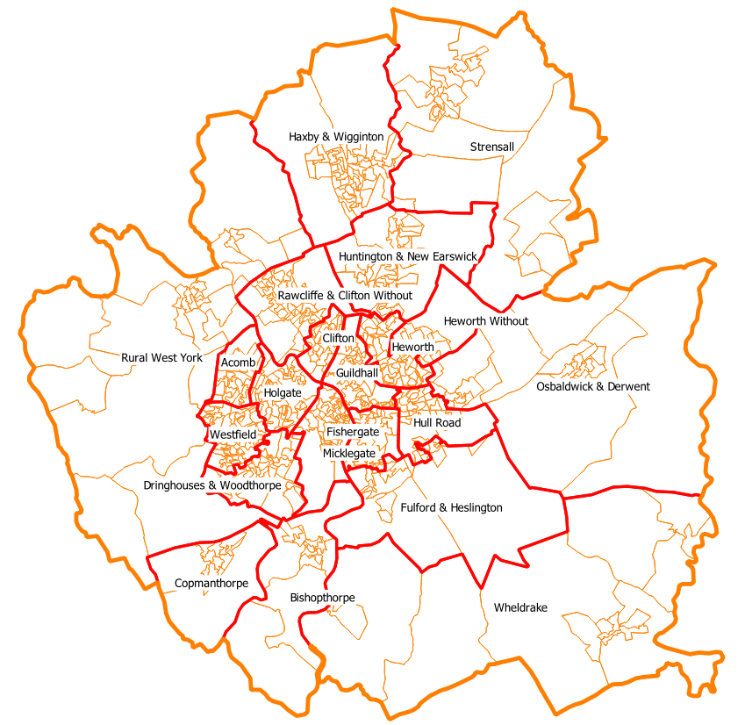

4.2 Population profile and demography

The City of York covers a surface area of 105 square miles (272 km²). In 2020 there were approximately 561,000 residents living in the York postcode area, an increase of approximately 56,000 since 2002. The average age of the population is 43.5 years, an increase of 2.5 years for the same period.

In 2020 the population density was 128 residents per square kilometre. The population has grown by 11.1% since 2002. The population is growing slower than the population in England and Wales which has grown 13.5%.

The Vale of York population is forecast to rise by 7.6% to 388,500 by 2040, which will increase the number of expected deaths per year by around 300 people. In addition, the proportion of people across both York and North Yorkshire Local Authorities over the age of 75 is expected to increase; people are likely to be more elderly when they die and are therefore more likely to have multiple long-term conditions and need greater care and support. Using ONS population data based on 2018 projections, the over 65 population of York in 2021 was 18,810. This is set to rise to 20,075 by 2026 and by 2030 to increase to 21,376 ⁽¹⁹⁾.

The population has become more culturally and religiously diverse with a Black and Minority Ethnic (BME) population of 9.8% (non-White British) compared to 4.9% in 2001.

Population data for 2021 indicates that York has become a much more open and diverse culture in recent years with a wide range of families living in the city. There are currently 83,552 households and, of that number, only 26,903 claim that they are married. Cohabitating couples make up 9,173 of the total and there are 136 households with same sex marriage partnerships. One parent household are on the rise and currently make up 7,288 of all families in York. Other household types make up 7,455 of the total number of households. By 2025, it is estimated that:

- the population aged over 65 in York will have increased by 16%
- the population aged over 85 in York will have increased by 32%
- the population aged between 0-19 will have risen by about 9% ⁽⁴⁾

4.3 Housing and Development Strategy

The emerging City of York Local Plan, submitted in May 2018 (as proposed to be amended by the ‘modifications’ published in 2019 and 2021), is currently the subject of an independent examination by the Planning Inspectorate.

The York Local Plan sets out a plan for new housing and commercial developments in the city to 2037 - 38 and policies for the amount affordable housing and design standards that will be required from new development. The development sites allocated in the Plan include a mix of smaller development sites, and larger sites with over 1,000 new homes planned, the Garden Village, west of Elvington Lane is expected to accommodate over 3,000 homes. Additionally, the University of York Heslington East Campus is due to expand significantly and a new site for expansion accommodating a mix of University uses and knowledge business floorspace.

To view the Local Plan, the examination process and for further updates on projected build out timelines see: https://www.york.gov.uk/LocalPlan.

The impact of the occupants of these new developments will need to be taken into account in informing future pharmaceutical needs assessments for York residents.

One (3%) respondent in the pharmacy survey felt that extensive housing developments in surrounding areas would impact on the need for pharmacy services over the next four years.

4.4 Car ownership
The latest published data for modal shares comes from the 2011 census, which showed that 57% of journeys to work in York were by car. This was lower than for comparable historic cities, largely because of York’s higher cycling mode share. The 2019, York Transport Consultation key findings report highlighted that 23% of people who were surveyed expected their car use to increase over the next 5 years ⁽²⁰⁾. Car ownership using 2011 census data indicated that car and van ownership in York was 455 per 1,000 which was the same as Ipswich (455) but higher than Bristol (445) ⁽²¹⁾.

4.5 Life expectancy

Using PHE profile data for 2020, York has a life expectancy at birth for males of 79.4 years, compared with the England average of 78.7 years. For females, life expectancy at birth is 83.4 years compared with the England average of 82.6 years ⁽¹⁹⁾. York is similar to most Local Authorities in that there is a gap in life expectancy between the affluent and those living in relative deprivation. There is generally an association between life expectancy at birth and deprivation across North Yorkshire, including York ⁽¹⁹⁾.

The broad causes of death which account for the greatest disparity in deaths between
males in the most and least deprived quintiles in York are circulatory diseases (28.1%),
cancer (19.3%), external causes (17.7%) and respiratory (14.6%) ⁽¹⁹⁾.

4.6 Wider determinants of health

Wider determinants, also known as social determinants, are a diverse range of social, economic and environmental factors which impact on people’s health. They determine the extent to which different individuals have the physical, social and personal resources to identify and achieve goals, meet their needs and deal with changes to their circumstances. The Marmot review ⁽²²⁾ published in 2010, raised the profile of wider determinants of health by emphasising the strong and persistent link between social inequalities and disparities in health outcomes. Addressing the wider determinants of health has a key role to play in reducing health inequalities.

4.7 Index of Multiple Deprivation (IMD)

The English Index of Multiple Deprivation (IMD) is a measure of area deprivation, based on 37 indicators, across seven domains of deprivation. IMD is a measure of the overall deprivation experienced by people living in a neighbourhood, although not everyone who lives in a deprived neighbourhood will be deprived themselves. The Index of Multiple Deprivation (IMD) 2019 measures socioeconomic disadvantage across seven domains:

- Income
- Employment
- Health
- Education
- Barriers to housing and services
- Crime
- Living environment

The overall IMD 2019 is a weighted average of the indices for the seven domains. Data is published by Lower Super Output Area (LSOA) - Super Output Areas are a geographic hierarchy designed to improve the reporting of small area statistics; Lower Super Output Areas are small areas designed to be of similar population size, have an average population of 1500 and 650 households. Figure 3 indicates the local footprint for LSOAs in York.

The 32,844 LSOAs in England are divided into deprivation ‘deciles’ i.e., the most deprived 3,284 LSOAs form the most deprived national decile. The following table provides an indication of the 120 LSOAs in York which fall in relation to these national deciles.

Table 2 – Local footprint for LSOAs in York

National Deprivation Decile | No. of York LSOAs | % of York LSOAs
Decile 1 - Most Deprived | 1 | 0.8%
Decile 2 | 5 | 4.2%
Decile 3 | 10 | 8.3%
Decile 4 | 4 | 3.3%
Decile 5 | 4 | 3.3%
Decile 6 | 9 | 7.5%
Decile 7 | 13 | 10.8%
Decile 8 | 12 | 10.0%
Decile 9 | 21 | 17.5%
Decile 10 - Least Deprived | 41 | 34.2%
Total | 120 | 100.0%
City of York Council Deprivation in York 2019

In 2019 one decile in York - 18B in Westfield was ranked close to the threshold between 10% and 20% most deprived in England. In 2015 there were 32 LSOAs in the least deprived decile nationally, in 2019 there were 41.

Figure 3 - Index of Multiple Deprivation - LSOA York 2019
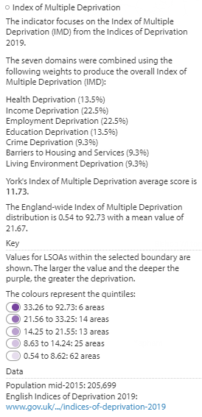
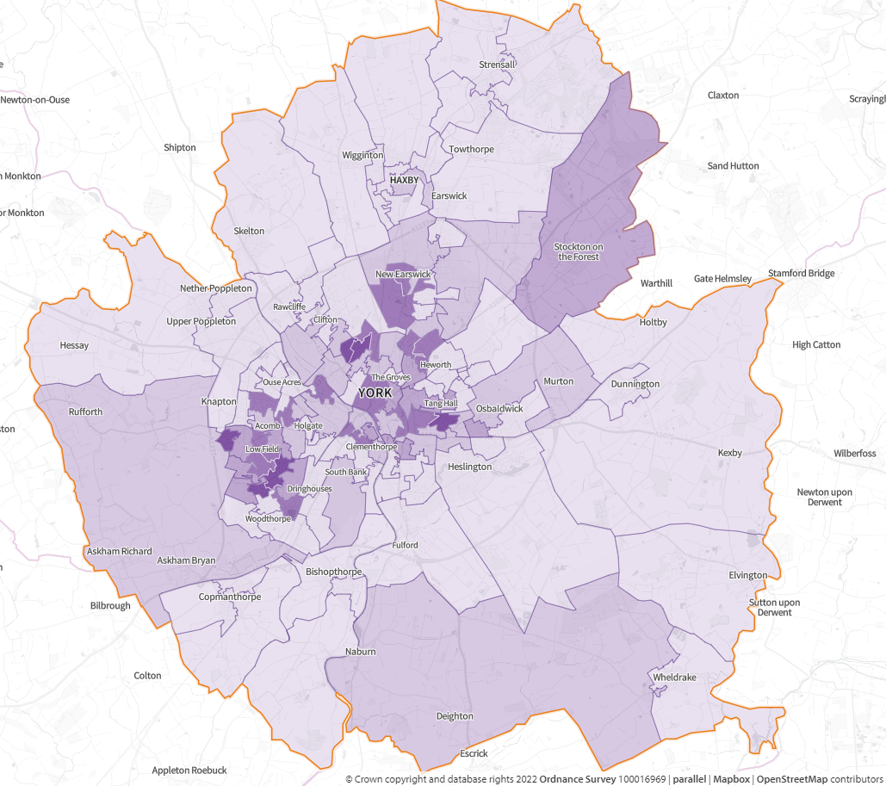

4.7.1 Income

Households living on low incomes experience many disadvantages which can be far-reaching. Households in employment may still be in poverty, as income may not be sufficient to meet the costs of accommodation and daily living. Low-income households are particularly vulnerable to changes in the cost of living and suffer the social exclusion and increased health risks of poverty. Average (mean) full-time earnings for workers who are York residents was £597.9 per week; this is above the regional average of £568.5, but below the Great Britain average (£613.1) ⁽²³⁾.

4.7.2 Employment

In York, NOMIS labour market statistics data for 2021 indicates, there were 139,000 people between the ages of 16 and 74. Professional occupations ranked highest among all percentages of employment at 32.3% of the workforce, 11.4% fall into the managerial sector and 14.9% are in the associate professional sector. Administrative and secretarial work make up 10.39%, skilled trades are 6.3%, care services are 6.9%, sales are 5.1%%, and process, plant and machinery workers make up the smallest section at 3.6%. Educators make up 11.4% of the total working population ⁽²³⁾.

Employment for working people aged people can protect against social exclusion as well as impacting positively on health and wellbeing. The percentage of out of work benefit claimants in York (aged 16 - 64) in April 2022 was 1.9% which is lower than the regional average 4.3% (Yorkshire and the Humber) and the Great Britain average of 4.0% ⁽²³⁾.

In York, 114,700 people (82.1% of the population) are economically active, with 24,200 (17.9%) economically inactive ⁽²³⁾. This indicates that North Yorkshire has a lower rate of economic inactivity compared to the region (22.6) and Great Britain (21.6%).

4.7.3 Education, skills, qualifications

In 2021 59.3% of 16 – 64 year olds in York were qualified to at least NVQ Level 4 or above. This was higher than the regional average of 38%, and the Great Britain average of 43.5. Overall, 93% of the population are qualified to NVQ level 1 and above ⁽²³⁾.

4.7.4 Housing and Homelessness

Rough sleepers in York have declined steadily over the 2 years from 2018 - 2019 ⁽²⁴⁾. Data for 2020 indicates that the rough sleeper count has reduced to 3. Additional measures in place to support people during COVID-19 and to minimise transmission rates have contributed to these reductions. Support is also in place to offer emergency accommodation to people to address issues which may have led them to becoming homeless. This includes referral to services for mental health or substance misuse, as well as training for work and how to manage a lasting tenancy. The needs of homelessness people in York are assessed at interview with the Housing Options Team. In 2018 - 19, 818 applications were assessed and formal decision made. In 2017 – 18, 166 presentations were made and 90 applications accepted as homeless.

Priority need is assessed as:

- Households with children or pregnant
- 16 and 17 year olds/vulnerable young people
- Old age households with physical illness or disabilities
- Households with mental health issues
- Domestic violence
- Emergency/other
- Asylum seekers

4.7.5 Crime

Crime can have a wide-ranging effect on people’s health. York ranks the 6th least deprived upper tier Local Authority for Crime, which is made up from crimes of violence, burglary, theft and criminal damage. In 2021, CrimeRate reports ⁽²⁵⁾ indicate that the overall crime rate for York was 73 per 1,000 residents. This was lower than Bristol at 90 per 1,000. Most crime is recorded in and around the York City Centre and Westfield. The most common crimes recorded are violence and sexual offences, with the least common crime theft from the person (pickpocketing).

Force average | 50.96
North Yorkshire | 49.11
York | 56.12
ONS 2021 Police recorded crime rates based on 1,000 population

4.8 Health Needs
Inequalities in health and their causes run deep through our society and through how people access, experience and receive care from the NHS. The Core20PLUS5 approach is designed to support Integrated Care Systems to drive targeted action in health inequalities improvement. The ‘Core20’ is a focus on the 20% of the population in the lowest deprivation quintile, which is meant to pick up and take on the overarching impact of deprivation on access, experience and outcomes ⁽²⁶⁾.
The five key clinical areas prioritised in the NHS Long Term Plan ⁽⁸⁾, i.e., continuity of maternity care for women in the most deprived areas and those from Black, Asian and minority ethnic groups, annual health checks for those with serious mental illness, chronic obstructive pulmonary disease management (with a focus on Covid-19, flu and pneumonia vaccination uptake), early cancer diagnosis and hypertension case-finding.
Making changes such as stopping smoking, improving diet, increasing physical activity, losing weight and reducing alcohol consumption can help people to reduce their risk of poor health significantly. Making Every Contact Count (MECC) is an approach to behaviour change that utilises the millions of day to day interactions that organisations and people e.g. pharmacists have with other people to encourage changes in behaviour that have a positive effect on the health and wellbeing of individuals, communities and populations ⁽²⁷⁾.

4.8.1 Smoking

Smoking accounts for more lives lost than any other modifiable risk factor. People from lower socio-economic groups, those suffering from mental health conditions and some minority ethnic groups have higher rates of smoking. Factors influencing smoking prevalence include educational attainment, employment, housing, income, and social cues. Young people who grow up in a household where adults smoke, are more likely to become smokers themselves.

Using PHE profile data for 2019 - 20 smoking prevalence in adults in York is 12.3% which is lower than both the region (15.1%) and England 14.3%. Data for the same period indicates that 24.4% of adults are recorded as ex-smokers which is lower than the region (27.0%) and England (26.3%) ⁽²⁸⁾.

Using PHE data for 2014 - 15, the modelled national estimates for smoking prevalence for 15 year old regular smokers (defined as smoking at least one cigarette per week) nationally was 8.7%. In York this is 8.5% which is similar to the national average ⁽²⁸⁾.

Smoking in early pregnancy using 2019 data is 10.8% which is lower than the region (17.4%). The national prevalence of smoking in pregnancy is 10.4%.

In York, using Quarter 1 - 3 data for 2019 - 20 48% of smokers seen by a stop smoking advisor successfully quit smoking at 4 weeks ⁽²⁹⁾.

How pharmacies can support:

- NHS Health Checks
- Smoking Cessation
- Nicotine Replacement Therapy
- Active Intervention Smoking Cessation
- Smoking Cessation Advanced Service
- Supporting the annual public health campaign

4.8.2 Alcohol

The main source of data on drinking among adults in England is the Health Survey for England. This is an annual survey covering adults aged 16 and over living in private households in England. The most recent publication found that, in 2019, 54% of adults reported drinking alcohol in the last week.
In England, 10 million or more people drink at levels which increase their risk of health harms, and alcohol consumption is a leading factor for ill-health. Among those aged 15 - 49 in England it is the leading cause for ill-health, early mortality and disability ⁽³⁰⁾. Alcohol-related mortality rate for York, was 8.3 per 1,000 for 2020 (compared to 12.4 for the region and 10.8 for England) ⁽²⁸⁾.

Rates for hospital admissions in under 18s using PHE data for 2020 - 21 is higher for females than males at 37.4 which is higher than the region (31.2) and England average 36.1) ⁽²⁸⁾.

Number in treatment at alcohol specific services in York in 2020 - 21 was 275, of these 31% successfully completed their treatment. This is lower than the region (35%) and for England (35.3%).

How pharmacies can support:

- NHS Health Checks
- Healthy Living advice
- Information about harmful drinking
- Signposting to services

One pharmacy responding to the questionnaire stated that York was not doing as well in signposting to local alcohol services, another pharmacy felt that an alcohol locally commissioned service was required in York.

4.8.3 Substance misuse

Substance misuse refers to the harmful or hazardous use of psychoactive substances, including alcohol and drugs. Drug misuse includes the harmful use illegal drugs, 'legal highs' and prescription-only medicines. Substance misuse impacts on crime, health and social costs. Estimates of the prevalence of opiate and crack cocaine produced in 2016 - 17 ⁽³¹⁾ suggest that York has a rate of 4.95 per 1,000 population aged 15 - 64 who were recorded as opiate dependent and 3.48 of the population with a crack cocaine dependency, compared to an England rate of 8.85 per 1,000.

When engaged in effective treatment, people use fewer illicit drugs, commit less crime, improve their health and manage their health better. Preventing early drop-out and keeping people in treatment long enough to benefit contributes to these improved outcomes.

How pharmacies can support:

- Needle and syringe exchange
- Supervised administration of opiate substitutes
- Testing for blood borne diseases (e.g., Hep C)
- Brief intervention
- Signposting to support services
One respondent (3%) in the pharmacy questionnaire suggested a wound care service
for the homeless and addiction patients would benefit the health of their patients.

4.8.4 Obesity

Nationally, two thirds of adults, a quarter of 2 - 10 year olds and one third of 11 - 15 year olds are overweight or obese. By 2050 obesity is predicted to affect 60% of adult men, 50% of adult women and 25% of children. PHE 2020-21 profile data for York indicates 63.6% of adults are overweight or obese. This is slightly lower than the region (66.5%) and similar to England (63.5%). Over 21% of 4 - 5 year olds and over 30% of 10 - 11 year olds in the York community are measured as having excess weight. Obesity is associated with a range of health problems including type 2 diabetes, cardiovascular disease and cancer. The resulting national NHS costs attributable to overweight and obesity are projected to reach £9.7 billion by 2050, with wider costs to society estimated to reach £49.9 billion per year. These factors combine to make the prevention of obesity a major public health challenge ⁽²⁸⁾.

Overweight and obesity are terms that refer to having excess body fat, with a BMI of more than 30, which is related to a wide range of diseases, most commonly:

- Type 2 diabetes
- Hypertension (high blood pressure)
- Some cancers
- Heart disease
- Stroke
- Liver disease

The NHS Digital data for 2020 indicates that prescription data for the former Vale of York CCG area 2,535 prescriptions had been issued for obesity medication (orlistat). It is noted that this is likely to include information some areas of Selby which fall under the Vale of York CCG boundary ⁽³⁰⁾.

How pharmacies can support:

- Healthy Living Pharmacy - offering information, advice and support
- NHS Health Checks
- NHS Weight Management Programme referrals and provision
- Promotion of health lifestyles
- Hypertension Case-Finding service
- Supporting the annual public health campaign
20% of respondents in the residents' survey said they would find it useful if their local pharmacy offered specific help with medicines for people with a long-term illness or conditions - e.g., obesity, asthma or COPD (Chronic Obstructive Pulmonary Disease). 11% said they would find a short 'one to one' weight management programme useful.

One pharmacy responding to the survey suggested a weight management locally commissioned service is required in York.

4.8.5 Sexual Health

4.8.5.1 Sexually Transmitted Infections (STI)

The health and economic wellbeing of any population and the wellbeing of individuals can be critically influenced by sexual health. The financial case for sexual health services has been made repeatedly; effective sexual health services and the prevention of sexually transmitted infections (STI) and unplanned conceptions are cost-saving. Health inequalities exist within sexual health and key population groups can be identified for whom there are greater risks of experiencing sexual ill health. These are as follows: young people; gay, bisexual or other men who have sex with men; black and minority ethnic groups; and women of reproductive age.

PHE data (2020) for York, indicates that the diagnosis rates for STIs is 378 per 100,000 of the York population. This is lower than the region (419) and England (619). There are 3.6% positive test rates for STIs excluding chlamydia in York against the region (6.1%) and England (7.3%).

The residents survey indicated that 21% of respondents would find it useful if their local pharmacy offered NHS screening services, e.g., diabetes, HIV, Hepatitis B or C.

None of the pharmacies responding to the questionnaires stated they were delivering a chlamydia testing service. Two pharmacies responding to the questionnaire stated that a sexual health/chlamydia testing and treatment locally commissioned service was required in York.

4.8.5.2 Teenage pregnancy

Areas of high social disadvantage and deprivation typically correlate with high teenage pregnancy rates for reasons such as low aspirations, poor uptake of services and the cyclical nature of teenage pregnancy. ONS data for York in 2020, indicated that there were 12.4 conceptions per 1,000 females aged under 18. This lower than both the England rate (13.0) and the region (16.5). Of note is that this rate is lower than the previous year (2019) which was lower than the previous year at 16.4 per 1,000 ⁽¹⁹⁾.

How pharmacies can support:

- C-card scheme
- Emergency hormonal contraception
- Pregnancy testing
- Referral on for further contraception services
Feedback from one respondent in the residents survey: "My friends in other areas can get the morning after pill from a pharmacy for free but we can't here which doesn't seem right. It's great to be able to get my flu and COVID vaccinations in a pharmacy - it's a lot easier than going to the GP and the queues are much shorter." Several pharmacies responding to the questionnaire stated that there was a need for a free emergency contraception service as York is a large city with two Universities and younger people request the service. Supply of the morning after pill free of charge, STI testing, and contraception services were all suggested by residents as ways in which services provided by pharmacies could be improved.

It is important to note that free emergency hormonal contraception is available through general practice or specialist sexual health services in York without appointment.

4.9 Cancers

Death rates from all cancers have decreased significantly over the last two decades due to a combination of early detection and improved treatment.

PHE data for 2017-19 indicates that for York, the rates of mortality from cancer in under 75s (3 year range, 2017 - 19) was 132.2 per 100,000. This compared to 137.5 per 100,000 for the region and 129.2 per 100,000 for England ⁽²⁸⁾.

Of note the data for 2020, indicates that the under 75 mortality rate from cancers that were considered preventable was 52.2 for York was lower than the region (58.0) and higher than the England rate of 51.5 ⁽²⁸⁾.

How pharmacies can support:

- Advice and support
- Signposting
- Medicines optimisation
- New medicine service
- Discharge medicine service

4.10 Long-term conditions

A long-term condition (LTC) is a condition that cannot, at present, be cured but is controlled by medication and/or other treatment/therapies. Lifestyle factors play a major role in the prevention and management of LTCs and are largely modifiable. Healthier lifestyle patterns can delay the onset of chronic diseases, reduce premature deaths and have a considerable positive impact on wellbeing and quality of life.

The prevalence of long-term conditions increases with age and the proportion of the population with multiple long-term conditions also increases with age. People from lower socio-economic groups have increased risk of developing a long-term condition; better management can help to reduce health inequalities.

The JSNA for York ⁽⁵⁾, 2019 states that 15.3% of people report that they are living with a long-term illness or disability, 11.1% have multiple long-term conditions as recorded on more than one disease register. ONS Data for 2019/20 indicates that 12.0% with a long-term illness, disability or medical condition diagnosed at the age of 15. This is lower than the region 13.0% and England 14.1% ⁽²⁸⁾.

4.11 Cardiovascular disease

Cardiovascular disease (CVD) covers a number of different problems of the heart and circulatory system. It is more prevalent in lower socio-economic and minority ethnic groups.

Death rates from cardiovascular disease have decreased significantly over the last two decades due to a systematic approach to secondary prevention and improved treatment.

Cardiovascular disease is a cause of premature death and health inequalities with a mortality rate of 64.4 per 100,000 for persons aged under 75 in 2020 in York ⁽²⁸⁾. This is lower than the region (82.5) and England (73.8).

21% of respondents in the residents' survey stated that they would find Free Healthy Heart Checks a useful service from a local pharmacy. 12% stated they would find an anticoagulant monitoring service useful e.g., finger prick testing for patients on warfarin.

How pharmacies can support:

- NHS Health Checks
- Education and support
- New medicine service
- Discharge medicine service
- Hypertension Case-Finding service

4.12 Diabetes

Diabetes is a chronic and progressive disease that impacts upon almost every aspect of life. It can people of all ages and is becoming more common. Diabetes can result in premature death, ill-health and disability, yet these can often be prevented or delayed by high quality care. Preventing type 2 diabetes (the most common form) requires action to identify those at risk who have non-diabetic hyperglycaemia and prevention activities to tackle obesity, diet and physical activity.

Complications from diabetes result in considerable morbidity and have a detrimental impact on quality of life. Type 2 diabetes is typically associated with excess weight can be prevented or delayed by lifestyle changes.

In York, PHE data for 20 - 21 estimates that 5% prevalence of diabetes as recorded on GP practice Quality Outcome Framework (QOF) registers. This is lower than the region 7.5% and England 7.1% ⁽²⁸⁾.

21% of respondents in the residents' survey stated they would find it useful if their local pharmacy offered NHS screening services, e.g., diabetes, HIV, Hepatitis B or C.
How pharmacies can support:

- Lifestyle advice and support including low carb diet and exercise
- Healthy living advice
- Random blood glucose checks

4.13 Respiratory

Respiratory diseases (those affecting the airways and lungs) are diagnosed in 1 in 5 people and are the third leading cause of death in the UK, after cardiovascular disease and cancer. They are also a major driver of health inequalities, and much of this disease is largely preventable. Respiratory disease covers a wide variety of conditions, including common conditions such as asthma and chronic obstructive pulmonary disease (COPD), lung cancer, infections such as pneumonia and flu, and less common diseases such as interstitial lung disease and mesothelioma ⁽³³⁾.

In York, respiratory diseases are a contributor to premature death and health inequalities with a death rate of 25.1 per 100,000 persons aged under 75 in 2020 ⁽²⁸⁾ compared to 34.4 for the region and 29.4 per 100,000 for England. The rate of premature mortality from respiratory disease considered preventable is 12.9 per 100,000 in the population aged under 75 for 2020. This is lower than the England average (17.1).

20% of respondents in the residents' survey said they would find it useful if their local pharmacy offered specific help with medicines for people with a long-term illness or conditions - e.g., obesity, asthma or COPD (Chronic Obstructive Pulmonary Disease).

How pharmacies can support:

- Advice and support
- Correct inhaler technique
- New medicine service
- Discharge medicine service

4.14 Dementia

Dementia is a group of related symptoms associated with an on-going decline of brain functioning. This may include problems with memory loss, confusion, mood changes and difficulty with day-to-day tasks.

The biggest risk factor for dementia is age; the older you are the more likely you are to develop the condition. But dementia is not an inevitable part of ageing. Although it is not possible to completely prevent dementia, leading a healthy lifestyle and taking regular exercise can lower the risk of dementia.

There are different types of dementia; all of them are progressive and interfere with daily life. Alzheimer’s disease and vascular dementia together make up the vast majority of cases. Although there is no cure for dementia, early diagnosis and the right treatment can slow its progress, help to maintain mental function, and give time to prepare and plan for the future. The estimated dementia diagnosis rate (aged 65 and over) for York in 2021 is 56.9%, which is below the regional average (63.2%) and the national average (61.6%) ⁽²⁸⁾.

How pharmacies can support:

- Dementia Friends Programme
- Compliance aid assessment
- Repeat prescription service
- New medicine service
- Discharge medicine service

4.15 Mental Health and Mental Wellbeing

In recent years, there has been increasing recognition of the impact of mental illness on the population. A wide range of variable factors can affect people's mental wellbeing both positively and negatively throughout their lives. People with mental illness are more likely to experience physical illness and have a lower life expectancy than people without mental illness ⁽³⁴⁾. It is estimated that people living with severe mental illness may die up to 20 years earlier than the general population ⁽³⁵⁾.

The percentage of individuals reporting depression or anxiety in York is 11.5% and lower than the region 12.6% and England 12.3%. The JSNA ⁽⁵⁾ indicates hospital admissions for intentional self-harm as (172.4 per 100,000) and is lower than England (192.6 per 100,000). The highest rates were seen in teenagers 15 - 19 years. The suicide rate in York is 13.3 per 100,000 of the population and is 4 times higher in males.

Premature mortality of people with a severe mental illness is 94.9 per 100,00 of the population, 108.8 for the region and 212.4 for England.

One pharmacy responding to the questionnaire felt that a locally commissioned service would enable pharmacies to increase uptake of mental health and learning disability health checks.

How pharmacies can support:

- Information, advice and support on self-management and signposting to services

5. Current Provision of Pharmaceutical Services

5.1 Overview

NHS England is responsible for administering pharmacy services and for maintaining information regarding opening hours for all pharmacies, which is handled locally by North East and Yorkshire.

A table listing the current pharmacist services and key opening times is attached in appendix 6 and figure 1 shows the location of the community pharmacy provision across York.

In the York HWB area, there are currently 42 contractors providing NHS pharmaceutical services made up of ⁽³⁸⁾:

- 35 standard contract (40 hour) pharmacies
- 5 100 hour pharmacies
- 2 appliance contractors
- 4 dispensing doctors’ services

Based on ONS data population estimates (mid 2020) ⁽³⁶⁾, the national average number of pharmacies is 20.4 per 100,000 population in England, not including dispensing practices; this equates to one pharmacy per 4,901 population.

With 42 community pharmacy services in the York HWB area and a population of 211,012 (based on ONS 2020 mid-year population estimates), the average number of community pharmacies is 19.9 per 100,000 people; this equates to one pharmacy per 5,024 population. i.e., slightly lower than the national average.

Prescribing and data reports (ePACT2) published by NHS Business Services Authority (NHSBSA) in May 2022 indicated that a total of 3,608,853 items were prescribed by GPs in the York HWB area in 2020 – 21 ⁽³⁸⁾.

Information from NHS England indicates that there has been a decrease of three 40 hour pharmacies in the York HWB area since the last PNA was published. Further information regarding these changes and access to pharmacy services is described in section 6.

5.2 Standard contract (40 hours)

Figure 1 shows the current provision of essential pharmaceutical services within the York Local Authority boundary.

5.2.1 Core hours

Community pharmacy contractors provide Essential Services (see section 7.1 essential services) as part of the NHS Community Pharmacy Contractual Framework (the ‘pharmacy contract’). Most community pharmacies provide a core of 40 hours per week, although some pharmacies may be contracted to provide a 100 hour pharmacy service, and some may offer less than 40 hours.

Core opening hours can only be changed by first applying to NHS England and as with all applications, these may be granted or refused.

5.2.2 Supplementary hours

These are provided on a voluntary basis by the pharmacy contractor, often based on patient need and business viability. As such, they are additional to the core hours provided. Supplementary hours can be amended by giving NHS England 90 days' notice of the intended change but would not be expected to fall unless there had been prior reduction in demand.

In the York HWB area, a number of community pharmacies provide extended opening with the provision of supplementary hours, including 3 that provide services between 60 - 80 hours per week, 2 that provide between 80 and 100 hours (detailed in section 6). Provision of supplementary hours enables patients to access pharmacies for minor ailments, palliative care medicines and services e.g., CPCS.

5.3 100 hour pharmacies

Previous regulation ⁽⁶⁾ provided an exemption to the control of entry system for premises which are kept open for at least 100 hours per week for the provision of pharmaceutical services. Such 100 hour pharmacies provide extended and out-of-hours cover for pharmaceutical services across York. The new control of entry system came into force on 1st September 2012 whereby decisions on pharmacy contract applications became based on local PNAs. This removed the 100 hour exemption and exemptions allowing pharmacies to open automatically if they were situated in out-of-town shopping centres or one-stop primary care centres.

Information from NHS England indicates that there are currently five 100 hour pharmacies within the York area.

5.4 Pharmacy Access Scheme

In October 2016, as part of the renewed funding package for community pharmacies in England, the Department of Health and Social Care (DHSC) introduced of a Pharmacy Access Scheme (PhAS). This was to give patients access to NHS community pharmacy services in areas where there are fewer pharmacies with higher health needs, so that no area need be left without access to NHS community pharmaceutical services.

This scheme has been updated from January 2022, with revised criteria, and is based on both the dispensing volume of the pharmacy, and distance from the next nearest pharmacy. Information provided by NHS England in April 2022 identified five pharmacies as being eligible for the Pharmacy Access Scheme for 2022. These are:

- Your Local Boots Pharmacy, 25b The Village, Strensall, York
- Day Lewis Pharmacy, 5 York Street, Dunnington, York
- Bishopthorpe Pharmacy, 22-24 Acaster Lane, Bishopthorpe, York
- Copmanthorpe Pharmacy, Unit 8 The Shopping Prec, Main Street, Copmanthorpe, York
- Citywide Health - Poppleton Pharmacy, The Pharmacy, The Green, Upper Poppleton, York

5.5 Dispensing appliance contractors (DAC)

Dispensing appliance contractors (DAC) specialise in the supply of prescribed appliances such as catheter, stoma and incontinence products and dressings. These items are usually delivered direct to the patient’s home. Community pharmacies can also provide this service, in accordance with the pharmaceutical regulations.

Dispensing appliance contractors (DAC) are different to pharmacy contractors because they only dispense prescriptions for appliances and cannot dispense prescriptions for medicines. They tend to operate remotely, receiving prescriptions either via the post or the electronic prescription service, and arranging for dispensed items to be delivered to the patient.

Information from NHS England indicates there are two dispensing appliance contractors in the York HWB area.

5.6 Distance selling pharmacies

A distance selling pharmacy is a registered pharmacy that provides services over the internet. Distance selling pharmacies are required to deliver the full range of essential services, though the 2013 regulations ⁽⁶⁾ do not allow them to provide essential services to people on a face-to-face basis on the premises of the pharmacy. They will receive prescriptions either via the electronic prescription service or through the post, dispense them at the pharmacy and then either deliver them to the patient or arrange for them to be delivered.

They must provide essential services to anyone, anywhere in England, where requested to do so and may choose to provide advanced services, but when doing so must ensure that they do not provide any essential or advanced services whilst the patient is at the pharmacy premises.

As of 30th June 2021, there were 379 distance selling premises in England, based in 115 health and wellbeing board areas. Not every health and wellbeing board therefore has one in their area, however, it is likely that some of their residents will use one. Based on NHS England data there are no distance selling pharmacies in the York HWB area.

A distance selling pharmacy could be based in another part of the country and supply to York residents therefore, it is not possible to estimate how many suppliers operate in the York HWB area.

5.7 Dispensing Doctors

NHS legislation provides that in certain rural areas (classified as controlled localities) general practitioners may apply to dispense NHS prescriptions. A reserved location is designated, in a controlled locality, where the total patient population within 1.6 km (one mile) of the proposed location of a new pharmacy is less than 2,750 at the time an application is received. Patients living in these areas have the choice of having their prescriptions dispensed from a pharmacy or from a dispensing GP, if one is available within their practice. Where an application for a new pharmacy is made in a controlled locality, a determination must also be made as to whether the location of the pharmacy is in a reserved location.

Based on data from NHS England there are there are 4 dispensing doctors in York:

- Haxby Group Practice
- Old School Medical Practice
- MyHealth Group
- Elvington Medical Practice

Prescribing and data reports (ePACT2) published by NHS Business Services Authority (NHSBSA) in May 2022 indicated dispensing by these practices accounted for 7% (approximately 255,930) of the dispensed items in 2020 – 21 ⁽³⁸⁾. These services provide additional access to dispensing services for the population of York.

The Wheldrake branch site of Elvington Medical Practice closed during the initial COVID period when sites were prioritised and rationalised for infection control purposes. Since then, a number of concerns have become apparent around the material condition of the building and it is currently unsuitable for delivery of GP services. As part of the formal process for GP estate, a three-facet building survey has been undertaken which recommended significant capital investment in order to bring the building back up to an acceptable standard for the delivery of safe services, and the discussions are currently ongoing around the funding of repairs or alternative premises.

Primary care services are still being delivered for the population of Wheldrake through the main Elvington surgery site, but it is a significant distance away from where many Wheldrake patients live with poor public transport links.

Elvington Medical Practice dispensary remains open for collection of medication. A service to collect prescriptions at Wheldrake Surgery continues, but on a reduced basis between 2-4pm on Fridays.

5.8 Hospital Pharmacy Services

NHS hospital trusts and private hospitals do not provide services under the Community Pharmacy Contractual Framework and are therefore outside the scope of the PNA.

5.9 Out of area providers of pharmaceutical services

Consideration has been given to pharmaceutical services provided by community pharmacy contractors outside of the York HWB area that provide dispensing services to the registered population. Out of area providers may include community pharmacies that are in neighbouring HWB areas, in particular those that may be close to the boundaries. In addition, distance selling pharmacies which may be in more distant locations provide an alternative dispensing and delivery service. It is not possible to identify how many York residents access these services.

Information from SHAPE indicates there are 2 pharmacies outside the York HWB area but within a 5 miles radius.

6. Access to Community Pharmacy services in York

Information from NHS England indicates that since the last PNA 2018 ⁽³⁾ the following significant changes to pharmacy provision in York include the closure of the following premises:

- Lloyds Pharmacy Ltd, Lloyds Pharmacy, 3 Intake Avenue, York YO30 6HB (40 hour contract). Supplementary statement issued - “the closure of this pharmacy has reduced access to pharmacy services for approximately 1,500 people (estimated provide by the Public Health England SHAPE tool). These people are now more than 1.2km walk from a pharmacy (there is no nationally agreed threshold for reasonable walking distance to a pharmacy. By comparison people living in the rural villages of East Riding and North Yorkshire are substantially further from a pharmacy). In addition, the closure of this pharmacy has meant that the new homes intended for the local plan Nestle South (ST17) site are also likely to be a more than 1.2km walk from a pharmacy.”
- Boots UK Ltd, Boots Pharmacy, 66 Clarence Street, York YO31 7EW (40 hour contract)
- Boots UK Ltd, Boots Pharmacy, 5 St Mary's Square, The Coppergate Centre, York YO1 9NY (40 hour contract)

There has also one relocation of existing pharmacy services to an alternative location within the HWB area close to the previous site.

A full list of pharmacy services is summarised in appendix 6.

NHS England acknowledged that during the pandemic, there were occasions when temporary adjustments were needed to pharmacy opening hours as workload and other pressures on community pharmacy increased. It was recognised as important that pharmacy staff stay well and rest appropriately. Contractors were supported to consider steps to temporarily shorten the working day or have periods of time for staff to recover and catch up with any backlog of work.

All pharmacies, both those providing 40 and 100 hour services were required to be open at specific times during the day as defined by NHS England and patients provided with information about how to contact the pharmacy if urgent help was required. This flexible approach to opening hours was no longer applicable by the time this PNA was carried out.

Subsequently, there have been some changes in hours of service, specifically regarding supplementary hours rather than changes in core service delivery, with formal notification to NHS England as required by the NHS Regulations.

Feedback from the residents survey indicated that 58% stated the pharmacy was open when they needed it, 37% stated it was open most of the time, while 4% stated it was not open when they needed it. Information from the pharmacies who responded to the survey indicated two pharmacies (7%) were commissioned to provide an out of hours service. 16% of respondents in the residents' survey indicated they had used the out of hours service.

6.1 Out of area dispensing activity

Prescribing and data reports (ePACT2) published by NHS Business Services Authority (NHSBSA) in May 2022 indicated that in the financial year 2020/2021, over 90.5% of the items prescribed by GP practices in the York HWB area were dispensed by pharmacies or dispensing GP practices in the York HWB area and 9.5% were dispensed "out of area." (For "in area" the Office for National Statistics (ONS) Postcode Lookup was used to determine postcodes in the Local Authority area) ⁽³⁸⁾.

The number of prescriptions dispensed out of area has decreased over the last 3 years with 18.6% being dispensed out of area in 2018 - 19 and 11.9% in 2019 – 20 ⁽³⁸⁾.

Out of area dispensing may be due to people choosing to use a distance selling pharmacy for their medicine supplies or people who live on the boundaries of the area accessing pharmacies which are convenient to visit but are in a neighbouring HWB area.

6.2 Access to pharmacies for older people

Figure 4 shows the distribution of community pharmacies and dispensing doctors in or near to areas with a high proportion of the population aged 65 and over where the darker shading on the map indicates the more densely populated areas. In general, the pharmacies are in areas where there is more dense population although there are areas where there is an older population and there are few pharmacies. This is compensated for, in part, with the dispensing doctor service provision although other pharmacy services, in particular the advanced services such as the New Medicine Service and the Hypertension Case-Finding Service may be less accessible to people in the more rural/outlying areas.

6.3 Access to pharmacies in areas of high deprivation

Figure 5 shows that generally there is a good distribution and sufficient provision of community pharmacies in or near to areas with the highest levels of deprivation.

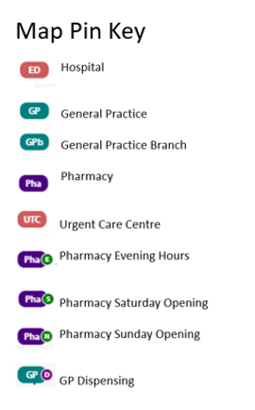
Figure 4 - Access to pharmacies in areas with a high proportion of the population aged 65 years and over in York
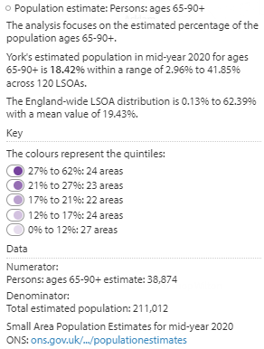
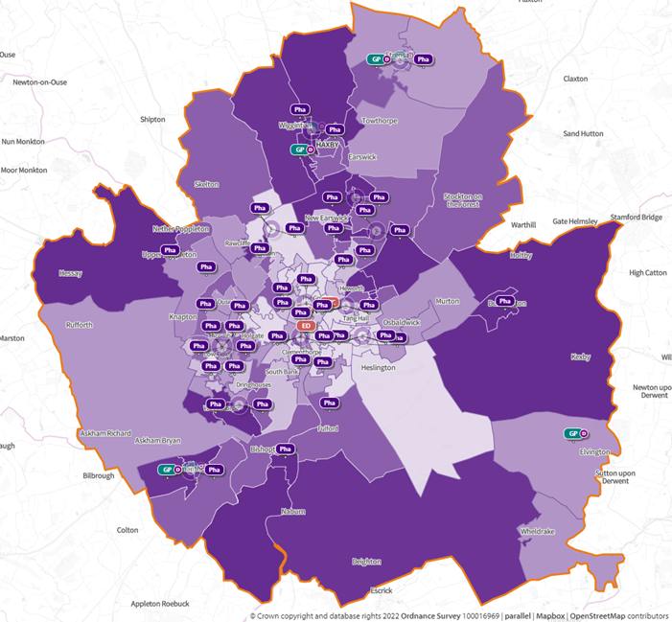

Figure 5 - Access to pharmacies in areas with high levels of deprivation (based on the Index of Multiple Deprivation 2019) in York
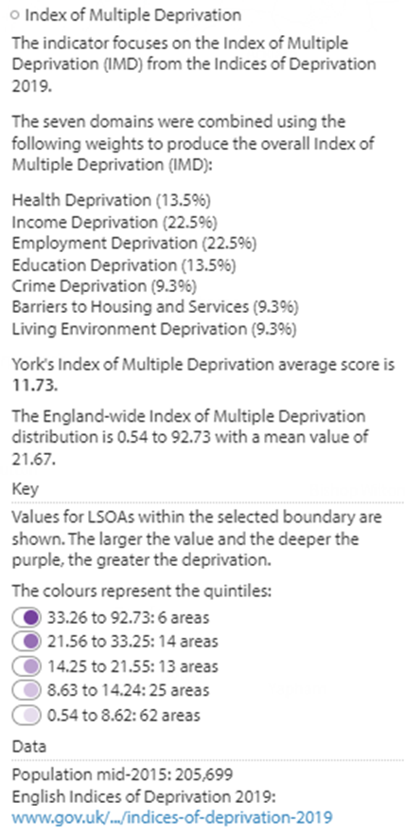
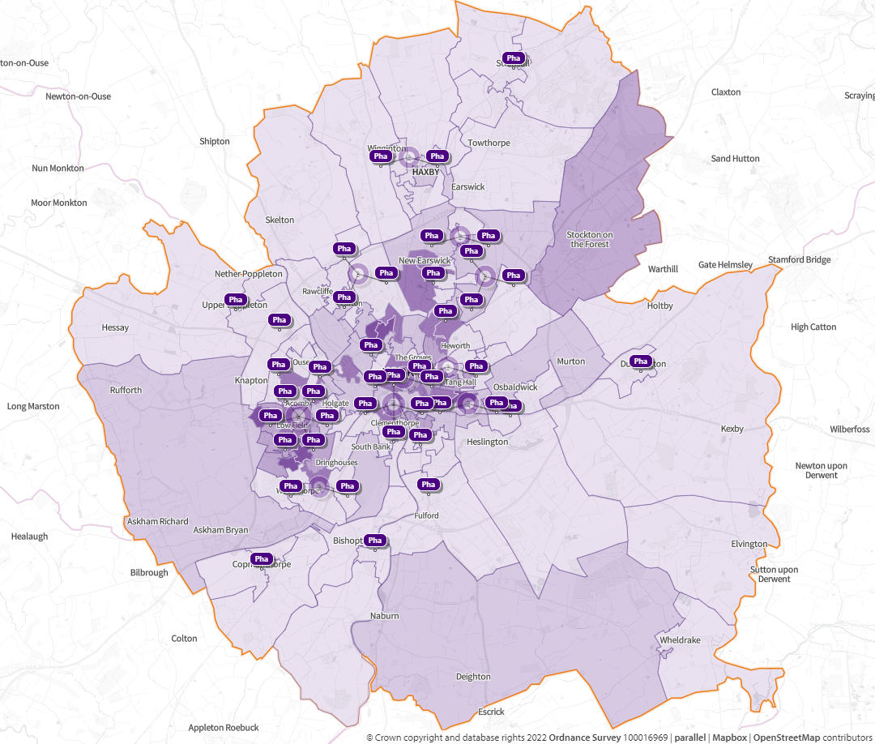

6.4 Access to pharmacies by opening hours

Community pharmacy contractors are required to open for a minimum of 40 core hours per week, unless a reduction is agreed with NHS England. These core hours are provided as part of essential pharmacy services. There are five 100 hour pharmacies in York, opened under the previous exemption which enabled longer opening hours, and these pharmacies must be open for at least 100 hours per week as core hours. Dispensing appliance contractors are required to open for a minimum of 30 core hours per week.

In York, 86% of pharmacies are open for more than the core contracted 40 hours. Information provided by NHS England ⁽³⁷⁾ in January 2022 indicated that an additional 1105.25 supplementary hours of access to community pharmacy services were being provided per week across the York area.

Analysis of opening hours in appendix 6 highlights generally good accessibility during the week between 9.00am and 5.30pm. Outside of these times access is more variable, particularly in the evenings where there is a reliance on five 100 hour pharmacies across the city.

Table 3 below and the charts that follow illustrate how important supplementary hours are to the provision of good access to pharmaceutical services.

Table 3 - Distribution of the number of hours that pharmaceutical service (excluding appliance contractors) available each week in York

York Community pharmacy services | 2022
Number of hours open each week | Number | %
Exactly 40 hours | 6 | 14%
More than 40 and up to 45 hours | 14 | 33%
More than 45 and up to 50 hours | 9 | 22%
More than 50 and up to 55 hours | 3 | 7%
More than 55 and up to 60 hours | 0 | 0%
More than 60 and up to 80 hours | 3 | 7%
More than 80 and less than 100 hours | 2 | 5%
Exactly 100 hours | 5 | 12%
Data source: ⁽³⁷⁾

In addition to the five 100 hour pharmacies in York there are five pharmacies that provide significantly extended supplementary hours beyond their 40 hour core contracts and provide access on both Saturdays and Sundays.

The HWB board recognises the importance of access to pharmacies in the evenings and weekends and that, in addition to the 100 hour pharmacy provision, some pharmacies provide extended opening hours as supplementary hours which, if reduced could impact on access for the population of York.

6.5 Ease of access to pharmacies

The following sections provide a summary of the opening hours of community pharmacies in York, split between weekdays and weekend provision. For the weekdays a pharmacy has been counted as being open during a particular time slot if it is open on three out of the five days.

4% of respondents in the residents' survey stated they did not find the location of their pharmacy convenient and 1% stated there was a lack of public transport.

6.5.1 Weekday opening

Access to community pharmacies is well provided for during the hours from 9.00am until 6.00pm on weekdays in York.

There are 24 pharmacies in York that are not 100 hour pharmacies which remain open without closing for lunch time. Most of the pharmacies that have a break in service are closed for an hour over lunchtime.

6.5.1.1 Weekday mornings

All community pharmacies in York are open from 9.00am on weekday mornings. The pharmacies providing earlier opening times, as seen in chart 1, are generally those providing a 100 hour service and therefore these opening hours are included in the core service. The majority of 40 hour pharmacies are open from 9.00am in the weekday mornings.

6.5.1.2 Weekday evenings

Most pharmacies remain open until between 5.30pm and 6.00pm after which there is a noticeable reduction in provision. Provision after 7.00pm is provided for by the five 100 hour pharmacies as well as three pharmacies offering supplementary hours until 8.00pm or 9.00pm. Figure 6 shows the locations of the pharmacies that are open on weekday evenings. There is adequate weekday evening provision around the Urgent Care Centre area.

Chart 1 shows the distribution trend of opening hours across the York area and how these are delivered in terms of core and supplementary hours

5% of respondents in the residents' survey stated they were unhappy with the daytime opening times of their pharmacy and 17% were unhappy with the evening opening times.
Figure 6 - Pharmacy Provision – Weekday Evenings (denoted with PhaE) in York
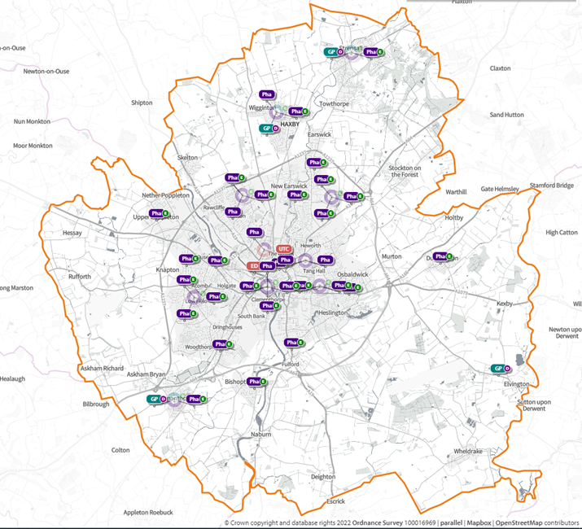

6.5.2 Weekend opening

None of the dispensing appliance contractors are open on Saturdays or Sundays. However 74% of respondents from the residents' survey said that they were able to find a pharmacy that was open on a Sunday or Bank Holiday.

6.5.2.1 Saturday opening

In total, 27 pharmacies across the area are open on Saturdays. All these pharmacies open on Saturday mornings, this is reflected in chart 2. This reduces to 16 pharmacies that remain open on Saturday afternoons until 4.00pm and after 7.00pm is mainly provided by the 100 hour pharmacies. There is adequate pharmacy provision on Saturdays across the York footprint, as shown in figure 7.

6.5.2.2 Sunday opening

In total, 11 pharmacies (figure 8) in York are open on Sundays, the majority of which are open between 10.00am and 4.00pm (chart 3). This provides adequate pharmacy provision on Sundays for York.

One respondent from the residents survey said that "3 Jan 2022 Bank Holiday Monday there was not one pharmacy open after 6pm in York. Having visited the OOH at York Hospital then driving to Leeds after searching for a pharmacy using Google to find a pharmacy open and then travelling to Leeds to get antibiotics before that pharmacy closed at 8pm is an experience I wouldn’t want to repeat. Is there a way that a pharmacy could be open till at least 10 or 11pm on a Bank Holiday?"

Access to prescribed medicines in the out of hours period, including bank holidays, are for consideration by local commissioners, and may include direct supply from out of hours providers or urgent treatment centres, rather than through extended pharmacy opening hours.

Chart 2 shows the distribution trend of Saturday opening hours across the York area and how these are delivered in terms of core and supplementary hours

Chart 3 shows the distribution trend of Sunday opening hours across the York area and how these are delivered in terms of core and supplementary hours
Figure 7 - Pharmacies Opening on Saturdays (denoted with PhaS) in York
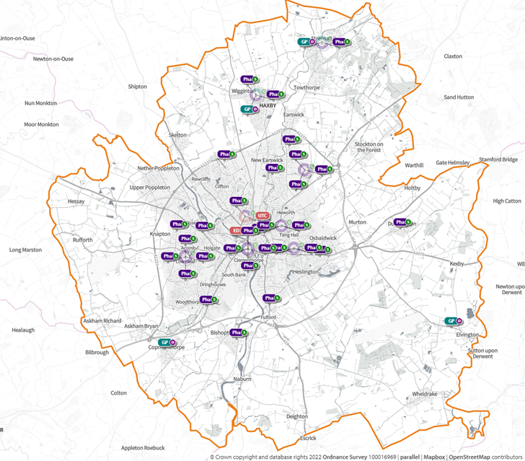
Figure 8 - Pharmacies opening on Sundays (denoted with PhaN) in York

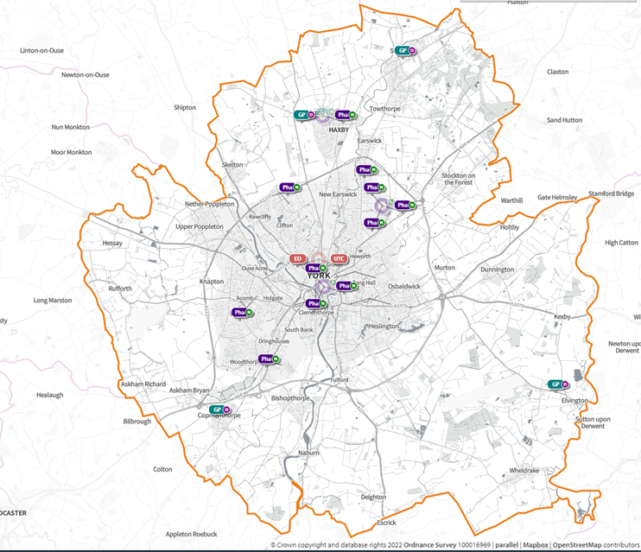

York HWB board recognises the importance of access to pharmacies in the evenings and weekends and that, in addition to the 100 hour pharmacy provision, some pharmacies provide extended opening hours as supplementary hours which, if reduced could impact on access for the population of York.

6.5.3 Opening during extended GP access, GP out of hours and Urgent Care Centre opening hours

There is seen to be adequate provision, largely provided by the 100 hour pharmacies and those with extended opening via supplementary hours, for accessing prescribed medicines. As mentioned previously, out of hours providers provide patients with their medication directly.

The HWB recognises the importance of the 100 hour provision and of the supplementary hour provision by pharmacies within the area and the possible impact a change of these hours of delivery could have on access to pharmacy provision in York. The extended opening hours that are currently in place provide adequate access to both essential pharmaceutical services and locally commissioned services, however the HWB will continue to be vigilant in monitoring the impact of changes of hours of community pharmacy providers.

The GP practice that responded to the survey felt the GP extended services opening hours matched the rota times/extended opening hours of local community services which indicates the current pharmacy hours provision is adequate.

6.6 Access to pharmacies by foot and by public transport

The following maps (figures 9a and 9b) demonstrate access to community pharmacies by foot and by public transport in terms of travel time and distance travelled. The denser colour of the maps indicates the proximity of the pharmacy. This indicates that there is adequate pharmacy provision for people who do not drive or have access to a car.

In York there are a number of community pharmacies in short walking distance of each other, particularly in the city centre. This provides significant choice to people who visit the town centre, not only those who live nearby, but those who travel into the centre for work.

Figure 9 - Access to pharmacies by foot in York

9a - by distance walked

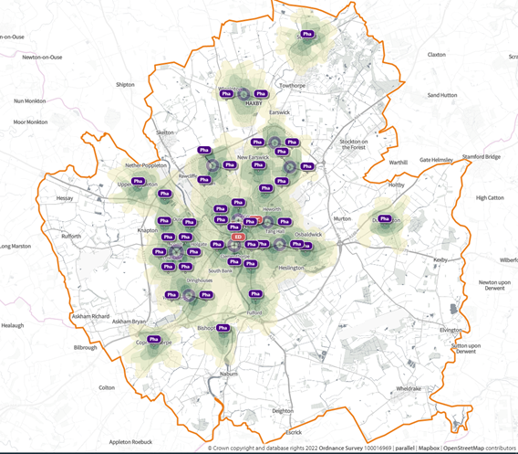
9b - by time taken to walk

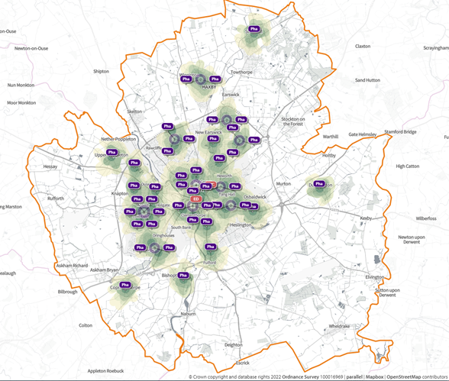

Figure 10 - Access to pharmacies using public transport in York
10a - Pharmacy distance by public transport – morning weekdays
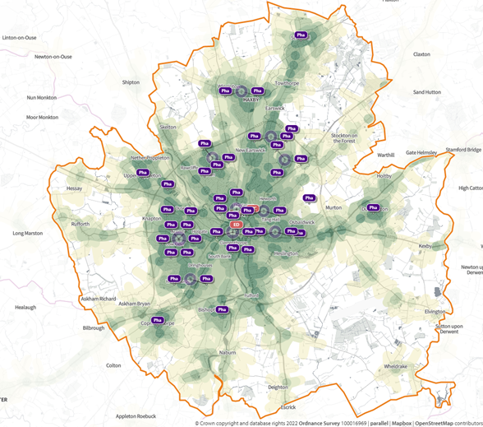
10b - Pharmacy distance by public transport – evening weekdays
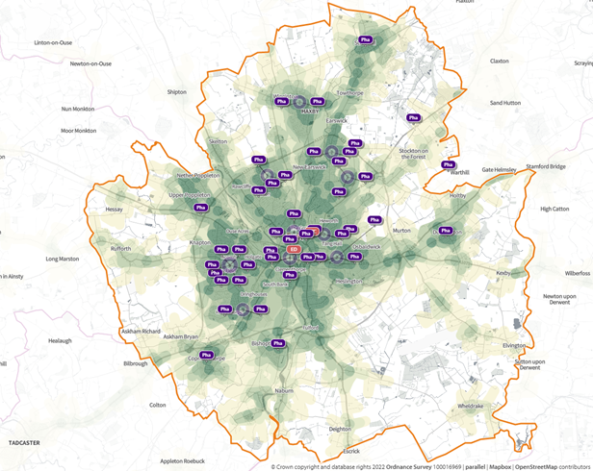

Most parts of more densely populated areas in York are accessible by public transport and therefore access to pharmacies by foot or by public transport is considered accessible in these areas. Also, the majority of the residents living within the deprived areas of York, which may mean that there is not access to a car, are also able to access pharmaceutical services within one mile (1.6 km) of their residence.

There is some provision of dispensing doctors’ services to enable access to dispensed medicines in some areas. However, dispensing doctors do not provide advanced and locally commissioned pharmacy services.

The Wheldrake branch of Elvington Medical Practice closed during the initial COVID period when sites were prioritised and rationalised for infection control purposes. Primary care services are still being delivered for the population of Wheldrake through the main Elvington surgery site, but it is a significant distance away from where many Wheldrake patients live with poor public transport links. Elvington Medical Practice dispensary remains open for collection of medication. A service to collect prescriptions at Wheldrake Surgery continues, but on a reduced basis between 2-4pm on Fridays.

There has been no change since the previous PNA in access to the nearest community pharmacy for residents of Wheldrake. According to the Public Health England SHAPE tool, access by car to the nearest pharmacy on the outskirts of York city centre is approximately 10 minutes (Citywide Health, Fulford Pharmacy). Access by public transport is approximately 30 minutes, although there are a limited number of bus services per day.

The population density based on mid-year 2020 estimates is 345 population per km2 which is in the lowest quintile of LSOAs, and is comparable to other more rural areas on the boundaries of the York Health and Wellbeing Board area.

The HWB acknowledge the current issues in Wheldrake with regards to access to GP services, however these are outside of the scope of this PNA. It is acknowledged that the dispensing service from the practice has been reduced and the HWB would encourage continued local dialogue to improve access from either the existing site, or from alternative premises. Access to the nearest pharmacy has remained unchanged and is not dissimilar to other rural villages.

Since the last PNA, there has been a significant increase of use of electronic prescriptions which enable patients to have their prescriptions (especially repeat prescriptions) sent electronically to a pharmacy of their choice, such as one close to their workplace or near their home. In addition, patients could choose to access medicines via a distance selling pharmacy, again utilising the electronic prescription service, thereby broadening possible choice of pharmacy service for the customer.

Locally pharmacies in the area have developed a collection and delivery service to these patients to ensure that patients, especially those who are vulnerable or elderly, are not disadvantaged by this closure. Delivery is not an element of the pharmacy contract and is not funded either by the NHS or Local Authorities.

6.7 Access to pharmacy services out of the York area

It is important to note that pharmacy services that are out of the York area may provide additional alternatives for people to access medicines and advice. In particular, there may be pharmacies close to residents who live on or close to the HWB area boundaries. Information from SHAPE indicates there are two pharmacies outside the York HWB area but within a 5 miles radius.

In addition, figure 11 demonstrates the population density (darker colour indicating the denser population) for York. People living on the edges of the York area are in proximity to pharmacy services in the neighbouring areas. On occasions, pharmacies in these areas may be closer for people to access than those located within the boundaries of York itself.

Other options for accessing pharmacy services include choosing to have prescriptions dispensed closer to someone's place of work for convenience or to utilise distance selling pharmacy services. In addition, some prescriptions may be specialist items which services such as dispensing appliance contractors can supply. This may also be facilitated using out of area provision.

Figure 11 - Map population density (darker areas more densely populated) and pharmacy locations in York
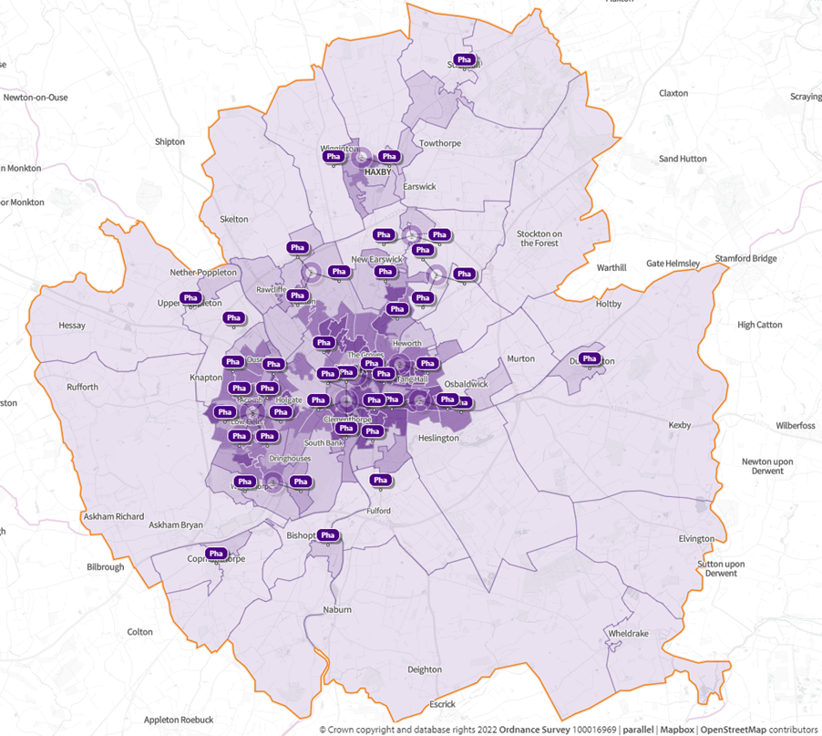

6.8 Feedback from customers regarding access to pharmacies

In response to the residents survey, when asked how people usually travel to the pharmacy, the majority of people indicated that they walked (58%) or travelled by car (38%), with 9% of people having their medicines delivered by the pharmacy.

1% of respondents indicated there was a lack of public transport and 11% said there was a lack of parking. 4% of respondents stated it was difficult to get into the building/shop.

6.9 Improving access

6.9.1 Electronic prescription service

Whilst the Electronic Prescription Service (EPS) was being introduced across GP and pharmacy services at the time of the previous PNA publication, it has now been implemented as part of the essential dispensing service all community pharmacies are now required to provide.

EPS makes the prescribing and dispensing process more efficient and convenient for both patients and staff. Prescriptions can be sent directly from the GPs computer to the computer in the community pharmacy via a secure internet link. Eventually the paper prescription, which is currently given to the patient, will no longer be necessary and will cease to be the legal prescription. This will streamline the transfer of prescriptions from GP surgery to the community pharmacy nominated by the patient. It is also used to encourage more GPs to consider using the repeat dispensing scheme if a person’s medicines are stable and suitable.

Over the last three years, there has been a significant increase in the application of electronic prescribing. During 2020 - 21, 90% of the prescriptions issued in the York HWB area were via the electronic prescribing system (38).

77% of respondents in the residents' survey stated they had used this service and 64% were satisfied with it, 11% knew about the service but didn’t use it, while 4% said they were unaware a pharmacy could offer this service.

96% of the pharmacies responding to the questionnaire indicated that they have EPS and actively use it.

6.9.2 Collection and delivery services

Two further services which improve access to medicines are prescription collection from the GP surgery and home delivery services. Patients are often surprised to find that these are not NHS services. 9% of respondents in the residents' survey stated they were unaware pharmacies offered a delivery service, 6% stated they always had their prescriptions delivered by their pharmacy while 3% said they sometimes did. 3% indicated this was because otherwise they would find it difficult to collect their medication.

It is also important to recognise that in response to COVID-19, the pandemic delivery service by community pharmacies was commissioned by NHS England. The service remained active until 31 March 2022 for people notified of the need to self-isolate by NHS Test and Trace in all areas of England.

6.10 Disability access

To comply with the Equality Act 2010 ⁽¹³⁾, community pharmacies must make reasonable provision for access by patients who have disabilities. It sets out a framework which requires service providers to ensure they do not discriminate against persons with a disability. A person is regarded as being having a disability if they have a physical or mental impairment which has a substantial adverse effect on that person’s ability to carry out day to day activities. If there are obstacles to accessing a service, then the service provider must consider what reasonable adjustments are needed to overcome that obstacle.

Common adjustments in community pharmacies include:

- Easy open containers
- Large print labels
- Reminder charts, showing which times of day medicines are to be taken
- Monitored dosage system (MDS) to improve their adherence to medicines taking

Most community pharmacies have made arrangements to ensure that those with a disability can access their pharmacy and consultation rooms. As part of the NHS England regulations and guidance ⁽⁶⁾, almost all pharmacies comply with the need to have a consultation room as specified in order to deliver advanced services.

The requirements for the consultation room are that it is:

- Clearly designated as a room for confidential conversations, for example a sign is attached to the door to the room saying Consultation room
- Distinct from the general public areas of the pharmacy premises
- A room where both the person receiving the service and the person providing it can be seated together and communicate confidentially

6% of respondents in the residents' survey indicated that there was a lack of access to a consultation in private. 4% of respondents stated that they found it difficult to get into the building/shop.

7. York Pharmaceutical Services Overview

The requirements for the commissioning of pharmaceutical services are set out in the NHS (Pharmaceutical and Local Pharmaceutical Services) Regulations 2013 ⁽⁶⁾ and the Pharmaceutical Services (Advanced and Enhanced Services) (England) Directions 2013 ⁽³⁹⁾.

NHS England commissions pharmaceutical services via the national Community Pharmacy Contractual Framework. Community pharmacies provide three tiers of pharmaceutical service which have been identified in regulations. These are:

- Essential Services: services all community pharmacies are required to provide
- Advanced Services: services to support patients with safe and effective use of medicines or appliances that all community pharmacies may choose to provide as long as they meet the requirements set out in the directions
- Enhanced Services: services that can be commissioned locally by NHS England

Any organisation can commission services from community pharmacies. NHS England commissions essential, advanced and enhanced pharmaceutical services (see section 5) whilst Local Authorities and ICBs commission ‘locally commissioned services.'

In addition, a Local Pharmaceutical Service (LPS) contract allows NHS England to commission community pharmaceutical services tailored to meet specific local requirements. It provides flexibility to include a broader or narrower range of services (including services not traditionally associated with pharmacy) than is possible under the national pharmacy contract arrangements. Locally commissioned community pharmacy services can be contracted via a number of different routes and by different commissioners, including Local Authorities, Clinical Commissioning Groups (CCGs) and local NHS England teams.

7.1 Essential services

The NHS Community Pharmacy Contractual Framework (CPCF or the ‘pharmacy contract’) ⁽¹⁰⁾ that all pharmacies, including distance selling pharmacies, are required to provide the essential services.

As of October 2021, the essential services are:

- Dispensing of prescriptions.
- Dispensing of repeat prescriptions i.e., prescriptions which contain more than one month’s supply of drugs on them.
- Disposal of unwanted medicines returned to the pharmacy by someone living at home, in a children’s home, or in a residential care home.
- Promotion of healthy lifestyles, which includes providing advice and participating in NHS England health campaigns.
- Signposting people who require advice, treatment or support that the pharmacy cannot provide to another provider of health or social care services.
- Support for self-care which may include advising on over the counter medicines or changes to the person’s lifestyle.
- Discharge medicines service. This service was introduced in 2021 and aims to reduce the risk of medication problems when a person is discharged from hospital. It is estimated that 60 percent of patients have three or more changes made to their medicines during a hospital stay. However, a lack of robust communication about these changes may result in errors being made once the person has left hospital. In summary, under this service a pharmacist will review a person’s medicines on discharge and ensure that any changes are actioned accordingly.
- Dispensing of appliances (in the "normal course of business”).

Dispensing appliance contractors have a narrower range of services that they must
provide:

- Dispensing of prescriptions.
- Dispensing of repeat prescriptions.
- For certain appliances, offer to deliver them to the patient and provide access to expert clinical advice.
- Where the contractor cannot provide a particular appliance, signposting or referring a patient to another provider of appliances who can.

In the previous PNA, all pharmacies were required to participate in the Health Living Pharmacy Scheme in recognition of the role that community pharmacy can play to help reduce health inequalities. The principle of community pharmacy being proactive in supporting the public health agenda has now been incorporated into the essential services.as the promotion of health lifestyles.

In addition, the Pharmacy Quality Scheme (PQS) forms part of the Community Pharmacy Contractual Framework (CPCF). PQS is designed to support delivery of the NHS Long-term Plan and reward community pharmacies that deliver quality criteria in three quality dimensions: clinical effectiveness, patient safety and patient experience.

7.1.1 Digital solutions

In the previous PNA, digital solutions were in the process of being introduced and implemented to provide connectivity across healthcare settings.

Under the terms of service ⁽⁴⁰⁾ community pharmacies are now required to have digital solutions in place including:

- Premises-specific NHSmail account which their staff can access and can send and receive NHSmail from thereby ensuring safe and secure transfer of information across healthcare settings. Pharmacy contractors should ensure that NHSmail accounts are regularly checked throughout the opening hours of the pharmacy.
- Pharmacy staff have access to the Electronic Prescription Service (EPS) at their pharmacy premises which must be constant and reliable throughout core and supplementary opening hours, in so far as that is within the control of the contractor. In addition, where a contractor is unable to access the EPS to dispense an EPS prescription, they must take all reasonable steps to ensure that the item is supplied within a reasonable timescale.
- There is a comprehensive and accurate profile for their pharmacy on the NHS website (www.nhs.uk).
- Staff working at the pharmacy can access NHS Summary Care Records (SCR) and that access is consistent and reliable during the pharmacy’s opening hours, in so far as that is within the control of the contractor. Subject to the normal patient consent requirements, those registered professionals should access patients’ SCRs whenever providing pharmaceutical services to the extent that they consider, in their clinical judgement, that it is appropriate to do so for example; prescription queries, advising patients on suitable medication, providing emergency supplies.

7.2 Advanced Services

In addition to the essential services, the NHS Community Pharmacy Contractual Framework (CPCF) allows for the provision of 'advanced services.' Community pharmacies can choose to provide any of these services as long as they meet the service requirements including accreditation of the pharmacist providing the service and/or specific requirements to be met in regard to premises. They are commissioned by NHS England and the specification and payment is agreed nationally.

Advanced services currently (2022) include:

- Appliance Use Review (AUR)
- Community Pharmacy Consultation Service (CPCS)
- Hepatitis C Testing Service
- Hypertension Case-Finding Service (from October 2021)
- New Medicine Service (NMS)
- Stoma Appliance Customisation Service (SAC)
- Flu Vaccination Service
- Smoking Cessation Advanced Service (from 10 March 2022)

Additional advanced services were also established in response to the COVID-19 pandemic including:

- COVID-19 Lateral Flow Device Distribution Service
- Pandemic Delivery Service

In April 2021, the Medicines Use Review (MUR) and Prescription Intervention Service services were decommissioned. Until 31 December 2020, 70% of MURs had to be targeted at high-risk medicines or patients who had recently been discharged from hospital.

The NHS Discharge Medicines Service was introduced as an essential service on 1 January 2021.

Table 4 - Distribution of community pharmacies signed up to provide advanced services in York

Community Pharmacy Advanced Service | Number of York pharmacies signed up to provide this service
Community Pharmacy Consultation Service (CPCS) | 40
Hepatitis C Testing Service | 5
Hypertension Case-Finding Service | 25
Smoking Cessation Service | 6
New Medicine (NMS) | 38*
Flu Vaccination Service | 35*
Data Source: ⁽³⁷⁾
*NHS England did not hold this information, data obtained from SHAPE

7.2.1 Appliance Use Review (AUR)

Appliance Use Reviews (AURs) can be carried out by a pharmacist or a specialist nurse in the pharmacy or at the patient’s home. Alternatively, where clinically appropriate and with the agreement of the patient, AURs can be provided by telephone or video consultation (in circumstances where the conversation cannot be overheard by others - except by someone whom the patient wants to hear the conversation, for example a carer). AURs should improve the patient’s knowledge and use of any ‘specified appliance.’

This service is usually provided by the appliance contractors as a specialism of the services although this service could also be provided by local community pharmacies.

Two pharmacies responding to the survey indicated they are accredited to deliver this service.

7.2.2 Community Pharmacist Consultation Service (CPCS)

The NHS Community Pharmacist Consultation Service launched on 29 October 2019 as an advanced service. Since 1 November 2020, general practices have been able to refer patients for a minor illness consultation via CPCS, once a local referral pathway has been agreed. The service, which replaced the NHS Urgent Medicine Supply (NUMSAS) connects patients who have a minor illness or need an urgent supply of a medicine with a community pharmacy.

As well as referrals from general practices, the service takes referrals to community pharmacy from NHS 111 (and NHS 111 online for requests for urgent supply), Integrated Urgent Care Clinical Assessment Services and in some cases, patients referred via the 999 service.

The CPCS aims to relieve pressure on the wider NHS by connecting patients with community pharmacy, which should be their first port of call and can deliver a swift, convenient, and effective service to meet their needs. The service provides community pharmacy the opportunity to play a bigger role than ever within the urgent care system. Since the CPCS was launched, an average of 10,500 patients per week are being referred for a consultation with a pharmacist following a call to NHS 111; these are patients who might otherwise have gone to see a GP (41).

In January 2022, NHS England announced that community pharmacy contractors could expect to receive more referrals from NHS 111 for the Community Pharmacist Consultation Service (CPCS) following a review of the NHS Pathway algorithms.

Information from NHS England indicated that in August 2022, there were 40 community pharmacies in the York HWB area signed up to CPCS delivery, including the five 100 hour pharmacies, as shown in figure 12. However, there was no data available regarding number of type of referrals at the time of producing this PNA.

24% of respondents in the residents' survey stated they had used this service and 22% were satisfied with it. 38% were aware of the service but didn’t use it, while 27% stated they were unaware that a pharmacy could offer this service.

92% of the pharmacies responding to the questionnaire indicated that they are accredited to deliver the Community Pharmacist Consultation Service.

7.2.3 Hepatitis C Testing Service

The Hepatitis C testing service was launched in September 2020 and focused on provision of point of care testing (POCT) for Hepatitis C (Hep C) antibodies to people who inject drugs (PWIDs), i.e., individuals who inject illicit drugs, e.g., steroids or heroin, but who haven’t yet moved to the point of accepting treatment for their substance use. Where people test positive for Hepatitis C antibodies, they will be referred for a confirmatory test and treatment as appropriate.

Information from NHS England indicated that in August 2022 5 pharmacies in York are signed up to provide this service, as shown in figure 13. 21% of respondents in the residents' survey stated they would find it useful if their pharmacy offered NHS screening services, e.g., diabetes, HIV, Hepatitis B or C.

Figure 12 – Pharmacies signed up to provide Community Pharmacist Consultation Service (CPCS) in York
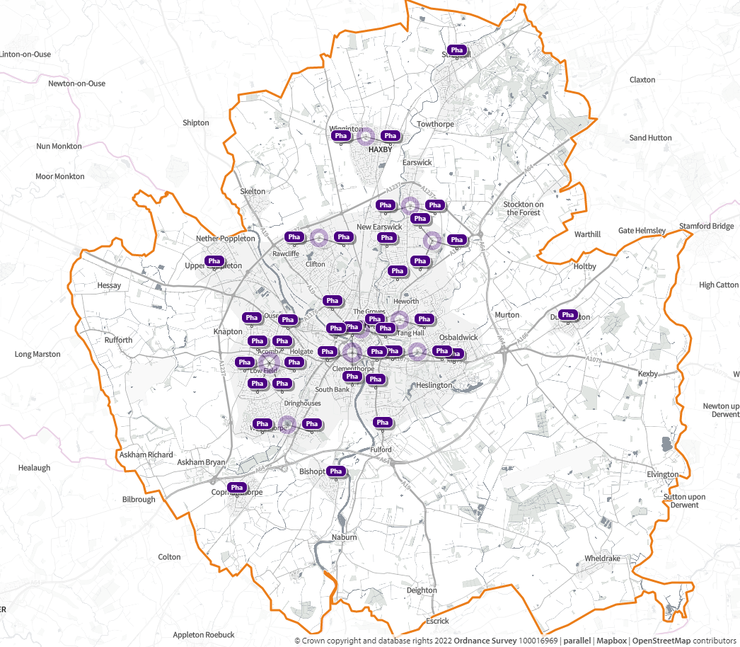
Figure 13 - Pharmacies signed up to provide Hepatitis C Testing Service in York
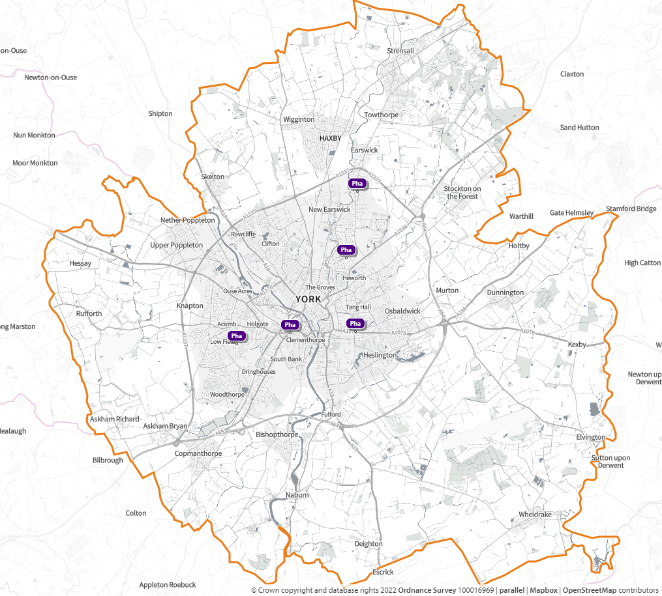

7.2.4 Hypertension Case-Finding Service

In 2020, NHS England commenced a pilot involving pharmacies offering blood pressure checks to people 40 years and over. In some pharmacies within the pilot, where the patient’s initial blood pressure reading was elevated, they would be offered 24-hour ambulatory blood pressure monitoring (ABPM), which is the gold-standard for diagnosis of hypertension.

Following the initial findings of the pilot, the Department of Health and Social Care (DHSC) and NHS England proposed the commissioning of a new Hypertension Case-Finding service, as an advanced service was commenced in October 2021 to support the programme of identification of undiagnosed cardiovascular disease.

The service aims to:

- Identify people with high blood pressure aged 40 years or older (who have previously not had a confirmed diagnosis of hypertension), and to refer them to general practice to confirm diagnosis and for appropriate management
- At the request of a general practice, undertake ad hoc clinic and ambulatory blood pressure measurements
- Provide another opportunity to promote healthy behaviours to patients

Information from NHS England in August 2022 indicated that 35 pharmacies were signed up to delivery of the Hypertension Case-Finding Service in York including four of the 100 hours pharmacies. It is recognised that there may be more pharmacies registering to deliver the service as it becomes established.

53% of the pharmacies responding to the questionnaire indicated that they are accredited to deliver the Hypertension Case-Finding Service.

Figure 14 - Pharmacies signed up to provide Hypertension Case-Finding Service in York

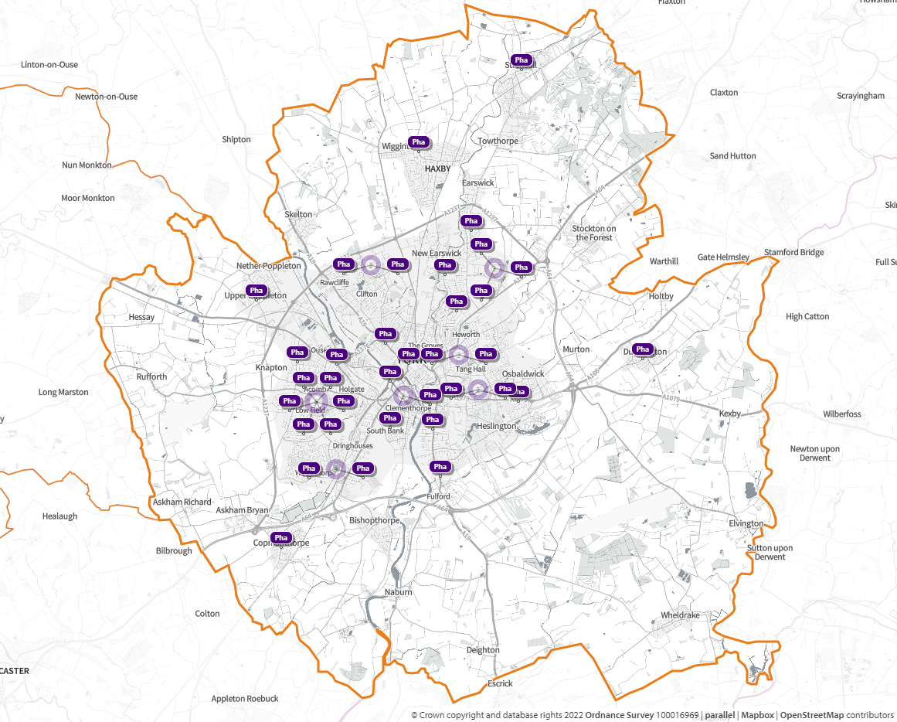

7.2.5 New Medicine Service (NMS)

In England, around 15 million people have a long-term condition (LTC), and the optimal use of appropriately prescribed medicines is vital to the management of most LTCs. Non-adherence to prescribed medicine regimens is often a hidden problem, undisclosed by patients and unrecognised by prescribers. People make decisions about the medicines they are prescribed and whether they are going to take them very soon after being prescribed the new medicine.

The New Medicine Service provides support for people with long-term conditions newly prescribed a medicine to help improve medicines adherence; it is focused on specific patient groups and conditions.

From 1 September 2021, a broad range of following conditions were covered by the service including respiratory conditions, diabetes (type 2); hypertension, hypercholesterolaemia, osteoporosis, gout, glaucoma, epilepsy, Parkinson’s disease, urinary incontinence/retention and many cardiac related conditions such as heart failure, atrial fibrillation, coronary heart disease, strokes and long-term risks of venous thromboembolism/embolism.

At the time of writing this PNA there was incomplete information from NHS England to determine how many community pharmacies were signed up to provide NMS. Information from SHAPE in April 2022 populated with data from NHS England indicated there are 38 pharmacies accredited to deliver this service.

16% of respondents in the residents' survey had used the service and 14% were satisfied with it. 33% were aware of the service but hadn’t used it, while 37% stated they were unaware a pharmacy could offer this service.

All the pharmacies responding to the questionnaire indicated that they are accredited to deliver the New Medicine Service. One respondent to the pharmacies’ survey stated that patients getting medication from a dispensing doctor come to them for advice regarding a new medicine which demonstrates the additional services that community pharmacies offer.

Figure 15 - Pharmacies signed up to provide New Medicine Service (NMS) in York

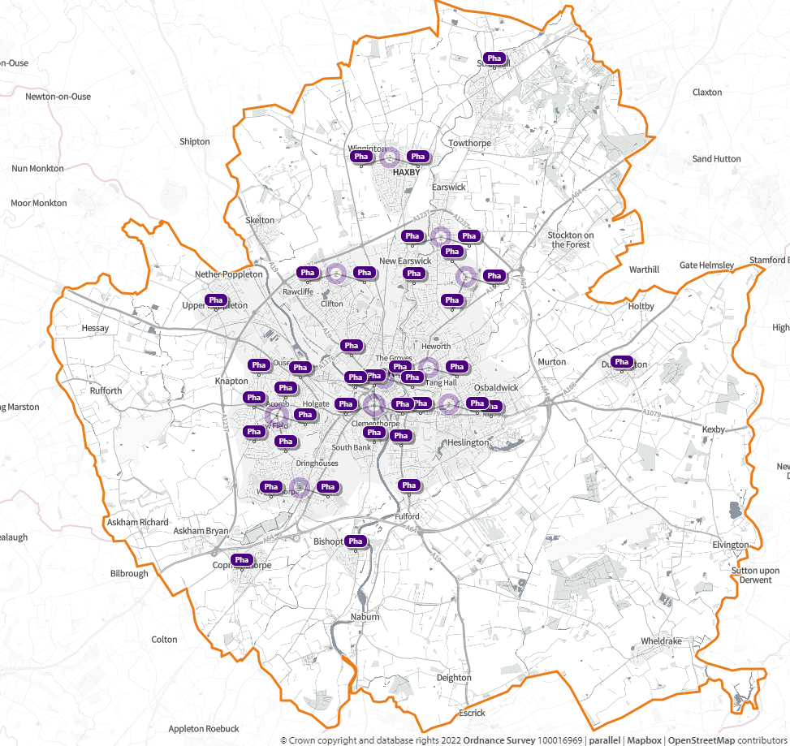

7.2.6 Stoma Appliance Customisation Service (SAC)

The Stoma Appliance Customisation service is based on modifying stoma appliance(s) to suit the patient’s measurements or a template. The aim of the service is to ensure proper use and comfortable fitting of the stoma appliance and to improve the duration of usage, thereby reducing waste.

Feedback from the pharmacies survey indicated there are two pharmacies that are accredited to deliver this service. Another pharmacy responded by saying the service is needed, this demonstrates not all contractors are aware of the full range of services they can deliver.

7.2.7 Flu Vaccination Service

Community pharmacy has been providing flu vaccinations under a nationally commissioned service since September 2015. Each year from September through to March the NHS runs a seasonal flu vaccination campaign aiming to vaccinate all patients who are at risk of developing more serious complications from the virus. The accessibility of pharmacies, their extended opening hours and the option to walk in without an appointment have proved popular with patients seeking vaccinations.

At the time of writing this PNA there was incomplete information from NHS England to determine how many community pharmacies were signed up to provide Flu vaccination service. Information from SHAPE populated with data from NHS England in April 2022 indicated there are 35 pharmacies accredited to deliver this service.

46% of respondents in the residents' survey stated they had used this service and 43% were satisfied with it.

96% of the pharmacies responding to the questionnaire indicated they are accredited to deliver the Flu Vaccination Service.
Figure 16 - Pharmacies signed up to provide Flu Vaccination Service in York
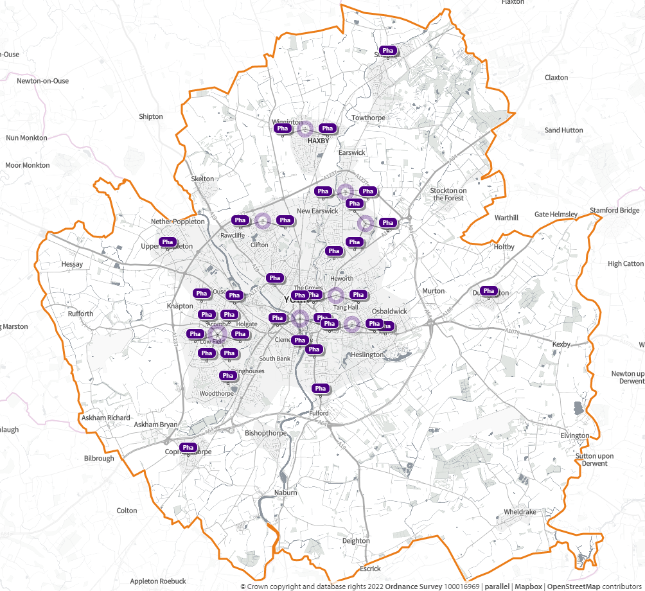

7.2.8 Smoking Cessation Advanced Service

The Smoking Cessation advanced service commenced in March 2022 for people referred to community pharmacies by hospital services. This service supplements other locally commissioned smoking cessation services and enables NHS trusts to refer patients discharged from hospital to a community pharmacy of their choice to continue their smoking cessation care pathway, including providing medication and behavioural support as required, in line with the NHS Long-term Plan care model for tobacco addiction.

Information from NHS England in August 2022 indicated that 7 pharmacies were signed up to delivery of the Smoking Cessation advanced service in York.

18% of the pharmacies responding to the questionnaire indicated that they are accredited to deliver the Smoking Cessation advanced service.

Figure 17 - Pharmacies signed up to provide Smoking Cessation Advanced Service in York

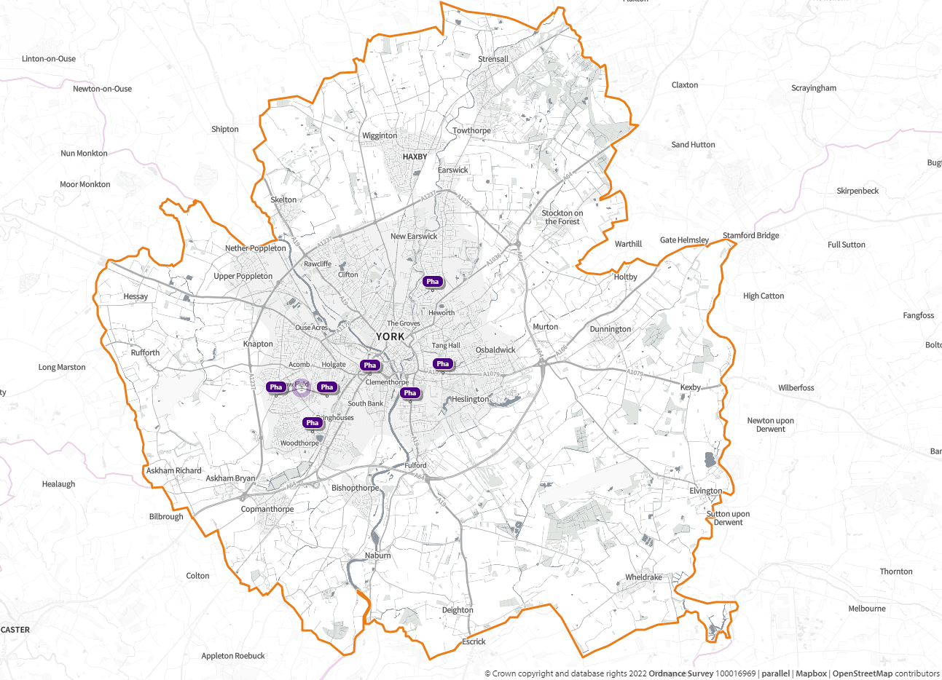

7.2.9 Additional Advanced services set up in response to the COVID-19 Pandemic

In response to the pandemic, the majority of providers were involved in the distribution of Lateral Flow Device (LFD) tests and the Pharmacy Pandemic Delivery Service of medicines to vulnerable people.

7.2.10 COVID-19 lateral flow device distribution service

At the end of March 2021, a new advanced service, the NHS community pharmacy COVID-19 lateral flow device distribution service (or ‘Pharmacy Collect’ as it was described in communications to the public) was added to the NHS Community Pharmacy Contractual Framework. This service aimed to improve access to COVID-19 testing by making lateral flow device (LFD) test kits readily available at community pharmacies for asymptomatic people, to identify COVID-positive cases in the community and break the chain of transmission.

The service was part of the Government’s offer of lateral flow testing to all people in England and it worked alongside other available COVID-19 testing routes. The Pharmacy Collect service finished on 31 March 2022.

24% of respondents in the residents' survey stated they had used this service and 19% were satisfied with it.

84% of the pharmacies responding to the questionnaire indicated that they have been involved in the delivery of the COVID-19 lateral flow device distribution service.

7.2.11 Pandemic Delivery of Medicines Service

Delivery of medicines by pharmacies has not previously been a commissioned service although many pharmacies have offered this service, sometimes at a small cost to the customer. The service was decommissioned on 31 March 2022.

7.3 Local Enhanced services

Enhanced services are the third tier of services that pharmacies may provide, and they can only be commissioned by NHS England.

7.3.1 COVID-19 vaccine administration (Local Enhanced Service)

Alongside vaccination centres and hospitals, Primary Care Networks, (PCN) over 600 community pharmacy sites in England supported the vaccination of patients and health and care workers against coronavirus. Through their strong relationships in local places and neighbourhoods, community pharmacies helped to tackle vaccine inequalities and improve vaccination take-up.

Delivery of this service was as a Locally Commissioned Service and required the pharmacists to submit an expression of Interest application in order to become a designated site for this service delivery.

Information from NHS England in April 2022 indicated that 6 pharmacies in the York HWB area were providers of this local enhanced service.

35% of respondents in the residents' survey had used this service and were satisfied with it.

15% of the pharmacies responding to the questionnaire indicated that they are accredited to deliver the COVID-19 vaccination administration.

8. York Locally Commissioned Services

Locally commissioned services are not described in the 2013 regulations, but the term is often used to describe those services commissioned from pharmacies by Local Authorities, ICBs and local NHS England teams. As noted in the definition of enhanced services, they are not classified as enhanced services because they are not commissioned by NHS England.

From 1st July 2022 clinical commissioning groups were replaced by integrated care boards. These will be able to take on delegated responsibility for pharmaceutical services, and from April 2023 NHS England expects all integrated care boards to have done so. Health and Wellbeing Boards should therefore be aware that some services that are commissioned from pharmacies by clinical commissioning groups (and are therefore other NHS services) will move to the integrated care boards and will fall then within the definition of enhanced services.

In York, pharmacy services are currently commissioned locally by the Council’s Public Health Team, Vale of York CCG (now part NHS Humber and North Yorkshire ICB) and the local NHS England team.

NHS Humber and North Yorkshire ICB commission a Palliative Care Stock in Community Pharmacy service at selected pharmacies. Community Pharmacists (owners or managers) agree that their name is included in a list maintained by the ICB and provided to all pharmacies, GPs, nurses and palliative care providers. The pharmacists included in this scheme will be contracted to hold a minimum stock of an agreed range of palliative care medicines and is the stock available from all participating pharmacies. In addition to the basic level provision, there will be one pharmacy that will also hold the ‘extended level provision’ stock and this pharmacy will be identified by the ICB and the details of this pharmacy will be communicated with all relevant parties.

19% of the pharmacies responding to the questionnaire stated they are accredited to deliver the Palliative Care Stock in Community Pharmacy. One pharmacy indicated that this scheme is needed which demonstrates that pharmacies are not all aware of the locally commissioned services they can participate in.

8.1 York City Council Public Health commissioned services

As part of its range of public health interventions York City Council Public Health Team currently commissions the following services from community pharmacies. At the time of writing this PNA current contracts were being extended with Pharmacies and some may not accept the extension. Information from Local Authority:

- Healthy Start Vitamins/Voucher Service
- Needle Exchange Service
- Supervised Consumption Service

8.1.1 Healthy Start Vitamins/Voucher Service

This was a new service piloted in the City of York for a period of three years (start date 1 November 2019). Benefits to distributing the Healthy Start vitamins/vouchers via pharmacies include:

- Improved access to the vitamins (through location and opening hours)
- Pharmacies are best-placed to manage those aspects of storage and supply that are related to the Safe and Secure Handling of Medicines and client-specific eligibility criteria
- Pharmacies are a trusted and well-used resource within communities, particularly in relation to the supply of medicines and associated products
- Community Pharmacy staff are skilled at giving advice and guidance
- Potential frequency of opportunity to raise the issue of Healthy Start due to other Community Pharmacy attendances/potential purchases that are baby/child related
- Opportunity to collate routine performance and monitoring data electronically via PharmOutcomes.

Information from the Local Authority indicated there are 8 pharmacies signed up to provide this service. 48% of respondents to the residents' survey indicated that they didn’t know a pharmacy could offer this service, only 3% had used the service and said they were satisfied with it. 38% of respondents knew about the service but didn’t use it. One respondent stated that a pharmacy could improve by providing breastfeeding advice and support. There could be better awareness and improved multi-agency working to significantly improve uptake of the service in York.

Conclusions regarding Healthy Start Vitamins/Voucher Service
Healthy Start is a statutory UK-wide government means-tested scheme which aims to improve the health of pregnant women and young children on benefits or low incomes. Healthy Start supports eligible low-income families with young children in eating healthily, by providing them with vouchers to spend on cow’s milk, plain fresh or frozen fruit and vegetables, and infant formula milk. Women and children eligible for Healthy Start food vouchers also get vitamin coupons to exchange for free Healthy Start vitamins, which are specifically designed for pregnant and breastfeeding women and growing children. Healthy Start is a valuable service in York as it aims to improve and promote health in the families most vulnerable to poor diets.

Figure 18 - Pharmacies signed up to provide Healthy Start Vitamins/Voucher Service in York
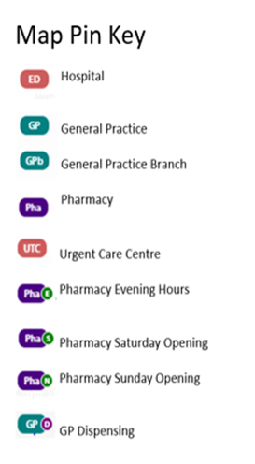
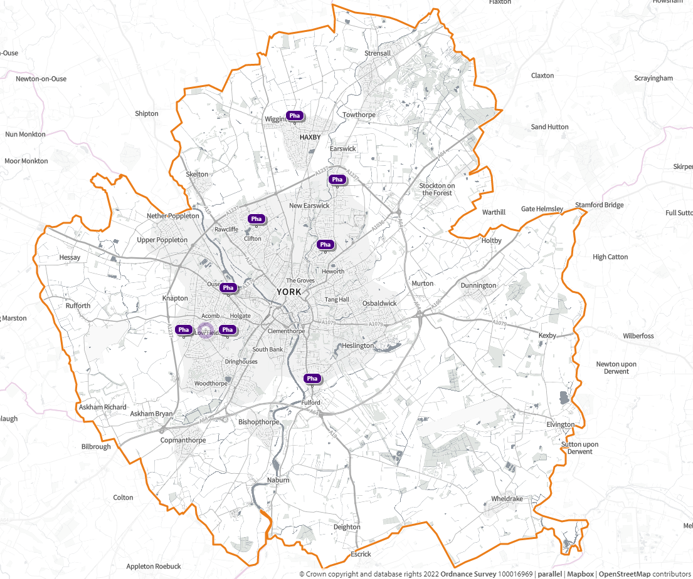

8.1.2 Needle Exchange Service

Figure 19 - Pharmacies signed up to provide Needle Exchange Service in York
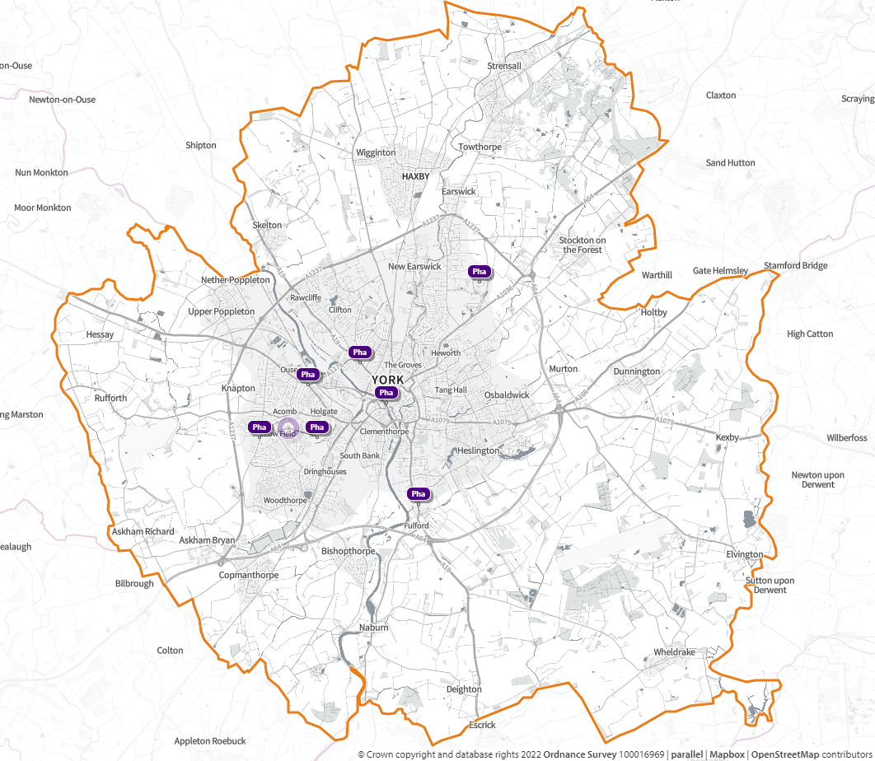

The Service Specification relates to the provision of a community pharmacy needle and syringe programme. The Service provided will include the distribution and collection of sterile injecting equipment and its safe disposal and the provision of a range of other harm reduction support and interventions.

Information from the Local Authority indicated there are 7 pharmacies signed up to provide this service. 15% of the pharmacies responding to the questionnaire are accredited to deliver the Needle and Syringe Exchange Service.

One pharmacy responding to the questionnaire stated there was a need for this service which demonstrates there is lack of awareness of the services that pharmacies can deliver.

Conclusions regarding Needle Exchange Service
A needle exchange service is a valuable service in York as it reduces the use of contaminated needles and provides safe disposal of needles. The service makes it easy for users to get sterile equipment which reduces disease transmission.

8.1.3 Supervised Consumption Service

Figure 20 - Pharmacies signed up to provide Supervised Consumption Service in York

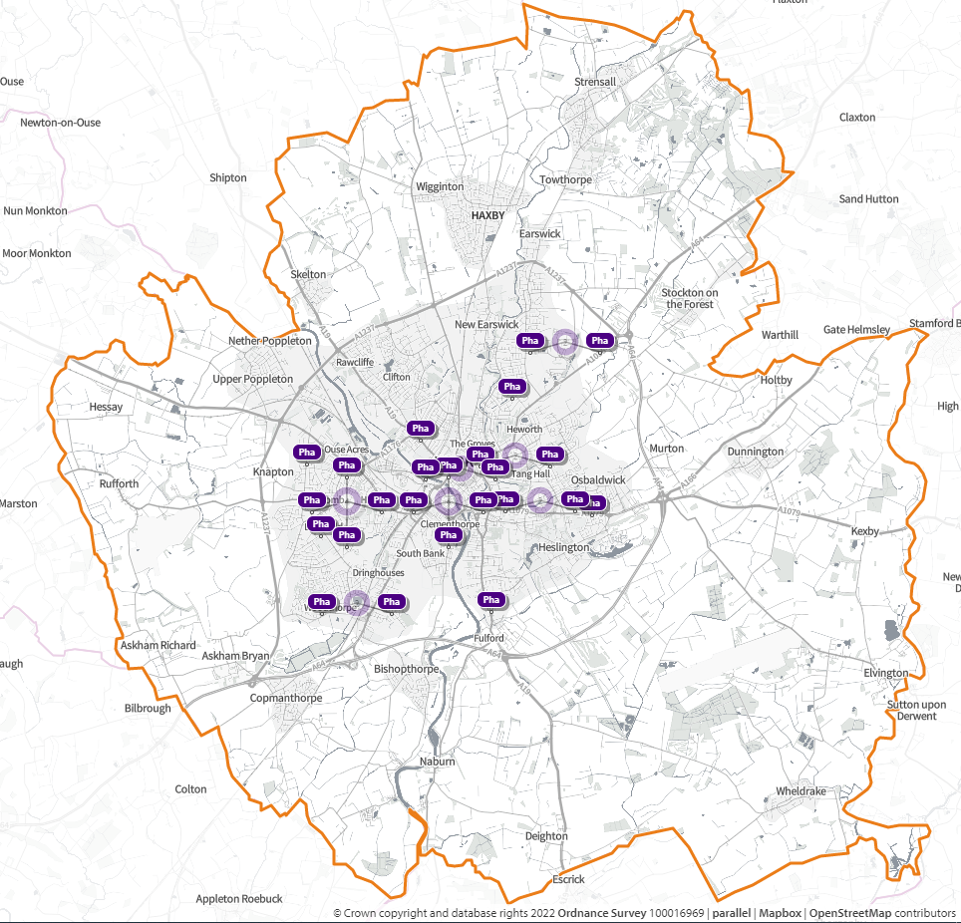
This service is provided to drug users who are prescribed methadone, buprenorphine (Subutex® or Suboxone®) in the York area. The Service will encompass supervised support and advice to service users in a safe environment. The aims of the service are to ensure compliance with the service user’s agreed care plan, by dispensing prescribed medication in specified instalment and ensuring each supervised dose is correctly administered; liaising with those directly involved with the service user's care; improve drug treatment delivery and retention; reduce the risk to communities through drug misuse.

Information from the Local Authority indicated there are 24 pharmacies signed up to this service. 53% of pharmacies responding to the questionnaire are accredited to deliver the Supervised Consumption Service.

Conclusions regarding Supervised Consumption Service
A supervised consumption service is considered to be an important service in York. It is recommended that provision is reviewed on a regular basis to ensure that there is accessibility to meet need.

Chart 4 - Pharmacies signed up to provide Locally Commissioned Services in York (information provided by Local Authority)

8.2 Non-Commissioned Services

Community pharmacies provide a range of services which are neither part of the core contract with the NHS, nor commissioned by Local Authority council, the ICB or NHS England. These services may not be aligned with the strategic priorities of the ICB or the council but may be fulfilling a customer generated demand for non-NHS services and are often very valuable for certain patient groups e.g., the housebound. However, these services are provided at the discretion of the pharmacy owner and may or may not incur an additional fee.

As these services are not reimbursed by the NHS, the decision to provide the service is often a commercial one, especially when the service increases the pharmacy’s overhead costs. Non-commissioned services identified in the pharmacist PNA questionnaire included:

- Collection of prescriptions from GP practices
- Delivery of dispensed medicines
- Dispensing of medicines into Monitored Dosage Systems

It is worth noting that patients are often surprised to find that these are not NHS services.

8.3 Collection and delivery services

Delivery of medicines is not currently a commissioned service provided by pharmacies. 12% of respondents in the residents' survey said they would be happy to pay a charge for the service if it was affordable.

Regarding delivery services, 3% of respondents in the residents' survey stated that without the delivery service they would find it difficult to collect their medication.

One respondent in the pharmacy questionnaire stated that the delivery service is in demand, but they have a strict criteria as it runs at a loss for the pharmacy.

8.4 Monitored Dosage Systems

Pharmacies are expected to make suitable arrangements or “reasonable adjustment” for patients who have disabilities which ensure that they can take their medicines as instructed by the doctor in line with the Equality Act 2010 ⁽¹³⁾. This will sometimes require the use of monitored dose systems (MDS) to help patients take complicated drug regimens these are often seen as weekly or monthly cassettes with medication placed in boxes relating to the day and time of the day that the medicine is to be taken.

Family or carers may ask for medicines to be dispensed in MDS, without any assessment of whether this is the most appropriate way of providing the help that the patient needs to safely take their medicines. This is an ideal opportunity for the pharmacy service to engage with the person or their representative to ascertain the most appropriate delivery system for medicines to suit their needs.

NICE guidance NG67 ⁽⁴²⁾ published in March 2017 recognised the role that pharmacists play in supporting people in the community and recommended that “use of a monitored dosage system should only be when an assessment by a health professional (for example, a pharmacist) has been carried out."

16% of respondents in the residents' survey indicated they had used this service and 12% were satisfied with it.

Feedback from one respondent from the residents survey was "There should be more capacity for pharmacies to provide blister packs for patients that need them. The availability in York for blister packs is poor." One pharmacy response to the questionnaire indicated that they felt there was a need for a locally commissioned service.

At the time of renewing the PNA, work is ongoing to establish the use of a Reasonable Adjustment Flag (RAF) feature in the NHS electronic prescribing system to enable information to be input to help enable health and care professionals to record, share and view patients’ key potential reasonable adjustments or more often related considerations across the NHS; enabling staff and services to carry out their duty to provide assessments or adjustments when relevant criteria may be fulfilled.

This information sharing should help to identify patients who would benefit from interventions such as the provision of medicines in a MDS and evidence assessments that have been undertaken to support this decision.

9. Current and Future pharmacist role

York HWB values the contribution that community pharmacy makes to the local health economy through their essential services, advanced services and locally commissioned services. They are an important part of the medicines optimisation approach that helps patients to improve their outcomes, take their medicines correctly, avoid taking unnecessary medicines, reduce wastage, and improve medicines safety.

The addition of the discharge medicine service and the essential services provided by community pharmacy and the advance services such as the Community Pharmacy Consultation Service, New Medicine Service and the Hypertension Case-Finding Service will further enhance the role of community pharmacy as being integral to the support of good medicine practice in the community.

City of York Council’s Public Health Team strongly supports the role that community pharmacy plays in promoting health and healthy lifestyle and in delivering evidence-based interventions for stop smoking, sexual health, and substance misuse.

The national vision for community pharmacy is in line with the local strategy and aspirations that community pharmacy has a critical role to play in the York health system. It is essential that community pharmacy continues to be recognised and supported to support the health needs of the population of York and that the people of York are aware of and fully utilise the services available from their Community Pharmacy services.

Company Chemists’ Association (CCA) reports that over the last 5 years an alarming shortfall of over 3,000 community pharmacists has developed in England. Pharmacies are struggling to recruit staff, there is increasing pressure on community pharmacy staff, and vacancy rates for community pharmacists have more than doubled in 2021 since 2017. In 2019 the NHS pledged to recruit 6,000 pharmacists to Primary Care Networks (PCNs) by 2024. Since then, around 2,400 com National pharmacist shortfall of over 3,000 poses significant risk to local pharmacies - The Company Chemists' Association (thecca.org.uk) say that community pharmacists have been recruited into PCNs, depleting the community pharmacist workforce which has added significant pressure on pharmacists who choose to stay in community pharmacies ⁽⁴³⁾.

CCA members report that many more pharmacists are choosing to work part-time, in some cases because of exhaustion, and so now the sector requires more pharmacists to help maintain the same level of services the public has come to expect during the pandemic. The shortfall of pharmacists within teams is also one of the reasons behind temporary closures. The Health Secretary wants NHS England to adopt a ‘Pharmacy First’ model where pharmacy will be the first port of call for minor ailments and illnesses, to free up capacity for GPs. Under this model, pharmacy will be pushed to do more, but CCA feel the Government is failing to recognise the real pressures the workforce is currently under ⁽⁴³⁾.

21% of respondents in the residents' survey indicated pharmacy services could be improved by more staffing. One resident reported they had experienced issues accessing the out of hours pharmacies over Christmas as both were closed and had to travel to Leeds. Another resident stated "a family member is a pharmacist and says there is a national shortage of trained pharmacists, and all pharmacies are finding it extremely difficult to fill pharmacy technicians' vacancies. It will be difficult to provide later opening hours if the staff are not available to work extra hours. The council should be ensuring 100 hours pharmacies fulfil their contracts and not allow pharmacies especially in supermarkets to reduce their hours as is happening in other areas of the country.”

One respondent to the pharmacy survey stated that “that the five year plan for community pharmacies holds many services but pharmacists are in short supply and funding means wages are low leading to a staffing crisis.”

The GP practice responding to the survey felt that funding restrictions could lead to pharmacy closures, and they had seen gaps in service provision and service closures. They also expressed concerns there was not enough pharmacists being trained for need leading to increased costs for employing. Feedback from the pharmacists’ survey identified concerns around recruitment of pharmacists in the ICS, funding for pharmacy, workload and workforce pressures leading to burnout.

10. Engagement and Consultation

10.1 Stakeholder engagement

To gather views on current pharmacy provision a series of questionnaires were developed. One was aimed at residents, one at pharmacies and one for stakeholders (i.e., professional users of pharmacy services). The questionnaires were hosted online, with paper copy and easy read version available on request, running for a 5 week period ending on 28 March 2022.

The resident questionnaire was promoted through the Local Authority social media accounts and through signage in local pharmacies. The stakeholder questionnaire was promoted through professional networks including PNA steering group, Health and Wellbeing Board and the York Health and Care Collaborative. It was also disseminated through the Public Health Team to colleagues, professionals and commissioned services. The pharmacy questionnaire was promoted by the Local Pharmacy Committee (Community Pharmacy North Yorkshire), by directly emailing all pharmacy locations across York, including sending several reminder emails. Face to face visits were also undertaken to all pharmacy sites across the city, to explain what the questionnaire was and encourage the pharmacist or manager to complete it.

10.1.1 Overview of responses to the Residents Survey

A total of 62 people responded to the survey; significantly lower than the last PNA when 287 responses were received. The full results of the survey can be found in appendix 3. Key headlines from the survey responses show that the majority of York residents were positive about the availability of pharmacies and services provided which suggests that overall, they were happy with the services their usual pharmacy provided. Areas for improvement were increased opening times. more staffing, and better waiting times.

- 66% of respondents indicated that they used the local high street pharmacy, 6% used the pharmacy inside a supermarket, and 27% used a pharmacy inside a doctors’ surgery.
- 51% of respondents indicated that they had used their pharmacy every month for medicines or prescriptions, 8% of respondents indicated that they use their pharmacy on a weekly basis and 25% use the pharmacy every couple of months.
- The majority (43%) of respondents indicated that they always used the same pharmacy all the time with a further 51% usually using the same pharmacy.
- 18% of respondents indicated that they chose a pharmacy near to their home rather than the pharmacy or pharmacies that they normally used. 11% indicated that this choice was based on good customer care/friendly staff, 10% said it was because of convenient opening times to use on an evening or weekend.
- The majority of respondents (58%) indicated that they walked to their pharmacy, while 38% travelled by car.
- 6% of respondents always have their medicines delivered by the pharmacy, 3% sometimes get them delivered. 4% of respondents stated this was because it was convenient while 3% said they would find it difficult to collect them.
- The majority of respondents (41%) said they would manage without a delivery service if it was withdrawn or charged for by the pharmacy, while 4% said they wouldn’t manage without the service, and 27% stated they knew others who couldn’t manage without the delivery service. 12% said they would be willing to pay for the delivery service if it was affordable, while 11% said they wouldn’t be able to afford to pay.
- 62% of respondents stated they would use a pharmacy for a minor health problem before going to A&E while 30% said they would go their GP. More public promotion of the pharmacist’s role in managing minor health problems would reduce this demand on GPs.
- 25% of respondents stated that they would do without treatment if the pharmacy medicines for a minor health issue were too expensive to buy, while 45% of respondents stated they would go their GP.
- 37% of respondents stated that the pharmacy was open most of the time they needed it, 58% stated it was open when they needed it, although 4% of respondents said that it wasn’t open when they needed it.
- 93% of respondents said they used the pharmacy for themselves, 29% for their children, 9% for an older relative, and 32% for another family member. We wanted to know if this was because of barriers to accessing pharmacies. One respondent mentioned that this was because the pharmacy wasn’t open at a useful time.
- 40% of respondents said the pharmacies they used were excellent, 25% said they were very good, 24% said they were good, while 6% said they were poor and 1% said they were very poor.
- 21% of respondents stated they were unhappy with their pharmacy because of the weekends/bank holidays opening times, 17% said they were unhappy due to evening opening times, and 11% stated this was due to lack of parking.
- 6% of respondents said they were unhappy with their pharmacy because there was a lack of access to a consultation in private which could impact people seeking advice from their pharmacist. 4% of respondents said there was a lack of access to a pharmacist they could trust, and 2% said they had received poor quality advice.
- 53% of respondents were aware that pharmacies could offer free advice on healthy lifestyles, although 88% stated they had never been offered this by their pharmacy.
- 46% of respondents used their pharmacy for flu vaccine administration and were satisfied with it, a further 46% indicating that they were aware of the service but didn’t use it.
- 35% of respondents had used their pharmacy for COVID-19 vaccination administration and were satisfied with it, 3% stated they would use the service if it was available.
- The most commonly used services by respondents: electronic prescription service, repeat prescription ordering/collection, advice for a minor health problem, flu vaccination service, and disposal of medicines.
- The top 4 services that respondents reported not knowing about: Healthy Heart Checks (48%), Healthy Start Vitamins (48%), NHS Health Checks (38%), and CPCS (38%). It is worth noting that NHS Health Checks are not currently commissioned from pharmacies in York.
- Services that respondents felt would be useful were Free Healthy Heart Checks (21%), NHS screening services, e.g., diabetes, HIV, Hepatitis B or C (21%), specific help with medicines for people with a long-term illness or conditions - e.g., obesity, asthma or COPD (Chronic Obstructive Pulmonary Disease) (20%), anticoagulant monitoring service - e.g., fingerprick testing for patients on warfarin (12%), short 'one to one' weight management programme (11%), gluten free food supply service without prescription (7%), advice and support in a language other than English (7%). One resident suggested developing a simple how to guide (e.g., how to request online ordering, prepayment options etc).
- The provision of interpretation/non-spoken interpretation and translation services could be better promoted both to pharmacies and the public.
- Residents also reported being unaware of the services that pharmacies offered. This demonstrates that there is a need for better engagement and promotion of local pharmacy services to communities.

10.1.2 Overview of responses to the Pharmacies Survey

26 of the pharmacies responded to the survey (17 in the last PNA) and full details of the responses can be found in appendix 4. As only 26 of the community pharmacy contractors completed the questionnaire and not all responses provided information regarding all sections, it was noted that although the information provides an overview it does not reflect the full-service delivery across the area.

In terms of provision of, or willingness to provide additional locally commissioned services, it was clear that pharmacy providers would be willing to support and deliver additional services, if these were commissioned. The commissioning of services is outside the scope of the Health and Wellbeing Board. This responsibility lies within commissioning of health services. A number of pharmacies indicated that they provided locally commissioned services although others indicated that they would provide these "if the service was commissioned." This suggests that there could be improved engagement and awareness regarding services that pharmacies in York could provide.

Many of the pharmacies responding to the survey felt there was need for further locally commissioned services, especially free emergency hormonal contraception and a minor ailments scheme. Although pharmacies in York do not supply free emergency hormonal contraception, it is important to note that free emergency hormonal contraception is available through general practice or specialist sexual health services in York without appointment.

Feedback from the residents survey indicated that 25% of respondents said they would go without treatment for a minor health problem if the medicines were too expensive to buy and 45% said they would go to their GP if the medicines were too expensive to buy. A minor ailments scheme within community pharmacy improves patient accessibility to health care services and encourages the use of community pharmacies as a first point of call for a health consultation, thus reducing the demands that such patients can make on their GPs.

10.1.3 Overview of responses to the Stakeholder Survey

Only one response was received from a general practice which covered services in both North Yorkshire and City of York. A summary of this response can be found in appendix 5. Several organisation types are therefore not represented in this assessment.

10.2 Formal consultation

In line with the regulations, York Health and Wellbeing Board consulted for a minimum of 60 days with the following statutory consultees about the contents of this PNA:

Stakeholders were asked to respond to the following specific consultation questions:

- Do you think that the draft PNA captures all of the relevant information needed to identify gaps in pharmaceutical provision in York?
- Do you think that the draft PNA captures all of the relevant information needed to enable commissioning decisions about pharmaceutical service provision over the next three years?
- Do you agree with the conclusions identified in the draft PNA?
- Is there anything that you think is missing from the PNA that should be included or taken into account when reaching conclusions about services and need?
- Pharmacies provide a range of different services. How do you think these should be communicated and publicised?
- If you have any further comments, please leave them below.

10.2.1 Findings of consultation

In total 64 responses to the consultation were received from:

- 47 citizens
- 6 organisations:
  - 3 community pharmacies
  - East Riding Health and Wellbeing Board
  - 1 ward councillor from City of York Council
  - York and Scarborough Teaching Hospitals NHS Foundation Trust
- 1 "other"
- 10 respondents skipped this question

Additionally, Community Pharmacy North Yorkshire (Local Pharmaceutical Committee) and YorLMC (Local Medical Committee) provided responses to the consultation via email rather than through the online questionnaire.

Q1. Do you think that the draft PNA captures all of the relevant information needed to identify gaps in pharmaceutical provision in North Yorkshire?

- 18 responses, 46 skipped this question
  - Yes = 9 responses
  - No = 8 responses
  - N/A = 1 response
- 2 of these responses provided further comments, both of which highlighted that the draft PNA does not make reference to the closure of Wheldrake Surgery (a branch site of a dispensing doctors practice, Elvington Medical Practice) and the impact this has had on prescription collection for residents of Wheldrake.

Q2. Do you think that the draft PNA captures all of the relevant information needed to enable commissioning decisions about pharmaceutical service provision over the next three years?

- 16 responses, 48 skipped this question
  - Yes = 7 responses
  - No = 8 responses
  - N/A = 1 response
- 1 of these responses provided a further comment to highlight the lack of access to a pharmacy for residents of Wheldrake.

Q3. Do you agree with the conclusions identified in the draft PNA?

- 17 responses, 47 skipped this question
  - Yes = 8 responses
  - Mostly = 2 responses
  - No = 6 responses
  - N/A = 1 response
- 1 of the respondents provided a further comment which stated that the draft PNA did not recognise that Wheldrake has a problem regarding the closure of Wheldrake Surgery.

Q4. Is there anything that you think is missing from the PNA that should be included or taken into account when reaching conclusions about services and need?

- 16 responses, 48 skipped this question
  - Yes = 10 responses
  - No = 4 responses
  - N/A = 2 responses
- 6 further comments were received which highlighted that the draft PNA does not make reference to the closure of Wheldrake Surgery (a branch site of a dispensing doctors practice, Elvington Medical Practice) and the impact on prescription collection for residents of Wheldrake. All respondents highlighted that they wanted to see GP services to resume in Wheldrake and for a community pharmacy to open in the village. One respondent noted that that there was not widespread awareness of the PNA consultation within the village and advised caution in interpreting the responses on this topic.
- 1 comment was received regarding the roles of other pharmacy sectors and whether these should be covered by the PNA.
- 2 comments was received from community pharmacies regarding commissioned services. One was from a pharmacy on the border of a neighbouring HWBB area about inclusion in local service development opportunities. The other comment highlighted that commissioned services are not always available for pharmacies to participate in.
- 1 comment suggested that contact voluntary sector charities would have been a method to increase response to the consultation.

Q5. Pharmacies offer a range of different services. How do you think these should be communicated and publicised?

- 16 responses, 48 skipped this question
- 8 responses were received, with suggestions for communication and publicising including:
  - Social media/online
  - Direct mail
  - Radio/television adverts
  - Healthcare settings (e.g. electronic noticeboards, posters, leaflets)
  - Signposting by community groups
  - Promotion through voluntary organisations
  - Promotion in local community premises e.g. in West offices and local libraries
  - Individual pharmacy websites
  - NHS choices
- One respondent also suggested that close working and collaboration with the ICS Boards, Partnerships and PCNs with a seamless approach to integration was an important factor.
- 3 responses were further comments relating to the lack of GP and pharmacy services in Wheldrake, rather than direct answers to this question.
- 4 responses either answered "yes" or "n/a" with no further comments and therefore it was not possible to consider these.

Q6. Do you have any other comments?

- 11 responses, 53 skipped this question
- 5 comments were received which highlighted issues arising from the closure of Wheldrake Surgery (a branch site of a dispensing doctors practice, Elvington Medical Practice) on access to GP services and the impact on prescription collection for residents of Wheldrake. Respondents commented that prescription collection was limited to collection from the main GP site at Elvington Medical Practice or from Wheldrake Surgery once a week on a Friday between 2-4pm.
- 1 comment was received regarding access to GP and pharmacy services in the respondents village, however the location was not stated.
- 1 comment suggested that GP practices and pharmacies should continue to use EPS and paperless repeat prescriptions which are sent directly to the patient's chosen pharmacy. The system for reviewing repeat medication should be done automatically and patients notified when medication is ready to be collected.
- 1 comment emphasised the importance of listening to the views of the public are part of the public consultation process.
- 1 comment was made regarding the information in sections 6.5.2 and 6.5.3 regarding the contribution that 100-hour pharmacies make to the access to pharmacy services at weekends and during extended GP access, GP out of hours and Urgent Care Centre opening hours. The comment questioned whether there was an implication that a 'gap' would be created if one of the 100-hour pharmacies closes. Additionally the respondent also questioned why the draft PNA makes reference to the applications to open a distance selling pharmacy.
- 1 comment was received from a community pharmacy that lack of time and exhaustion is often a barrier to getting services started. Each service contains lots of tick box exercises that are probably unnecessary.
- 1 response answered "n/a" with no further comments.

Additionally a comment was received separately to the online survey from Community Pharmacy North Yorkshire regarding the section describing weekend opening hours. In response to a comment from the residents survey which described difficulties in obtaining medicines on a Bank Holiday evening, the draft PNA makes that statement that "This demonstrates that in York pharmacies opening hours on bank holidays, provision needs to be increased to alleviate issues of patients having to travel further to obtain medication". CPNY expressed the view that if Sunday opening hours up until 4pm are considered to be adequate, then the same should apply to Bank Holiday opening hours, and that for a pharmacy to be open at that time it would involve a Directed Enhanced Service opening from NHSE&I and would be very costly. They also commented that the out of hours service at York are supposed to supply the medications to the patient before leaving.

10.2.1 Health and Wellbeing Board response to consultation findings

Wheldrake Surgery Closure

The Wheldrake branch of Elvington Medical Practice closed during the initial COVID period when sites were prioritised and rationalised for infection control purposes. Since then, a number of concerns have become apparent around the material condition of the building and it is currently unsuitable for delivery of GP services. As part of the formal process for GP estate, a three-facet building survey has been undertaken which recommended significant capital investment in order to bring the building back up to an acceptable standard for the delivery of safe services, and the discussions are currently ongoing around the funding of repairs or alternative premises.

Primary care services are still being delivered for the population of Wheldrake through the main Elvington surgery site, but it is a significant distance away from where many Wheldrake patients live with poor public transport links.

Elvington Medical Practice dispensary remains open for collection of medication. A service to collect prescriptions at Wheldrake Surgery continues, but on a reduced basis between 2-4pm on Fridays.

There has been no change since the previous PNA in access to the nearest community pharmacy for residents of Wheldrake. According to the Public Health England SHAPE tool, access by car to the nearest pharmacy on the outskirts of York city centre is approximately 10 minutes (Citywide Health, Fulford Pharmacy). Access by public transport is approximately 30 minutes, although there are a limited number of bus services per day.

The population density based on mid-year 2020 estimates is 345 population per km² which is in the lowest quintile of LSOAs, and is comparable to other more rural areas on the boundaries of the York Health and Wellbeing Board area.

Since the last PNA, there has been a significant increase of use of electronic prescriptions which enable patients to have their prescriptions (especially repeat prescriptions) sent electronically to a pharmacy of their choice, such as one close to their workplace or near their home. Some pharmacies in the area offer a collection and delivery service to ensure that patients can access medicines. In addition, patients can choose to access medicines via a distance selling pharmacy, again utilising the electronic prescription service, thereby broadening possible choice of pharmacy service for the customer.

The HWB acknowledge the current issues in Wheldrake with regards to access to GP services, however these are outside of the scope of this PNA. It is acknowledged that the dispensing service from the practice has been reduced and the HWB would encourage continued local dialogue to improve access from either the existing site, or from alternative premises. Access to the nearest pharmacy has remained unchanged and is not dissimilar to other rural villages. Therefore, the PNA considers the current pharmacy provision to be adequate.

Roles of other pharmacy sectors

As noted in section 1.2, the PNA is a strategic commissioning document which will be used primarily by NHS England in its assessment of applications to join the pharmaceutical list under the NHS (Pharmaceutical and Local Pharmaceutical Services) Regulations 2013.

The PNA will also be used to:

- Ensure that decisions about applications for market entry for pharmaceutical services are based on robust and relevant information
- Inform commissioning plans about pharmaceutical services that could be provided by community pharmacists and other providers to meet local need - these services can be commissioned by Local Authorities, NHS England and ICBs
- Support commissioning of high-quality pharmaceutical services including locally enhanced services
- Ensure that pharmaceutical and medicines optimisation services are commissioned to reflect the health needs and ambitions outlined within the Joint Health and Wellbeing Strategy
- Facilitate opportunities for pharmacists to make a significant contribution to the health of the population of York

Hospital pharmacies do not provide services under the Community Pharmacy Contractual Framework and are therefore outside the scope of this PNA.

The HWB acknowledge the significant role played by other pharmacy sectors, however the focus of the PNA is on pharmaceutical services provided by community pharmacies.

Weekend opening

Section 6.5.2 describes the community pharmacy provision across York over the weekend period.

In total, 27 pharmacies across the area are open on Saturdays and 11 pharmacies are open on Sundays. This provides adequate pharmacy provision across the weekend for York. Access is largely provided by the 100 hour pharmacies and those with extended opening via supplementary hours, for accessing prescribed medicines. It is noted that out of hours providers provide patients with their medication directly.

In response to a comment from the residents survey which described difficulties in obtaining medicines on a Bank Holiday evening, the draft PNA makes that statement that "This demonstrates that in York pharmacies opening hours on bank holidays, provision needs to be increased to alleviate issues of patients having to travel further to obtain medication".

The wording of this section has been updated to reflect that access to prescribed medicines in the out of hours period should be considered by local commissioners, and may include direct supply from out of hours providers or urgent treatment centres.

100-hour pharmacies and extended access opening hours

Section 6.5.3 describes the community pharmacy provision across York during the GP extended access, out of hours and urgent care centre opening hours.

There is seen to be adequate provision, largely provided by the 100 hour pharmacies and those with extended opening via supplementary hours, for accessing prescribed medicines. It is noted that out of hours providers provide patients with their medication directly.

The HWB recognises the importance of the 100 hour provision. Equally, the HWB recognises the importance of the supplementary hour provision by pharmacies within the area and the possible impact a change of these hours of delivery could have on access to pharmacy provision in York.

The draft PNA stated that loss of any of the 100 hour pharmacies could cause significant gaps in access to both essential pharmaceutical services and locally commissioned services that respond to particular population health needs. The wording of this section has been updated to reflect that the extended opening hours that are currently in place provide adequate access to services, however the HWB will continue to monitor the impact of changes of hours of community pharmacy providers.

Other comments

The HWB acknowledge and note the other comments received as part of the consultation.

11. Summary of findings

Following the development of the PNA 2022 - 2025, the conclusions and final recommendations of York Health and Wellbeing Board are:

- Community pharmacy services play an important role of the landscape in supporting the services provided by GP practices/dispensing GP practices and the PCNs.
- Community pharmacies can support the wider health needs of their population by providing the essential, advanced, and locally commissioned services as described in this report.
- York Health and Wellbeing Board also wishes to acknowledge the contribution that Community pharmacy services have made to the recent COVID-19 pandemic response. Community pharmacies provided support to the local community both in terms of maintaining essential medicine services, and also in the delivery of medicines to those unable to leave their homes, supplying Lateral Flow Device testing kits and in the support and administration of the COVID-19 vaccination programme.
- There is adequate choice of pharmacies and a good geographic spread of pharmacies in York. The majority of people are within reasonable walking or travel distance of a pharmacy.
- Overall, there is good pharmaceutical service provision in most of York from Monday to Friday. In urban areas there is good provision of pharmaceutical services on Saturday and Sundays.
- Community pharmacy opening hours in York are sufficient to meet need, and there is adequate provision in the evening and weekends. This is reflected in the survey results which identified that most people could find a pharmacy open in the evening or at weekends. There was one concern raised by a resident about the availability of pharmacies/opening hours on a bank holiday.
- The survey also identified that people in York value extended opening hours, and value the better access that this provides. Therefore, any applications to reduce pharmacy opening hours in York should be considered carefully, with appreciation of the importance to the public in this matter.
- Overall, the quantity of community pharmacies in York is good and appears sufficient to broadly meet the health needs of residents in York. The data suggests that a large proportion of the adult population of York use a pharmacy at least once a month and public satisfaction in community pharmacy services in York appears good.
- One respondent in the residents survey felt there needs to be a pharmacy on the University site so that local people can have more access to the pharmacy services. Currently the University of York website directs students to the closest pharmacies - Missionstart Ltd on Fulford Road, Whitworth Chemists on Melrosegate and Badger Hill Pharmacy on Yarburgh Way (which is within a moderate walking distance for many students). Students on campus are supported by a regular bus route which allows them to access a choice of pharmacies nearer the centre of York. Additionally, many of the student areas are well served by bus routes allowing students to access pharmacies closer to where they live.
- The population in York is growing and is getting older. Within the next three years it is that the population of York will include a greater number of people with long-term health conditions, this will rise faster than the total number of people. Overall, this means that the population need for community pharmacies in York may be expected to increase.
- There is good pharmacy coverage in the more deprived wards in York. This is partly because the more deprived wards of York tend to be the more urban wards nearer the city centre, where the majority of pharmacies are situated.
- Some population groups have more limited access to pharmacies. This includes residents living in the rural areas on the edge of the city boundaries. If community pharmacy services were not maintained, then travel time to the next available pharmacy would be significantly increased for some residents.
- Opening times are important to people and are an important element of the overall accessibility of that pharmacy, at present there appear to be a sufficient number of pharmacies open during evenings and weekends, most people report they can find a pharmacy when they need one. York has a high rate of employment and an overrepresentation of employment sectors that use shift work rotas. This means reduced flexibility to access pharmacy services during the working day. Therefore, any applications to reduce pharmacy opening hours in York should be considered carefully, with appreciation of the importance to the public in this matter.
- The residents of York currently have better health than their peers nationally and are a well skilled and well educated group. This means that there will be opportunities for greater self-care and self-monitoring of conditions, some of which may be facilitated by community pharmacies.
- The current provision of “standard 40 hour” pharmacies should be maintained, especially in rural/outlying areas.
- Pharmacists can support the opportunistic delivery of consistent and concise healthy lifestyle information to individuals by using the MECC approach. MECC maximises the opportunity within routine health and care interactions for a brief or very brief discussion on health or wellbeing factors to take place.
- The HWB recognises the importance of the supplementary hour provision by pharmacies within the area and the possible impact a change of these hours of delivery could have on access to pharmacy provision in York. The HWB will continue to be vigilant in monitoring the impact of changes of hours of community pharmacy providers.
- The extended opening hours that are currently in place provide adequate access to both essential pharmaceutical services and locally commissioned services, however the HWB will continue to be vigilant in monitoring the impact of any changes to 100 hour provision or supplementary hours.
- There are proposed future housing developments across York which may mean that these areas will need to be reviewed on a regular basis to identify any significant increases or changes in pharmaceutical need. In the case of the very large developments individually, the developments may result in an increased need for community pharmacy services.
- The area is changing rapidly and as well as consulting this PNA, the Pharmaceutical Services Regulations Committee (PSRC) at NHS England should carry out a rapid review of any area where there is an application, to ensure that the needs of this area have not changed in the lifetime of the PNA. This could include review of rural and urban classification and should be published alongside the PNA in the supplementary statements.
- There is good awareness and uptake of both advanced services and locally commissioned services in York. There could also be better awareness and improved multi-agency working to significantly improve uptake of services in York.
- Promotion of the available community pharmacy services to both pharmacy contractors and the local community could be increased as feedback from both surveys identified there was a lack of service awareness. It is important for the pharmaceutical needs assessment to consider ‘knowledge gaps’ as well as ‘service gaps;’ if the public is not broadly aware of a service, then it will not be used to its fullest extent. In particular, there were knowledge gaps in the services offered beyond a pharmacies core contractual duty.
- The closure of the Lloyds pharmacy, 3 Intake Avenue, York, YO30 6HB, area indicates that there may be an increased walking distance of more than 1.2km for people to access pharmacy services. This will need to remain under review with consideration for the new homes planned for the Nestle South ST17 site.
- The response from the GP practice stating they are unaware about the Healthy Living Pharmacy (HLP) framework suggests that pharmaceutical services may still require regular promotion to stakeholders. The Healthy Living Pharmacy (HLP) framework is aimed at achieving consistent provision of a broad range of health promotion interventions through community pharmacies to meet local need, improving the health and wellbeing of the local population and helping to reduce health inequalities. This is important to ensure that the available services are used to improve and protect health in primary care.
- Feedback from both the residents and pharmacy surveys indicates the provision of interpretation and translation services could be better promoted.
- Community pharmacists are keen to offer services to their community but may face barriers which are preventing them from provision of service. One contractor commented that “currently not having a blood pressure monitor is preventing us from starting the Hypertension Case-Finding Service. Likewise, a lack of scales and height measurement is preventing us from providing a useful weight loss service.”
- The Health and Wellbeing Board should note that opening hours of pharmacies alone is not an indicator of improved pharmaceutical services. Therefore, they should avoid identifying a need for, or improvement or better access to, opening hours. If there is a gap in the provision of services of certain times this would be articulated as an improvement or better access to specified services at specified times.
- Any application must demonstrate that it is necessary, will provide value to the NHS and can improve on the availability of services across the specific area.
Out of area provision impacts not only the delivery of dispensing services but also the provision and accessibility of enhanced or locally commissioned services, especially where areas border each other. Commissioners should take cross border issues into account and consult with relevant stakeholders when they are reviewing, commissioning or decommissioning services, to avoid or mitigate against creating inequity of provision for the local population.
- The Health and Wellbeing Board has the responsibility for publishing supplementary statements when the pharmaceutical need and services to an area change significantly. It is the responsibility of the organisation managing the GMS contracts to inform NHS England when a practice ceases to dispense as this could affect the overall provision of pharmaceutical services across an area. It is the responsibility of NHS England to inform the HWB of any changes to pharmaceutical service provision, including dispensing services, so that a decision can be made as to whether this change will affect access. This is particularly important where pharmacies are closing or consolidating due to the impact of recent funding cuts. The HWB has a duty to respond to all notifications under Regulation 26A (consolidation of pharmacies). It is proposed that the supplementary statements are issued every 3 months by NHS England (a member of the Board) as they hold all the relevant data. They will be published on the City of York Council website alongside the PNA.

Appendix 1 - Dispensing GP practices and addresses

Information from NHS England April 2022

Practice Name | Address | PCN
Haxby Group Practice | The Haxby & Wigginton Health Centre, 2 The Village, York, YO32 2LL | West, Outer and North East York (WoNE York)
Old School Medical Practice | Old School Medical Centre, Horseman Lane, York, YO23 3UA | West, Outer and North East York (WoNE York)
MyHealth Group | Strensall Medical Centre, Southfields Road, York, YO32 5UA | York East PCN
Elvington Medical Practice | Elvington Medical Practice, The Surgery, Church Lane, York, YO41 4DY | York East PCN

Appendix 2 - Membership of the Steering Committee

Name | Role/Organisation
Clare Beard (Chair) | Public Health Consultant, NYCC
Kurt Ramsden | Medicines Management Support to NYCC
Heather Baker | Public Health Improvement Officer, CoY
Leo Beacroft | Public Health Senior Intelligence Specialist, NYCC
Claire Lawrence | Public Health, NYCC
Ian Dean | Chief Executive Officer, Community Pharmacy NY
Daniel Harry | Democratic Services, NYCC
Peter Roderick | Public Health, CoY
Phil Truby | Public Health, CoY
Patrick Duffy | Democratic Services, NYCC
Sian Balsom | Healthwatch, York
Tracy Wallis | HWB, CoY
Shanna Carrell | Participation and Engagement Manager, NYCC
Rachel Ainger | CSU Medicines Management Team
Duncan Rogers | YOR Local Medical Committee Limited
Terry Rudden | CoY
Mike Wimmer | CoY
David Iley | NHS England
Andy Reay | Senior Medicines Optimisation Pharmacist, NECS
Naida Rafiq | Medicines Optimisation Pharmacist, NECS
Steven Llewellyn | Medicines Optimisation Pharmacist, NECS

Appendix 3 - Residents Survey

When We Consulted
Over a 5 week period ending on 28 March 2022

How We Consulted and Who Responded
The questionnaires were hosted online, with paper copy and easy read version available on request, running for a 5 week period ending on 28 March 2022.

The resident questionnaire was promoted through the Local Authority social media accounts and through signage in local pharmacies.

62 people provided complete survey responses. This was significantly lower than the last PNA when 287 responses were received. Although the number of responses only represent a small percentage of the York population, they do provide a useful indication of how people use and their views about pharmacy services in York. A large proportion (79%) of respondents to the survey were female. More than 27% of responses came from people aged 40 - 49. More than 51% of responses came from people aged 50 - 79 years who are potentially more likely to utilise pharmacy services due to long-term health conditions or to be carers and therefore well informed about pharmacy provision. People from ethnic minority backgrounds were under-represented in the survey.

Pharmaceutical Needs Assessment (PNA) – Resident Survey

Which area do you live in?
North Yorkshire
City of York

Please state the first four digits of your postcode:

Age:
Under 16
16-19
20-29
30-39
40-49
50-59
60-69
70-79
80 plus
Prefer not to say

How do you identify?
Male
Female
I describe myself in another way
Prefer not to say

How would you describe your ethnic origin?
White British
White Irish
White - Any other White background
Asian or Asian British - Bangladeshi
Asian or Asian British - Indian
Mixed - any other mixed background
Asian or Asian British - Pakistani
Asian or Asian British - Any other Asian background
Black or Black British - African
Black or Black British - Caribbean
Other Ethnic Group - Chinese
Black or Black British - any other black background
Other ethnic group - any other ethnic group
Mixed - White and Asian
Mixed - White and Black African
Mixed - White and Black Caribbean
I do not wish to disclose
Other

Over the last 12 months, how would you say your health has been?
Very good
Good
Fair
Bad
Very bad
Do not wish to disclose

Do you consider yourself to be a disabled person or have a long-term health condition?
Yes
No
Do not wish to disclose this

If yes, please tick any impairment listed which affects you, as you may experience more than one. If none of the categories apply, please select 'other.'
Physical Impairment
Mental Health Problem
Long-standing illness
Sensory Impairment
Learning Disability/Difficulty

Do you consider yourself to be a carer?
Yes
No

If you have a minor health problem, before going to A&E would you visit:
A pharmacy
A walk-in centre
Your GP

Please tell us about the pharmacy services where you live:
I have a choice about which pharmacy I use?
Yes
No

I can find a pharmacy open in the evening?
Yes
No

I can find a pharmacy open on a Sunday or a Bank Holiday?
Yes
No

Please tell us about the availability and quality of pharmacies in your area:
Overall, the availability of pharmacies in my area is:
Very good
Good
Adequate
Poor
Very Poor

Overall, the quality of pharmacies in my area is:
Very good
Good
Adequate
Poor
Very Poor

Thinking about medication services you use or might want to use at a pharmacy, consider the following options and tick the box that corresponds with your view:

New Medicine Service (extra advice if you're prescribed a medicine to treat a long-term condition for the first time):
I have used this service and I am satisfied with it
I have used this service and I am not satisfied with it
I know about this service, but I don’t use it
I didn't know a pharmacy could offer this service
I'd like to use this service if it was available for the following options

Repeat Prescription ordering/collection:
I have used this service and I am satisfied with it
I have used this service and I am not satisfied with it
I know about this service, but I don’t use it
I didn't know a pharmacy could offer this service
I'd like to use this service if it was available for the following options

NHS Repeat Dispensing (regular medication without the need to get new prescriptions every time:
I have used this service and I am satisfied with it
I have used this service and I am not satisfied with it
I know about this service, but I don’t use it
I didn't know a pharmacy could offer this service
I'd like to use this service if it was available for the following options

Electronic Prescription Service (where your prescription is sent electronically to the dispenser you have chosen, and it can be collected without needing to hand in a paper prescription:
I have used this service and I am satisfied with it
I have used this service and I am not satisfied with it
I know about this service, but I don’t use it
I didn't know a pharmacy could offer this service
I'd like to use this service if it was available for the following options

Delivery of medication:
I have used this service and I am satisfied with it
I have used this service and I am not satisfied with it
I know about this service, but I don’t use it
I didn't know a pharmacy could offer this service
I'd like to use this service if it was available for the following options

Medicines packaging (e.g., weekly boxes):
I have used this service and I am satisfied with it
I have used this service and I am not satisfied with it
I know about this service, but I don’t use it
I didn't know a pharmacy could offer this service
I'd like to use this service if it was available for the following options

Needle and Syringe Exchange:
I have used this service and I am satisfied with it
I have used this service and I am not satisfied with it
I know about this service, but I don’t use it
I didn't know a pharmacy could offer this service
I'd like to use this service if it was available for the following options

Sharps box disposal:
I have used this service and I am satisfied with it
I have used this service and I am not satisfied with it
I know about this service, but I don’t use it
I didn't know a pharmacy could offer this service
I'd like to use this service if it was available for the following options

NHS Urgent Medicine Supply Advanced Service (NUMSAS) (obtaining medication direct from a pharmacy, when appropriate):
I have used this service and I am satisfied with it
I have used this service and I am not satisfied with it
I know about this service, but I don’t use it
I didn't know a pharmacy could offer this service
I'd like to use this service if it was available for the following options

Electronic Prescription Transfer from your GP direct to pharmacy:
I have used this service and I am satisfied with it
I have used this service and I am not satisfied with it
I know about this service, but I don’t use it
I didn't know a pharmacy could offer this service
I'd like to use this service if it was available for the following options

Community Pharmacist Consultation Service (CPCS) - PSNC:
I have used this service and I am satisfied with it
I have used this service and I am not satisfied with it
I know about this service, but I don’t use it
I didn't know a pharmacy could offer this service
I'd like to use this service if it was available for the following options

Covid Lateral Flow Test Service:
I have used this service and I am satisfied with it
I have used this service and I am not satisfied with it
I know about this service, but I don’t use it
I didn't know a pharmacy could offer this service
I'd like to use this service if it was available for the following options

Out of Hours service:
I have used this service and I am satisfied with it
I have used this service and I am not satisfied with it
I know about this service, but I don’t use it
I didn't know a pharmacy could offer this service
I'd like to use this service if it was available for the following options

Disposal of medicines:
I have used this service and I am satisfied with it
I have used this service and I am not satisfied with it
I know about this service, but I don’t use it
I didn't know a pharmacy could offer this service
I'd like to use this service if it was available for the following options

Thinking about health services you use or might want to use at a pharmacy, consider the following options and tick the box that corresponds with your view:

NHS Flu Vaccination:
I have used this service and I am satisfied with it
I have used this service and I am not satisfied with it
I know about this service, but I don’t use it
I didn't know a pharmacy could offer this service
I'd like to use this service if it was available for the following options

NHS Covid Vaccination Service:
I have used this service and I am satisfied with it
I have used this service and I am not satisfied with it
I know about this service, but I don’t use it
I didn't know a pharmacy could offer this service
I'd like to use this service if it was available for the following options

Chlamydia Testing:
I have used this service and I am satisfied with it
I have used this service and I am not satisfied with it
I know about this service, but I don’t use it
I didn't know a pharmacy could offer this service
I'd like to use this service if it was available for the following options

Emergency Contraception (morning after pill):
I have used this service and I am satisfied with it
I have used this service and I am not satisfied with it
I know about this service, but I don’t use it
I didn't know a pharmacy could offer this service
I'd like to use this service if it was available for the following options

Contraception Service:
I have used this service and I am satisfied with it
I have used this service and I am not satisfied with it
I know about this service, but I don’t use it
I didn't know a pharmacy could offer this service
I'd like to use this service if it was available for the following options

NHS Health Checks:
I have used this service and I am satisfied with it
I have used this service and I am not satisfied with it
I know about this service, but I don’t use it
I didn't know a pharmacy could offer this service
I'd like to use this service if it was available for the following options

Health Heart Checks:
I have used this service and I am satisfied with it
I have used this service and I am not satisfied with it
I know about this service, but I don’t use it
I didn't know a pharmacy could offer this service
I'd like to use this service if it was available for the following options

NHS Healthy Start Vitamins/Vouchers:
I have used this service and I am satisfied with it
I have used this service and I am not satisfied with it
I know about this service, but I don’t use it
I didn't know a pharmacy could offer this service
I'd like to use this service if it was available for the following options

Substance-Misuse Services e.g., Supervised Consumption:
I have used this service and I am satisfied with it
I have used this service and I am not satisfied with it
I know about this service, but I don’t use it
I didn't know a pharmacy could offer this service
I'd like to use this service if it was available for the following options

If the pharmacy, you normally use is not where you live, please tell us which town/village it is:

What type of pharmacy do you normally use?
The local high street
Inside supermarket
Pharmacy in a doctor's surgery
Online
Other

When you go to a pharmacy in person, how do you usually get there?
Walk
Public transport (bus or train)
Taxi
Drive in my own car
Get a lift in somebody else's car

How often do you use it for medicines or prescriptions?
Every week
Every month
Every couple of months
Once or twice a year
Less often

Is the pharmacy open when you need it?
Yes
Most of the time
No

Who do you use the pharmacy on behalf of?
(Please tick all that apply)
Myself
My children
An older relative
Another family member
A friend or neighbour
Someone else – please state

If you use the pharmacy on behalf of someone other than yourself, is there a reason why they're unable to use the pharmacy on their own?

If you are unhappy with your pharmacy, please indicate why:
(Please tick all that apply)
Lack of parking
Difficult to get into the building/shop
Not in a convenient location
Lack of public transport
Opening times - daytime
Opening times - evening
Opening times - weekends/bank holidays
Lack of access to a pharmacist I trust
Lack of access to a consultation in private
Cost of prescriptions
Don’t know what services they provide
Pharmacist is difficult to understand
The pharmacist does not have the things that I need
Poor quality advice received
I’m a young carer and the pharmacist doesn’t understand my role
Other - if other please state

If you received advice from a pharmacy about a minor health problem, but the pharmacy medicines were too expensive for you to buy, what would you do?
Do without the treatment
Go to your GP
Go to A&E
None of the above

Has this ever happened to you?
Yes
No

Do you visit the same pharmacy?
Always
Usually
Rarely
Never

Do you have your prescription medicines delivered by a pharmacy?
Always
Sometimes
Never
Doesn't apply to me

What is the main reason why you get them delivered?
For convenience
I would find it difficult to collect them myself
It is a free service
I don't get them delivered
Other - if other please specify

Your local community pharmacy is not paid by the NHS to deliver prescription medicines. If the service was withdrawn or your pharmacy started charging for this service:
I would be able to manage without it
I know other people who could NOT manage without it
I would be prepared to pay if the charge was affordable
I would NOT be able to pay any delivery charge
I would NOT be able to manage without it

Do you usually pay for your prescription?
Yes
No
Don't know
Prefer not to say

Are your prescriptions sent electronically from your GP to your nominated pharmacy of choice for dispensing?
Yes
No
Don't know
Don't have prescriptions

Do you use an NHS pharmacy online service for NHS prescriptions?
Yes
No – if no, why not?

How would you rate the pharmacy or pharmacies that you have used or usually use?
Excellent
Very Good
Good
Poor
Very poor

Why do you not use the pharmacy or pharmacies that you normally use? (Choose all that apply)
Near to where you live
Prescription collection service
Near to where you work
Medicine delivery service
Near to your children's school
Special offers
Close to where I shop
Clean and pleasant environment
Easy to walk to it or reach it on public transport
Inside or close to the GP practice
Always used it
Good customer care/friendly staff
Range of services
Trusted advice
Convenient opening times to use on an evening or weekend
Some other reason

Choose up to THREE important reasons why you use a pharmacy?
Near to where you live
Prescription collection service
Near to where you work
Medicine delivery service
Near to your children's school
Special offers
Close to where I shop
Clean and pleasant environment
Easy to walk to it or reach it on public transport
Inside or close to the GP practice
Always used it
Good customer care/friendly staff
Range of services
Trusted advice
Convenient opening times to use on an evening or weekend
Availability of medication/products
Other - please explain

As well as advice on medicines and minor ailments, all pharmacies are able to offer advice on a range of Healthy Lifestyle issues (such as diet and nutrition, alcohol awareness, sexual health and physical activity). The availability of this type of advice from a pharmacy is encouraged both nationally and by your local council.

Did you know that pharmacies could offer free advice on healthy lifestyles?
Yes
No

Has your pharmacy ever offered you free advice on healthy lifestyles?
Yes
No

Has your ever taken up the offer of free advice on healthy lifestyles from your pharmacy?
Yes
No

If you have taken up the offer of free advice, could you please state what this was about?
Please do not share any personal information in your response which could lead to you being personally identified.

Do you view the pharmacy as part of the NHS?
Yes
No

Do you feel happy about patient confidentiality and consent?
Yes
No

Do you know that you can ask at any time to use the private consulting room available in all pharmacies?
Yes
No

Do you feel comfortable getting advice in the pharmacy about health problems?
Yes
No

Are the staff polite and helpful when you visit or contact them?
Yes
No

Thinking about the new services/advice & selfcare local pharmacies could offer (though not necessarily in the pharmacy you use), which of the following do you think might be useful?
Free Healthy Heart Checks
NHS Screening services, e.g., diabetes, HIV, Hepatitis B or C
Specific help with medicines for people with a long-term illness or conditions - e.g., obesity, asthma or COPD (Chronic Obstructive Pulmonary Disease)
Short 'one to one' weight management programme
Anticoagulant monitoring service - e.g., fingerpick testing for patients on Warfarin
Gluten free food supply service without prescription
Advice and support in a language other than English

How do you think the service your pharmacy provides, could be improved?
Medication availability
More staffing
Better waiting times
Communication
Product availability
Increase opening times
Offer more patient services and support
Other - please state

Please give examples of patient services and support:

Is there anything else you would like to tell us about pharmacies in City of York?
Please do not share any personal information in your response which could lead to you being personally identified.

Residents Survey Results
Which area do you live in? | Number of people |  | %
City of York | 62 |  | 100%
Grand Total | 62 |  | 100%
Age: | Number of people |  | %
40-49 | 17 |  | 27.42%
60-69 | 14 |  | 22.58%
30-39 | 10 |  | 16.13%
50-59 | 10 |  | 16.13%
70-79 | 7 |  | 11.29%
20-29 | 2 |  | 3.23%
80 plus | 1 |  | 1.61%
Prefer not to say | 1 |  | 1.61%
Grand Total | 62 |  | 100%
How do you identify? | Number of people |  | %
Female | 49 |  | 79.03%
Male | 10 |  | 16.13%
I describe myself in another way | 1 |  | 1.61%
Prefer not to say | 2 |  | 3.23%
Grand Total | 62 |  | 100%
How would you describe your ethnic origin? | Number of people |  | %
White British | 57 |  | 91.94%
White Irish | 1 |  | 1.61%
White - Any other White background | 1 |  | 1.61%
I do not wish to disclose | 3 |  | 4.84%
Grand Total | 62 |  | 100%
Over the last 12 months, how would you say your health has been? | Number of people |  | %
Fair | 27 |  | 43.55%
Good | 20 |  | 32.26%
Very good | 11 |  | 17.74%
Bad | 2 |  | 3.23%
Do not wish to disclose | 1 |  | 1.61%
(blank) | 1 |  | 1.61%
Grand Total | 62 |  | 100%
Do you consider yourself to be a disabled person or have a long-term health condition? | Number of people |  | %
No | 39 |  | 62.90%
Yes | 21 |  | 33.87%
Do not wish to disclose this | 2 |  | 3.23%
Grand Total | 62 |  | 100%
If yes, please tick any impairment listed which affects you, as you may experience more than one. If none of the categories apply, please select ‘other’:

6 (9%) people stated physical impairment
4 (6%) people stated mental health
15 (24%) people stated long-standing illness
1 (1%) person stated sensory impairment
2 (3%) people stated learning disability/difficulty
Do you consider yourself to be a carer? | Number of people |  | %
No | 50 |  | 80.65%
Yes | 10 |  | 16.13%
(blank) | 2 |  | 3.23%
Grand Total | 62 |  | 100%
If you have a minor health problem, before going to A&E would you visit: | Number of people |  | %
A pharmacy | 39 |  | 62.90%
Your GP | 19 |  | 30.65%
A walk-in centre | 3 |  | 4.84%
(blank) | 1 |  | 1.61%
Grand Total | 62 |  | 100%
Please tell us about the pharmacy services where you live:

I have a choice about which pharmacy I use | Number of people |  | %
Yes | 56 |  | 90.32%
No | 6 |  | 9.68%
Grand Total | 62 |  | 100%
I can find a pharmacy open in the evening | Number of people |  | %
No | 12 |  | 19.35%
Yes | 49 |  | 79.03%
(blank) | 1 |  | 1.61%
Grand Total | 62 |  | 100%
I can find a pharmacy open on a Sunday or a Bank Holiday | Number of people |  | %
No | 14 |  | 22.58%
Yes | 46 |  | 74.19%
(blank) | 2 |  | 3.23%
Grand Total | 62 |  | 100%
Overall, the availability of pharmacies in my area is: | Number of people |  | %
Good | 27 |  | 43.55%
Very Good | 22 |  | 35.48%
Adequate | 9 |  | 14.52%
Very Poor | 2 |  | 3.23%
Poor | 2 |  | 3.23%
Grand Total | 62 |  | 100%
Overall, the quality of pharmacies in my area is: | Number of people |  | %
Good | 23 |  | 37.10%
Very Good | 21 |  | 33.87%
Adequate | 11 |  | 17.74%
Very Poor | 2 |  | 3.23%
Poor | 2 |  | 3.23%
(blank) | 3 |  | 4.84%
Grand Total | 62 |  | 100%
Thinking about medication services you use or might want to use at a pharmacy, consider the following options and tick the box that corresponds with your view:

New Medicine Service (extra advice if you're prescribed a medicine to treat a long-term condition for the first time) | Number of people |  | %
I didn't know a pharmacy could offer this service | 23 |  | 37.10%
I know about this service but I don’t use it | 21 |  | 33.87%
I have used this service and I am satisfied with it | 9 |  | 14.52%
I'd like to use this service if it was available for the following options | 3 |  | 4.84%
I have used this service and I am not satisfied with it | 1 |  | 1.61%
(blank) | 5 |  | 8.06%
Grand Total | 62 |  | 100%
Repeat Prescription ordering/collection | Number of people |  | %
I have used this service and I am satisfied with it | 38 |  | 61.29%
I know about this service but I don’t use it | 13 |  | 20.97%
I have used this service and I am not satisfied with it | 8 |  | 12.90%
I'd like to use this service if it was available for the following options | 2 |  | 3.23%
(blank) | 1 |  | 1.61%
Grand Total | 62 |  | 100%
NHS Repeat Dispensing (regular medication without the need to get new prescriptions every time) | Number of people |  | %
I know about this service but I don’t use it | 19 |  | 30.65%
I didn't know a pharmacy could offer this service | 17 |  | 27.42%
I have used this service and I am satisfied with it | 10 |  | 16.13%
I'd like to use this service if it was available for the following options | 8 |  | 12.90%
I have used this service and I am not satisfied with it | 4 |  | 6.45%
(blank) | 4 |  | 6.45%
Grand Total | 62 |  | 100%
Electronic Prescription Service (where your prescription is sent electronically to the dispenser you have chosen, and it can be collected without needing to hand in a paper prescription) | Number of people |  | %
I know about this service but I don’t use it | 7 |  | 11.29%
I didn't know a pharmacy could offer this service | 3 |  | 4.84%
I have used this service and I am not satisfied with it | 8 |  | 12.90%
I have used this service and I am satisfied with it | 40 |  | 64.52%
I'd like to use this service if it was available for the following options | 3 |  | 4.84%
(blank) | 1 |  | 1.61%
Grand Total | 62 |  | 100%
Delivery of medication | Number of people |  | %
I know about this service but I don’t use it | 37 |  | 59.68%
I didn't know a pharmacy could offer this service | 6 |  | 9.68%
I have used this service and I am not satisfied with it | 3 |  | 4.84%
I have used this service and I am satisfied with it | 10 |  | 16.13%
I'd like to use this service if it was available for the following options | 3 |  | 4.84%
(blank) | 3 |  | 4.84%
Grand Total | 62 |  | 100%
Medicine packaging (e.g., weekly boxes) | Number of people |  | %
I know about this service but I don’t use it | 29 |  | 46.77%
I didn't know a pharmacy could offer this service | 17 |  | 27.42%
I have used this service and I am not satisfied with it | 2 |  | 3.23%
I have used this service and I am satisfied with it | 8 |  | 12.90%
I'd like to use this service if it was available for the following options | 2 |  | 3.23%
(blank) | 4 |  | 6.45%
Grand Total | 62 |  | 100%
Needle and Syringe Exchange | Number of people |  | %
I know about this service but I don’t use it | 48 |  | 77.42%
I didn't know a pharmacy could offer this service | 8 |  | 12.90%
I'd like to use this service if it was available for the following options | 1 |  | 1.61%
(blank) | 5 |  | 8.06%
Grand Total | 62 |  | 100%
Sharps box disposal | Number of people |  | %
I know about this service but I don’t use it | 40 |  | 64.52%
I didn't know a pharmacy could offer this service | 9 |  | 14.52%
I have used this service and I am satisfied with it | 1 |  | 1.61%
I'd like to use this service if it was available for the following options | 5 |  | 8.06%
(blank) | 7 |  | 11.29%
Grand Total | 62 |  | 100%
NHS Urgent Medicine Supply Advanced Service (NUMSAS) (obtaining medication direct from a pharmacy, when appropriate) | Number of people |  | %
I know about this service but I don’t use it | 25 |  | 40.32%
I didn't know a pharmacy could offer this service | 28 |  | 45.16%
I have used this service and I am not satisfied with it | 1 |  | 1.61%
I have used this service and I am satisfied with it | 1 |  | 1.61%
I'd like to use this service if it was available for the following options | 4 |  | 6.45%
(blank) | 3 |  | 4.84%
Grand Total | 62 |  | 100%
Electronic Prescription Transfer from your GP direct to pharmacy | Number of people |  | %
I know about this service but I don’t use it | 10 |  | 16.13%
I didn't know a pharmacy could offer this service | 1 |  | 1.61%
I have used this service and I am not satisfied with it | 8 |  | 12.90%
I have used this service and I am satisfied with it | 43 |  | 69.35%
Grand Total | 62 |  | 100%
Community Pharmacist Consultation Service (CPCS) - PSNC | Number of people |  | %
I know about this service but I don’t use it | 24 |  | 38.71%
I didn't know a pharmacy could offer this service | 17 |  | 27.42%
I have used this service and I am not satisfied with it | 1 |  | 1.61%
I have used this service and I am satisfied with it | 14 |  | 22.58%
I'd like to use this service if it was available for the following options | 1 |  | 1.61%
(blank) | 5 |  | 8.06%
Grand Total | 62 |  | 100%
Covid Lateral Flow Test Service | Number of people |  | %
I know about this service but I don’t use it | 27 |  | 43.55%
I didn't know a pharmacy could offer this service | 15 |  | 24.19%
I have used this service and I am not satisfied with it | 3 |  | 4.84%
I have used this service and I am satisfied with it | 12 |  | 19.35%
I'd like to use this service if it was available for the following options | 1 |  | 1.61%
(blank) | 4 |  | 6.45%
Grand Total | 62 |  | 100%
Out of Hours service | Number of people |  | %
I know about this service but I don’t use it | 25 |  | 40.32%
I didn't know a pharmacy could offer this service | 19 |  | 30.65%
I have used this service and I am not satisfied with it | 2 |  | 3.23%
I have used this service and I am satisfied with it | 8 |  | 12.90%
I'd like to use this service if it was available for the following options | 4 |  | 6.45%
(blank) | 4 |  | 6.45%
Grand Total | 62 |  | 100%
Disposal of medicines | Number of people |  | %
I know about this service but I don’t use it | 28 |  | 45.16%
I didn't know a pharmacy could offer this service | 3 |  | 4.84%
I have used this service and I am satisfied with it | 26 |  | 41.94%
(blank) | 5 |  | 8.06%
Grand Total | 62 |  | 100%
NHS Flu Vaccination | Number of people |  | %
I didn't know a pharmacy could offer this service | 2 |  | 3.23%
I have used this service & I am satisfied with it | 27 |  | 43.55%
I have used this service and I am not satisfied with it | 2 |  | 3.23%
I know about this service but I don’t use it | 29 |  | 46.77%
I would like to use this service if it was available | 1 |  | 1.61%
(blank) | 1 |  | 1.61%
Grand Total | 62 |  | 100%
NHS Covid Vaccination Service | Number of people |  | %
I didn't know a pharmacy could offer this service | 8 |  | 12.90%
I have used this service & I am satisfied with it | 22 |  | 35.48%
I know about this service but I don’t use it | 29 |  | 46.77%
I would like to use this service if it was available | 2 |  | 3.23%
(blank) | 1 |  | 1.61%
Grand Total | 62 |  | 100%
Chlamydia Testing | Number of people |  | %
I didn't know a pharmacy could offer this service | 14 |  | 22.58%
I have used this service & I am satisfied with it | 3 |  | 4.84%
I know about this service but I don’t use it | 41 |  | 66.13%
(blank) | 4 |  | 6.45%
Grand Total | 62 |  | 100%
Emergency Contraception (morning after pill) | Number of people |  | %
I didn't know a pharmacy could offer this service | 4 |  | 6.45%
I know about this service but I don’t use it | 25 |  | 40.32%
(blank) | 33 |  | 53.23%
Grand Total | 62 |  | 100%
Contraception Service | Number of people |  | %
I didn't know a pharmacy could offer this service | 10 |  | 16.13%
I have used this service and I am not satisfied with it | 1 |  | 1.61%
I know about this service but I don’t use it | 44 |  | 70.97%
I would like to use this service if it was available | 2 |  | 3.23%
(blank) | 5 |  | 8.06%
Grand Total | 62 |  | 100%
NHS Health Checks | Number of people |  | %
I didn't know a pharmacy could offer this service | 24 |  | 38.71%
I have used this service & I am satisfied with it | 3 |  | 4.84%
I know about this service but I don’t use it | 27 |  | 43.55%
I would like to use this service if it was available | 4 |  | 6.45%
(blank) | 4 |  | 6.45%
Grand Total | 62 |  | 100%
Healthy Heart Checks | Number of people |  | %
I didn't know a pharmacy could offer this service | 30 |  | 48.39%
I have used this service & I am satisfied with it | 1 |  | 1.61%
I know about this service but I don’t use it | 22 |  | 35.48%
I would like to use this service if it was available | 3 |  | 4.84%
(blank) | 6 |  | 9.68%
Grand Total | 62 |  | 100%
NHS Healthy Start Vitamins/Vouchers | Number of people |  | %
I didn't know a pharmacy could offer this service | 30 |  | 48.39%
I have used this service & I am satisfied with it | 2 |  | 3.23%
I know about this service but I don’t use it | 24 |  | 38.71%
(blank) | 6 |  | 9.68%
Grand Total | 62 |  | 100%
Substance-Misuse Services e.g., Supervised Consumption | Number of people |  | %
I didn't know a pharmacy could offer this service | 18 |  | 29.03%
I know about this service but I don’t use it | 37 |  | 59.68%
(blank) | 7 |  | 11.29%
Grand Total | 62 |  | 100%
If the pharmacy you normally use is not where you live, please tell us which town/village it is:

2 (3%) people stated Haxby
3 (4%) people stated Acomb
1 (1%) person stated Copmanthorpe
What type of pharmacy do you normally use? | Number of people |  | %
Inside supermarket | 4 |  | 6.45%
Pharmacy in a doctor's surgery | 17 |  | 27.42%
The local high street | 41 |  | 66.13%
Grand Total | 62 |  | 100%
When you go to a pharmacy in person, how do you usually get there? | Number of people |  | %
Drive in my own car | 21 |  | 33.87%
Get a lift in somebody else's car | 3 |  | 4.84%
Public transport (bus or train) | 1 |  | 1.61%
Walk | 36 |  | 58.06%
(blank) | 1 |  | 1.61%
Grand Total | 62 |  | 100%
How often do you use it for medicines or prescriptions? | Number of people |  | %
Every couple of months | 16 |  | 25.81%
Every month | 32 |  | 51.61%
Every week | 5 |  | 8.06%
Less often | 3 |  | 4.84%
Once or twice a year | 5 |  | 8.06%
(blank) | 1 |  | 1.61%
Grand Total | 62 |  | 100%
Is the pharmacy open when you need it? | Number of people |  | %
Most of the time | 23 |  | 37.10%
No | 3 |  | 4.84%
Yes | 36 |  | 58.06%
Grand Total | 62 |  | 100%
Who do you use the pharmacy on behalf of? (Please tick all that apply) | Number of people |  | %
Myself | 58 |  | 93.55%
(blank) | 4 |  | 6.45%
Grand Total | 62 |  | 100%
Who do you use the pharmacy on behalf of? (Please tick all that apply) | Number of people |  | %
My children | 18 |  | 29.03%
(blank) | 44 |  | 70.97%
Grand Total | 62 |  | 100%
Who do you use the pharmacy on behalf of? (Please tick all that apply) | Number of people |  | %
An older relative | 6 |  | 9.68%
(blank) | 56 |  | 90.32%
Grand Total | 62 |  | 100%
Who do you use the pharmacy on behalf of? (Please tick all that apply) | Number of people |  | %
Another family member | 20 |  | 32.26%
(blank) | 42 |  | 67.74%
Grand Total | 62 |  | 100%
Who do you use the pharmacy on behalf of? (Please tick all that apply) | Number of people |  | %
A friend or neighbour  (blank) | 3  59 |  | 4.84%  95.16%
Grand Total | 62 |  | 100%
If you use the pharmacy on behalf of someone other than yourself, is there a reason why they’re unable to use the pharmacy on their own?

Reasons stated include:
Collecting on behalf of their children, or for a disabled child, housebound, elderly neighbours who struggle to get to a pharmacy and no delivery available, carer for someone, collecting on behalf of someone who is at work and can’t get back in time, pharmacy isn’t open at a useful time.

If you received advice from a pharmacy about a minor health issue, but the pharmacy medicines were too expensive for you to buy, what would you do? | Number of people |  | %
Do without the treatment | 16 |  | 25.81%
Go to your GP | 28 |  | 45.16%
None of the above | 17 |  | 27.42%
(blank) | 1 |  | 1.61%
Grand Total | 62 |  | 100%
Has this ever happened to you? | Number of people |  | %
No | 53 |  | 85.48%
Yes | 9 |  | 14.52%
Grand Total | 62 |  | 100%
Do you visit the same pharmacy? | Number of people |  | %
Always | 27 |  | 43.55%
Rarely | 3 |  | 4.84%
Usually | 32 |  | 51.61%
Grand Total | 62 |  | 100%
Do you have your prescriptions delivered by a pharmacy? | Number of people |  | %
Always | 4 |  | 6.45%
Doesn't apply to me | 11 |  | 17.74%
Never | 44 |  | 70.97%
Sometimes | 2 |  | 3.23%
(blank) | 1 |  | 1.61%
Grand Total | 62 |  | 100%
What is the main reason you get them delivered? | Number of people |  | %
For convenience | 3 |  | 4.84%
I don’t get them delivered | 43 |  | 69.35%
I would find it difficult to collect them myself | 2 |  | 3.23%
It is a free service | 1 |  | 1.61%
Other | 3 |  | 4.84%
(blank) | 10 |  | 16.13%
Grand Total | 62 |  | 100%
Reasons stated:
Two respondents (3.23%) stated this was due to COVID-19

Your local community pharmacy is not paid by the NHS to deliver prescription medicines. If the service was withdrawn or your pharmacy started charging for this service: | Number of people |  | %
I know other people who could NOT manage without it | 17 |  | 27.42%
I would be able to manage without it | 26 |  | 41.94%
I would be prepared to pay if the charge was affordable | 8 |  | 12.90%
I would NOT be able to manage without it | 3 |  | 4.84%
I would NOT be able to pay any delivery charge | 7 |  | 11.29%
(blank) | 1 |  | 1.61%
Grand Total | 62 |  | 100%
Do you usually pay for your prescription? | Number of people |  | %
No | 35 |  | 56.45%
Yes | 27 |  | 43.55%
Grand Total | 62 |  | 100%
Are your prescriptions sent electronically from your GP? | Number of people |  | %
Don't have prescriptions | 3 |  | 4.84%
No | 2 |  | 3.23%
Yes | 57 |  | 91.94%
Grand Total | 62 |  | 100%
Do you use an NHS pharmacy online service for NHS prescriptions? | Number of people |  | %
No | 37 |  | 59.68%
Yes | 25 |  | 40.32%
Grand Total | 62 |  | 100%
If 'no' why not?

Reasons stated:
Too confusing, I like my local independent pharmacy, prefer to support my local pharmacy, don’t have a computer, it’s not an option, prefer the personal service

How would you rate the pharmacy or pharmacies you use? | Number of people |  | %
Excellent | 25 |  | 40.32%
Good | 15 |  | 24.19%
Poor | 4 |  | 6.45%
Very Good | 16 |  | 25.81%
Very poor | 1 |  | 1.61%
(blank) | 1 |  | 1.61%
Grand Total | 62 |  | 100%
Did you know that pharmacies could offer free advice on healthy lifestyles? | Number of people |  | %
No | 27 |  | 43.55%
Yes | 33 |  | 53.23%
(blank) | 2 |  | 3.23%
Grand Total | 62 |  | 100%
Has your pharmacy ever offered you free advice on healthy lifestyles? | Number of people |  | %
No | 55 |  | 88.71%
Yes | 6 |  | 9.68%
(blank) | 1 |  | 1.61%
Grand Total | 62 |  | 100%
Have you ever taken up the offer of free advice on healthy lifestyles from your pharmacy? | Number of people |  | %
No | 58 |  | 93.55%
Yes | 3 |  | 4.84%
(blank) | 1 |  | 1.61%
Grand Total | 62 |  | 100%
If you have taken up the offer of free advice, could you please state what this was about?

Reasons stated:
Blood pressure checks, weight management, private

Do you view the pharmacy as part of the NHS? | Number of people |  | %
No | 22 |  | 35.48%
Yes | 40 |  | 64.52%
Grand Total | 62 |  | 100%
Do you feel happy about patient confidentiality and consent? | Number of people |  | %
No | 5 |  | 8.06%
Yes | 57 |  | 91.94%
Grand Total | 62 |  | 100%
Do you know that you can ask at any time to use the private room? | Number of people |  | %
No | 7 |  | 11.29%
Yes | 55 |  | 88.71%
Grand Total | 62 |  | 100%
Do you feel comfortable getting advice in the pharmacy? | Number of people |  | %
No | 10 |  | 16.13%
Yes | 52 |  | 83.87%
Grand Total | 62 |  | 100%
Are the staff polite and helpful when you visit? | Number of people |  | %
No | 7 |  | 11.29%
Yes | 55 |  | 88.71%
Grand Total | 62 |  | 100%

If you are unhappy with your pharmacy please indicate why (Please tick all that apply) | Number of people | %
Opening times - weekends/bank holidays | 17 | 21%
Opening times - evening | 14 | 17%
Don’t know what services they provide | 4 | 5%
Lack of parking | 9 | 11%
The pharmacist does not have the things that I need | 3 | 4%
Opening times - daytime | 4 | 5%
Cost of prescriptions | 7 | 9%
Lack of access to a consultation in private | 5 | 6%
Lack of access to a pharmacist I trust | 3 | 4%
Lack of public transport | 1 | 1%
Not in a convenient location | 3 | 4%
Poor quality advice received | 2 | 2%
Pharmacist is difficult to understand | 0 | 0%
Difficult to get into the building/shop | 3 | 4%
Other | 7 | 9%
Grand Total | 82 | 100%

Other reasons stated:
Always too busy and not enough staff on to serve customer. When you receive a text to say your medication is ready to collect but then have to queue for 20 mins just to pick it up due to the queue. Medication is ready and waiting. Should be a separate fast track queue if you've received a text.
I think there needs to be a pharmacy on the university site so that local people can have more access to the pharmacy services.
Things often take a long time to be issued - they state to allow 7 days from ordering from the GP to collect meds but can't order 7 days early from the GP to allow for this time!
Constantly missing medicine from prescription.
Time taken to dispense meds after prescription received from GP. Texts not sent when meds are ready.
Takes up to 2 weeks for them to actually prepare the prescription, which we have to factor in. They never text when it's ready despite being asked to every month since January 2020.
Length of time between doctor sending prescription and it being dispensed.

Why do you not use the pharmacy or pharmacies that you normally use? (Choose all that apply) | Number of people | %
Near to where you live | 22 | 18%
Good customer care/friendly staff | 14 | 11%
Always used it | 9 | 7%
Inside or close to the GP practice | 6 | 5%
Close to where I shop | 9 | 7%
Trusted advice | 10 | 8%
Convenient opening times to use on an evening or weekend | 12 | 10%
Clean and pleasant environment | 6 | 5%
Easy to walk to it or reach it on public transport | 7 | 6%
Some other reason | 6 | 5%
Prescription collection service | 7 | 6%
Near to where you work | 7 | 6%
Range of services | 4 | 3%
Medicine delivery service | 2 | 2%
Special offers | 0 | 0%
Near to your children's school | 3 | 2%
Grand Total | 124 | 100%

Choose up to THREE important reasons why you use a pharmacy | Number of people | %
Near to where you live | 47 | 28%
Good customer care/friendly staff | 20 | 12%
Inside or close to the GP practice | 11 | 7%
Prescription collection service | 17 | 10%
Close to where I shop | 6 | 4%
Always used it | 7 | 4%
Easy to walk to it or reach it on public transport | 10 | 6%
Availability of medication/products | 9 | 5%
Trusted advice | 10 | 6%
Convenient opening times to use on an evening or weekend | 17 | 10%
Near to where you work | 4 | 2%
Clean and pleasant environment | 2 | 1%
Medicine delivery service | 3 | 2%
Range of services | 3 | 2%
Near to your children's school | 0 | 0%
Other | 0 | 0%
Grand Total | 166 | 100%

Thinking about the new services/advice & selfcare local pharmacies could offer (though not necessarily in the pharmacy you use), which of the following do you think might be useful? | Number of people | %
Free Healthy Heart Checks | 37 | 21%
NHS screening services, e.g., diabetes, HIV, Hepatitis B or C | 38 | 21%
Specific help with medicines for people with a long-term illness or conditions - e.g., obesity, asthma or COPD (Chronic Obstructive Pulmonary Disease) | 36 | 20%
Short 'one to one' weight management programme | 19 | 11%
Anticoagulant monitoring service - e.g., fingerprick testing for patients on Warfarin | 22 | 12%
Gluten free food supply service without prescription | 13 | 7%
Advice and support in a language other than English | 13 | 7%
Grand Total | 178 | 100%

How do you think the service your pharmacy provides, could be improved? | Number of people | %
Medication availability | 14 | 14%
More staffing | 21 | 21%
Better waiting times | 15 | 15%
Communication | 9 | 9%
Product availability | 7 | 7%
Increase opening times | 25 | 25%
Offer more patient services and support | 7 | 7%
Other - please state | 3 | 3%
Grand Total | 101 | 100%

Please give examples of patient services and support:
Delivery of medicines in daily packs, antibiotics for infections, ordering my prescription for me, morning after pill for free, breastfeeding advice and support, STI testing, contraception

Is there anything else you would like to tell us about pharmacies in York?
"York has very few independents like my local one. I find mine much more help than the big chains and better stocked."

"Our pharmacy is outstanding, we deal with multiple complex medications, and they are always fantastic in supporting that."

"My local pharmacy is excellent. They always try their very best to solve any issues that I or my friends/family/neighbours have."

“My pharmacy has been amazing over the years delivering my medication and advising me on adverse reactions. One occasion after advice I called an ambulance and needed emergency surgery. Had they not advised me I may have died. Recently I had a bad reaction to an ingredient from a new med and the pharmacist went into great depth to find out if there was any alternative that didn't have any similar bothersome ingredients."

"Well used and highly appreciated by customers. Always there to offer good advice and reassurance."

"Overall, the local pharmacy is very good."

"My local pharmacy has been very helpful during the pandemic when it has become almost impossible to see a GP; it is much more convenient to consult the pharmacist for minor problems."

"Excellent service and always give advice in a way that is understood. Always get treated as though you were important. Treated as a person not a case history."

Appendix 4 - Pharmacies Survey

When We Consulted
Over a 5 week period ending on 28 March 2022

How We Consulted and Who Responded
The pharmacy questionnaire was promoted by the Local Pharmacy Committee (Community Pharmacy North Yorkshire), by directly emailing all pharmacy locations across York, including sending several reminder emails. Face to face visits were also undertaken to all pharmacy sites across the city, to explain what the questionnaire was and encourage the pharmacist or manager to complete it.

The responses are very helpful in identifying any barriers to accessing services and potential opportunities for development.

26 of the pharmacies in York responded to the survey compared to 17 responses in the last PNA. It is important to note that as only 26 of the community pharmacy contractors completed the questionnaire, and although this information provides an overview it does not reflect the full service delivery and contractors views across the area.

Pharmaceutical Needs Assessment - Pharmacy Questionnaire

Contractor code (ODS Code):

Name of contractor (i.e., name of individual, partnership or company owning the pharmacy business):

Trading name:

Address of contractor pharmacy:

Which Local Authority area is this pharmacy in?
York
North Yorkshire

Is this pharmacy one which is entitled to Pharmacy Access Scheme payments?
Yes
No

Is this pharmacy a 100-hour pharmacy?
Yes
No

Is this pharmacy a Distance Selling Pharmacy? (i.e., it cannot provide Essential Services to persons present at or in the vicinity of the pharmacy)
Yes
No

Pharmacy premises shared NHS email account:

Pharmacy telephone:

Pharmacy fax (if applicable):

Pharmacy website address (if applicable):

Total hours of opening:

Consent to store this data and use for the PNA:
Yes
No

Do you have a private consultation room?
Yes
No
Exempt

Languages spoken (in addition to English):

Do you use a translation service?
Yes
No

Does the pharmacy dispense appliances?
Yes
No

Which of the following commissioned services are available from your pharmacy?
New Medicine Service
Hepatitis C Testing Service
Appliance Use Review service
Stoma Appliance Customisation service
Flu Vaccination Service
Lateral Flow Device/Test Service
Hypertension Case Finding Service
Stop Smoking Service (in addition to LA)
Community Pharmacist Consultation Service (CPCS)
Covid Vaccination Service
Anti-viral Distribution Service
Chlamydia Testing Service
Adherence Support for Long-term Conditions
Needle and Syringe Exchange Service
On Demand Availability of Specialist Drugs Service
Out of Hours Services
Palliative Care Scheme
Stop Smoking Service (LA commissioned)
Supervised Medicine Administration Service
Emergency Hormonal Contraception Service
Other – if other please state

If currently providing an Independent Prescribing Service, what therapeutic areas are covered?

What other private healthcare services do you offer?

Is there a particular need for a locally commissioned service in your area? If so, what is the service requirement and why?
Please do not share any personal information in your response which could lead to you being personally identified.

Are you aware of any barriers which prevent some of your patients from accessing the services you currently deliver?
Please do not share any personal information in your response which could lead to you being personally identified.

Are there any other services or locally commissioned services which could be delivered in your pharmacy, which you believe would benefit the health of your patients?
Please do not share any personal information in your response which could lead to you being personally identified.

Are you aware of any future national or local plans that may impact on the need for pharmacy services over the next four years?
Please do not share any personal information in your response which could lead to you being personally identified.

Is there anything else you’d like to tell us about pharmacy provision?
Please do not share any personal information in your response which could lead to you being personally identified.

Which of the following ways of providing feedback do you routinely advertise to customers?
Our own compliments, comments, and complaints policy (or similar)
NHS England
Care Quality Commission
Local Healthwatch
GP Practice Patient Participation Groups

Are there any barriers to providing further services through your pharmacy which would improve the health of your local population?
Please do not share any personal information in your response which could lead to you being personally identified.

Do you have EPS and CPCS?
Yes
No

Do you actively use it?
Yes
No

Pharmacy Survey Results
Is this pharmacy one which is entitled to Pharmacy Access Scheme payments? | Number of pharmacies | %
No | 20 | 76.92%
Yes | 6 | 23.08%
Grand Total | 26 | 100%

Is this pharmacy a 100-hour pharmacy? | Number of pharmacies | %
No | 23 | 88.46%
Yes | 3 | 11.54%
Grand Total | 26 | 100%

Is this pharmacy a Distance Selling Pharmacy? (i.e. it cannot provide Essential Services to persons present at or in the vicinity of the pharmacy) | Number of pharmacies | %
No | 24 | 92.31%
Yes | 1 | 3.85%
(blank) | 1 | 3.85%
Grand Total | 26 | 100%

Total hours of opening: | Number of pharmacies | %
40 | 7 | 26.93%
41.5 | 2 | 7.69%
42.5 | 1 | 3.85%
46 | 2 | 7.69%
46.25 | 1 | 3.85%
46.5 | 2 | 7.69%
47.5 | 3 | 11.54%
48 | 1 | 3.85%
51 | 1 | 3.85%
54 | 1 | 3.85%
63 hours | 1 | 3.85%
84 | 1 | 3.85%
100 | 3 | 11.54%
Grand Total | 26 | 100%

Consent to store this data and use for the PNA: |  |  | Number of pharmacies |  |  | %
No |  |  | 1 |  |  | 3.85%
Yes |  |  | 25 |  |  | 96.15%
Grand Total |  |  | 26 |  |  | 100%
Do you have a private consultation room? |  |  | Number of pharmacies |  |  | %
No |  |  | 1 |  |  | 3.85%
Yes |  |  | 25 |  |  | 96.15%
Grand Total |  |  | 26 |  |  | 100%
Languages spoken (in addition to English): |  |  | Number of pharmacies |  |  | %
Italian |  |  | 1 |  |  | 3.85%
Malaysian |  |  | 1 |  |  | 3.85%
N/A |  |  | 1 |  |  | 3.85%
None |  |  | 6 |  |  | 23.08%
Polish |  |  | 1 |  |  | 3.85%
Polish on some days, Mandarin on some days |  |  | 1 |  |  | 3.85%
Portuguese and Spanish |  |  | 1 |  |  | 3.85%
Several although translation services are available in the Trust |  |  | 1 |  |  | 3.85%
Sign language |  |  | 1 |  |  | 3.85%
Spanish, Portuguese |  |  | 1 |  |  | 3.85%
(blank) |  |  | 11 |  |  | 42.31%
Grand Total |  |  | 26 |  |  | 100%
Do you use a translation service? |  |  | Number of pharmacies |  |  | %
No |  |  | 22 |  |  | 84.62%
Yes |  |  | 4 |  |  | 15.38%
Grand Total |  |  | 26 |  |  | 100%
Does the pharmacy dispense appliances? |  |  | Number of pharmacies |  |  | %
No |  |  | 7 |  |  | 26.92%
Yes |  |  | 19 |  |  | 73.08%
Grand Total |  |  | 26 |  |  | 100%
Which of the following commissioned services are available from your pharmacy?
 |  | Number of pharmacies |  |  | %
New Medicine Service |  | 26 |  |  | 100%
Grand Total |  | 26 |  |  | 100%
 |  | Number of pharmacies |  |  | %
Hepatitis C Testing Service |  | 1 |  |  | 3.85%
(blank) |  | 25 |  |  | 96.15%
Grand Total |  | 26 |  |  | 100%
 |  | Number of pharmacies |  |  | %
Appliance Use Review service |  | 2 |  |  | 7.69%
(blank) |  | 24 |  |  | 92.31%
Grand Total |  | 26 |  |  | 100%
 |  | Number of pharmacies |  |  | %
Stoma Appliance Customisation service |  | 2 |  |  | 7.69%
(blank) |  | 24 |  |  | 92.31%
Grand Total |  | 26 |  |  | 100%
 |  | Number of pharmacies |  |  | %
Flu Vaccination Service |  | 25 |  |  | 96.15%
(blank) |  | 1 |  |  | 3.85%
Grand Total |  | 26 |  |  | 100%
 |  | Number of pharmacies |  |  | %
Lateral Flow Device/Test Service |  | 22 |  |  | 84.62%
(blank) |  | 4 |  |  | 15.38%
Grand Total |  | 26 |  |  | 100%
 |  | Number of pharmacies |  |  | %
Hypertension Case Finding Service |  | 14 |  |  | 53.85%
(blank) |  | 12 |  |  | 46.15%
Grand Total |  | 26 |  |  | 100%
 |  | Number of pharmacies |  |  | %
Stop Smoking Service (in addition to LA) |  | 3 |  |  | 11.54%
(blank) |  | 23 |  |  | 88.46%
Grand Total |  | 26 |  |  | 100%
 |  | Number of pharmacies |  |  | %
Community Pharmacist Consultation Service (CPCS) |  | 24 |  |  | 92.31%
(blank) |  | 2 |  |  | 7.69%
Grand Total |  | 26 |  |  | 100%
 |  | Number of pharmacies |  |  | %
Covid Vaccination Service |  | 4 |  |  | 15.38%
(blank) |  | 22 |  |  | 84.62%
Grand Total |  | 26 |  |  | 100%
 |  | Number of pharmacies |  |  | %
Anti-viral Distribution Service |  | 1 |  |  | 3.85%
(blank) |  | 25 |  |  | 96.15%
Grand Total |  | 26 |  |  | 100%
 |  | Number of pharmacies |  |  | %
Chlamydia Testing Service
(blank) |  | 26 |  |  | 100%
Grand Total |  | 26 |  |  | 100%
 |  | Number of pharmacies |  |  | %
Adherence Support for Long-term Conditions |  | 1 |  |  | 3.85%
(blank) |  | 25 |  |  | 96.15%
Grand Total |  | 26 |  |  | 100%
 |  | Number of pharmacies |  |  | %
Needle and Syringe Exchange Service |  | 4 |  |  | 15.38%
(blank) |  | 22 |  |  | 84.62%
Grand Total |  | 26 |  |  | 100%
 |  | Number of pharmacies |  |  | %
On Demand Availability of Specialist Drugs Service |  | 1 |  |  | 3.85%
(blank) |  | 25 |  |  | 96.15%
Grand Total |  | 26 |  |  | 100%
 |  | Number of pharmacies |  |  | %
Out of Hours Services |  | 2 |  |  | 7.69%
(blank) |  | 24 |  |  | 92.31%
Grand Total |  | 26 |  |  | 100%
 |  | Number of pharmacies |  |  | %
Palliative Care Scheme |  | 5 |  |  | 19.23%
(blank) |  | 21 |  |  | 80.77%
Grand Total |  | 26 |  |  | 100%
 |  | Number of pharmacies |  |  | %
Stop Smoking Service (LA commissioned) |  | 2 |  |  | 7.69%
(blank) |  | 24 |  |  | 92.31%
Grand Total |  | 26 |  |  | 100%
 |  |  | Number of pharmacies |  |  | %
Supervised Medicine Administration Service |  |  | 15 |  |  | 57.70%
(blank) |  |  | 11 |  |  | 42.30%
Grand Total |  |  | 26 |  |  | 100%
 |  |  | Number of pharmacies |  |  | %
Emergency Hormonal Contraception Service |  |  | 5 |  |  | 19.23%
(blank) |  |  | 21 |  |  | 80.77%
Grand Total |  |  | 26 |  |  | 100%
If currently providing an Independent Prescribing Service, what therapeutic areas are covered? |  |  | Number of pharmacies |  |  | %
N/A |  |  | 7 |  |  | 26.933%
Surgery, anticoagulation, HIV, hepatitis C, cardiology, renal and renal transplant, haematology, antimicrobials, frailty, admissions, rheumatology, dermatology, cystic fibrosis |  |  | 1 |  |  | 3.85%
Two pharmacists currently undergoing NMP course |  |  | 1 |  |  | 3.85%
(blank) |  |  | 17 |  |  | 65.38%
Grand Total |  |  | 26 |  |  | 100%
What other private healthcare services do you offer? |  |  | Number of pharmacies |  |  | %
(Non-NHS) emergency contraception, (non-NHS) emergency supply of medicines, (non-NHS) seasonal flu vaccination service (not at risk groups), (non-NHS) vaccination service, (non-NHS) travel clinic vaccination service |  |  | 1 |  |  | 3.85%
Care home pharmaceutical supply audit and training for care home staff |  |  | 1 |  |  | 3.85%
Flu vaccinations, pneumonia vaccinations |  |  | 1 |  |  | 3.85%
N/A |  |  | 2 |  |  | 7.69%
None |  |  | 3 |  |  | 11.54%
Online clinics, pneumonia vaccination |  |  | 1 |  |  | 3.85%
Otitis externa, UTI, weight management, period delay, EHC, travel clinic, OH vaccinations, chicken pox vaccination, HPV vaccination, shingles vaccination, erectile dysfunction, premature ejaculation, impetigo, acne, psoriasis, rosacea. We have recently employed a registered nurse who will undertake these and other services |  |  | 1 |  |  | 3.85%
Pneumonia vaccination service |  |  | 1 |  |  | 3.85%
Pneumonia vaccination/travel health advice |  |  | 1 |  |  | 3.85%
Private flu vaccination |  |  | 1 |  |  | 3.85%
Private medicine PGD service |  |  | 1 |  |  | 3.85%
Private prescriptions |  |  | 2 |  |  | 7.70%
Top up chemotherapy only |  |  | 1 |  |  | 3.85%
UTI, strep throat, impetigo, back pain, erectile dysfunction, acid reflux, period delay, hay fever, nausea, respiratory. |  |  | 1 |  |  | 3.85%
We dispense private prescriptions, and offer PGDs such as: EHC, contraceptive, otitis externa infection, ED, hydrocortisone for the face, Daktacort for athletes foot and impetigo, influenza vaccination, hepatis A and B vaccination, fexofenadine for hayfever, salbutamol inhaler for asthma, Dymista for rhinitis, naproxen for dysmenorrhea and norethisterone for period delay |  |  | 1 |  |  | 3.85%
(blank) |  |  | 7 |  |  | 26.92%
Grand Total |  |  | 26 |  |  | 100%

Is there a particular need for a locally commissioned service in our area? If so, what is the service requirement and why? | Number of pharmacies | %
Asthma reviews, morning after pill. There are many potential PGD services we could provide to reduce the workload on GPs | 1 | 3.85%
EHC | 2 | 7.69%
EHC - we undertake approx. 15-20 consultations per week. Women's decision is often based on cost not option advised. We refer people to 111 when they cannot afford to buy. UTI, otitis externa, sore throat - patients say that it can be difficult to see a GP. These account for most of our CPCS referrals. Most are young with no comorbidities. GPs often assess/Rx from a phone conversation. Our private services are in demand, but this further potentiates health inequalities in our area as those who cannot pay must wait longer and not have an in person assessment. Alcohol screening & signposting to local services - York does less well when it comes to alcohol use. Pharmacies are discrete and accessible. Compliance aids - we have a waiting list. Most pharmacies are not taking on new. It isn't funded & is expensive. Could increase concordance & so value for money from meds Rx ordering +/- delivery service - pharmacies are reducing this and/or charging but patients need it. Increases health inequalities. Routine childhood vaccinations - many children have missed due to COVID/illness/late returning of consent forms etc. Pharmacies are accessible (plentiful and often evening/weekend availability), trusted, many already provide vaccinations and have pharmacists available to provide information and discussion. This could be catch up programmes for school vaccinations for those who miss them and/or as an alternative option to using the GP. Providing a choice would increase uptake. Often schools and/or GP surgeries or large sites are not as accessible to those with anxiety and or neurodivergent folks and these people may cope better in pharmacies. Inhaler technique and asthma management - lots of long COVID sufferers use an inhaler now, also, lots of asthmatics work/study and find attending a practice difficult. Most asthma reviews are done by text/phone from GPs but pharmacies could do this in person. Mental health/learning disability/difficulty physical health checks - Pharmacies could increase uptake (currently low) | 1 | 3.85%
EHC and sexual health service - access to emergency contraception can be tricky especially on a weekend and the cost is quite high | 1 | 3.85%
EHC, we are a large city, with 2 universities so have a lot of younger patients asking for EHC provision and they can’t always afford the medication. My pharmacy is in a more deprived area of the city and again we see a number of prescriptions coming through from the GP as patients struggle to pay for the medication over the counter after a consultation with the pharmacist | 1 | 3.85%
Free EHC, | 1 | 3.85%
minor ailment, lots of free advice given, often not resulting in a sale to cover time spent- increased since GPs doors are not open “properly.” EHC - GP/sexual health service opening means many who can't afford to buy are struggling to access in good time | 1 | 3.85%
Minor ailments service - this would free up GP appointments which are at a critical level | 1 | 3.85%
Minor ailments, EHC | 1 | 3.85%
N/A | 3 | 11.54%
Not aware of anything | 1 | 3.85%
Not sure what's available | 1 | 3.85%
Stoma appliance customisation service, stop smoking service (in progress), covid vaccination service (in progress), anti-viral distribution service, chlamydia testing service, chlamydia treatment service, C-Card, language access service, adherence support for long-term conditions, minor ailment scheme, needle and syringe exchange service, palliative care scheme, emergency hormonal contraception service | 1 | 3.85%
(blank) | 10 | 38.46%
Grand Total | 26 | 100%

Are you aware of any barriers which prevent some of your customers from accessing the services you currently deliver? | Number of pharmacies | %
Cost mostly with respect to EHC - some high school aged children did not know about EHC until too late as they had not covered how to get contraception or emergency contraception in school. We do not have the staff capacity to provide more compliance aids as this is an expensive process and community pharmacy funding is decreasing in real terms so we cannot employ more staff for this (although we do have the physical space). Deliveries - the delivery service runs at a loss and so we now have to have strict criteria for free deliveries. It is very much in demand though. Other barriers include: parking (no parking outside although disabled parking still permitted on side street nearby and two car parks close by); step up into pharmacy (listed building in heritage area so not permitted to change this) | 1 | 3.85%
Distance from home to hospital. Limited public transport options | 1 | 3.85%
Lack of advert | 1 | 3.85%
N/A | 1 | 3.85%
No | 4 | 15.38%
Only one surgery has committed to CPCS service, this is a barrier to all patient's health who do not belong to that surgery. We have a significant number of vulnerable patients who would easily fit the criteria for the service but the Discharge Medicine Service is only used sporadically | 1 | 3.85%
Patients who collect from dispensing doctors not having access to NMS service that then come to me for advice on their meds. Usually ends up with me providing the advice for no remuneration. Irritating and unfair for both me and the patients | 1 | 3.85%
Perhaps transport for more vulnerable patients and language barriers for some of our patients | 1 | 3.85%
Wheelchair access is quite difficult as we have a ramp which is quite steep due to space constraints on footpath | 1 | 3.85%
(blank) | 14 | 53.85%
Grand Total | 26 | 100%

Are there any other services or locally commissioned services which could be delivered in your pharmacy, which you believe would benefit the health of your patients? |  | Number of pharmacies | %
COVID vaccination |  | 1 | 3.85%
Emergency hormonal contraception service |  | 1 | 3.85%
Falls prevention service |  | 1 | 3.85%
Hypertension service, smoking cessation, emergency contraception |  | 1 | 3.85%
Minor ailments, EHC |  | 1 | 3.85%
N/A |  | 1 | 3.85%
No |  | 2 | 7.69%
Paid for weekly dosette trays. GP CPCS - make the GPs utilise it rather than people ending up in A&E Minor ailment service, sharps box collection from patients. Walk in version of GP CPCS, medication reviews, dementia screening. Inhaler screening, eRD - time saving for GP practice too |  | 1 | 3.85%
Stoma appliance customisation service, stop smoking service (in progress), covid vaccination service (in progress, anti-viral distribution service, chlamydia testing service, chlamydia treatment service, C-Card, language access service, adherence support for long-term conditions, minor ailment scheme, needle and syringe exchange service, palliative care scheme, emergency hormonal contraception service |  | 1 | 3.85%
Stop smoking |  | 1 | 3.85%
We will be starting the hypertension case-finding service imminently and believe this will be a valuable service. Help with weight loss |  | 1 | 3.85%
Wound care for the homeless and/or addiction patients - many of our large number of addiction patients have/have had infected wounds. They do not engage well with most healthcare services and often miss appointments. Many end up receiving A&E and/or inpatient treatment. A pharmacy based wound management service could provide the care at the point of medication collection. This service could be widened to include administration of other important medicines/monitoring e.g., insulin, anticoagulants etc to improve outcomes. Provision of free contraception (condoms and POP), test kits and other sexual health services and onward referral when necessary. Pharmacies are discrete and accessible. With wide health inequalities locally, 2 universities & 1 busy sexual health clinic, additional services would be very much used. Mental health safe haven and onward referral - most weeks we speak to suicidal folk and/or those suffering a mental health breakdown. We look after them, sometimes provide food/drink/phone & help them to access crisis services which often takes hours. Inhaler technique - we issue many inhalers through prescriptions provided by out of hours services to new users of inhalers who have had the briefest of consultations about how to use their inhaler and many have not been assessed in person or may not have been counselled on inhaler use at all. This service would include inhaler technique training and could include the provision of an appropriate spacer device if necessary |  | 1 | 3.85%
(blank) |  | 12 | 46.15%
Grand Total |  | 26 | 100%
Are you aware of any future national or local plans that may impact on the need for pharmacy services over the next four years? |  | Number of pharmacies | %
Discharge medicines service, over-prescribing national review |  | 1 | 3.85%
Extensive housing developments in surrounding areas |  | 1 | 3.85%
HEE are funding large numbers of places for community pharmacy NMPs which may indicate that the NHS may be looking towards prescribing services within community pharmacies. The 5 year plan for community pharmacy holds many services but pharmacists are in short supply and funding means that wages are low for support staff. This is, undoubtably, leading to a staffing crisis within the sector. Local GPs are really wanting community pharmacy to do more and provide services such as: UTI PGD; otitis externa PGD; constipation PGD; pulse oximetry and temperature checks on collection of antibiotic prescription over the phone; pill checks; tonsillitis PGD; conjunctivitis PGD; impetigo PGD; minor skin infection PGD; physical assessments to inform GP diagnosis over the phone (BP, pulse, pulse oximetry, temperature, chest examination, otoscopy, BMs etc). Some GPs had hoped to get something set up at the end of last year |  | 1 | 3.85%
Massively reduced funding with increased overheads, skilled staff are leaving to take up unskilled posts that are better paid with little or no stress and who can blame them! Lack of advanced and enhanced services commissioned and used in York |  | 1 | 3.85%
N/A |  | 1 | 3.85%
No |  | 4 | 15.38%
Potential impact of decisions from RPS group which may be dictated by the needs of the multiples rather than the independent may significantly change provision to patients |  | 1 | 3.85%
Supply of oral contraceptive pill at pharmacy level could be useful, especially if we can now do BP check |  | 1 | 3.85%
The roll out of new clinical services like hypertension service and GP CPCS are welcome, but currently not well used locally. Pharmacy can support Minor illness and triaging through better promotion of the national GP CPCS service. I feel that the shift is taking too long and pharmacy can help free up primary care capacity with more involvement and better promotion of the service |  | 1 | 3.85%
(blank) |  | 14 | 53.85%
Grand Total |  | 26 | 100%
 |  | Number of pharmacies | %
Our own compliments, comments and complaints policy (or similar) |  | 23 | 88.46%
(blank) |  | 3 | 11.54%
Grand Total |  | 26 | 100%
 |  | Number of pharmacies | %
NHS England |  | 14 | 53.85%
(blank) |  | 12 | 46.15%
Grand Total |  | 26 | 100%
 |  | Number of pharmacies | %
Local Healthwatch |  | 7 | 26.92%
(blank) |  | 19 | 73.08%
Grand Total |  | 26 | 100%
 |  | Number of pharmacies | %
GP Practice Patient Participation Groups |  | 6 | 23.08%
(blank) |  | 20 | 76.92%
Grand Total |  | 26 | 100%
Do you have EPS and CPCS? |  | Number of pharmacies | %
No |  | 1 | 3.85%
Yes |  | 25 | 96.15%
Grand Total |  | 26 | 100%
Do you actively use it? |  | Number of pharmacies | %
Yes |  | 25 | 96.15%
(blank) |  | 1 | 3.85%
Grand Total |  | 26 | 100%

Is there anything you’d like to tell us about pharmacy provision?
"Government funding is insufficient to operate a viable pharmacy. The is further undermined by local CCG choosing to defund local pharmacies by using branded generics and choosing not to commission services that would be of benefit to local residents."

" We are ready, willing and able to take the pressure off the GP surgeries, we see their patients face to face regularly. Help us provide services to make a difference, keeping people out of A&E and allowing GPS to concentrate on the ill rather than the worried well!"

" Pharmacies are very much underutilised. They are community hubs who are capable of doing so much more in the way of: screening; signposting; examining and providing advice and treatment. They are able to support the work that other services do very well by making it more accessible to those who currently do not engage with the current services on offer. A Webinar held recently by the NHS Vaccination Commissioners started to consider community pharmacies as places for routine childhood vaccinations or at least for catch ups. I believe that York is in the minority of areas with no pharmacy commissioned EHC services and, when compared both locally and nationally, York has very few commissioned community pharmacy services at all. Most places around the country realise the great value of community pharmacy, NHS Scotland realises the value of community pharmacy, York is being left behind."

"Significant issues with recruitment of pharmacists in North Yorkshire and ICS. No schools of pharmacy in ICS limit opportunities to recruit from local universities. Existing workforce largely burnt out."

"For pharmacy to move away from volume-based dispensing to more clinical services we need paradigm shift in the way services are commissioned. A drip dip effect over time will not make a radical difference and help with capacity. Pharmacy needs to work collaboratively with Primary care practitioners including PCN and GP practice pharmacists to reduce tensions which currently exist. Pharmacy has been undervalued and nationally it has been nearly 8 years since we had an increase in remuneration. Having a 20% reduction in income followed by a 5 year 0% frozen contract and during a pandemic has created workforce pressures which are now at a critical level. If local organisations value pharmacy services like they have been saying during the last 2 years, there must be a way to properly fund new services. It's impossible with our funding envelope centrally to manage NLW increases, NIC contributions increase, pension regulations, Inflationary pressures, investment in our premises and automation. Joined up thinking and cross sector working is essential to ensure that pharmacy services will be viable ongoing.”

"Skilled group of people, who could save the NHS money if our skills were used and properly remunerated, from minor ailment to medication review. Patients are more honest with pharmacy as we have a better relationship and see them more regularly. We are often in a good position to notice changes in people as we see them regularly (dementia/mental health)."

" Covid vaccination in each pharmacy would be useful for accessibility."

Appendix 5 - Stakeholder Survey

When We Consulted
Over a 5 week period ending on 28 March 2022

How We Consulted and Who Responded
The stakeholder questionnaire was promoted through professional networks including PNA steering group, Health and Wellbeing Board and the York Health and Care Collaborative. It was also disseminated through the Public Health Team to colleagues, professionals and commissioned services.

Only one response was received from a general practice which covered both York and North Yorkshire. Several organisation types are therefore not represented in this assessment.

Pharmaceutical Needs Assessment - Stakeholder Survey

What is the name of your organisation?

Please tick which area your response to this survey will relate to:
North Yorkshire
City of York
Both

We would like to know, does your work (or your service) require contact with pharmaceutical providers?
Yes
No

Please indicate services that you (or your services) have contact with and how often: (Tick all that apply)
Hospital pharmaceutical services
Community pharmacy pharmaceutical services
Mental Health Trust pharmaceutical services
Prison/offender pharmaceutical services
Pharmaceutical advisory services to support Commissioners, e.g., in NHS England, for CCGs, Local Authority or similar
General practice-based prescribing support
Dispensing services provided by dispensing doctors in rural areas
Appliance dispensing

Which of the following best describes your organisation or affiliation?
General Practice
Adult Social Care Provider
Children's Social Care Provider
Dental Provider
Domiciliary Care
Drug and Alcohol Service Provider
Hospice
Mental Health Service Provider
Optician
Residential/Nursing Care Home
Community Pharmacy
Hospital Pharmacy
Prison
CCG
NHS England
NECS
Community Services provider
Acute Trust
Mental Health Trust
Local Authority Care Home
Care Home Provider
Dispensing doctor practice
LPC
LMC
Substance Misuse Service Provider
Out of House Service Provider
Voluntary Sector
Stop Smoking Service
GP Federation
Sexual Health Service
Other

What is your organisation's opinion on advice/screening services being offered by pharmacies for the people your organisation works with?

Advice on minor conditions
Available and meeting need
Available but not sufficient to meet need
Not available but required
Not available and not required
Don't know

Travel-related health advice
Available and meeting need
Available but not sufficient to meet need
Not available but required
Not available and not required
Don't know

Advice/screening on long-term conditions (e.g., diabetes, high blood pressure etc)
Available and meeting need
Available but not sufficient to meet need
Not available but required
Not available and not required
Don't know

Advice on or review of medicines (either new medicines or medicines used regularly)
Available and meeting need
Available but not sufficient to meet need
Not available but required
Not available and not required
Don't know

Advice on or review of appliances e.g., stoma bags
Available and meeting need
Available but not sufficient to meet need
Not available but required
Not available and not required
Don't know

Stop smoking advice
Available and meeting need
Available but not sufficient to meet need
Not available but required
Not available and not required
Don't know

Alcohol screening advice
Available and meeting need
Available but not sufficient to meet need
Not available but required
Not available and not required
Don't know

What is your organisation's opinion on medication services being offered by pharmacies for the people your organisation works with?

Repeat prescription ordering/collection
Available and meeting need
Available but not sufficient to meet need
Not available but required
Not available and not required
Don't know

Electronic prescription service
Available and meeting need
Available but not sufficient to meet need
Not available but required
Not available and not required
Don't know

Delivery of medication
Available and meeting need
Available but not sufficient to meet need
Not available but required
Not available and not required
Don't know

Medicine packaging (e.g., weekly boxes)
Available and meeting need
Available but not sufficient to meet need
Not available but required
Not available and not required
Don't know

Needle and syringe exchange
Available and meeting need
Available but not sufficient to meet need
Not available but required
Not available and not required
Don't know

Disposal of medicines
Available and meeting need
Available but not sufficient to meet need
Not available but required
Not available and not required
Don't know

What is your organisation's opinion on health services being offered by pharmacies for the people your organisation works with?

Flu vaccination
Available and meeting need
Available but not sufficient to meet need
Not available but required
Not available and not required
Don't know

Chlamydia testing
Available and meeting need
Available but not sufficient to meet need
Not available but required
Not available and not required
Don't know

Emergency contraception
Available and meeting need
Available but not sufficient to meet need
Not available but required
Not available and not required
Don't know

NHS Health Checks
Available and meeting need
Available but not sufficient to meet need
Not available but required
Not available and not required
Don't know

Falls Prevention Service
Available and meeting need
Available but not sufficient to meet need
Not available but required
Not available and not required
Don't know

NHS Healthy Start Vitamins/Vouchers
Available and meeting need
Available but not sufficient to meet need
Not available but required
Not available and not required
Don't know

Substance Misuse Services e.g., Supervised Consumption
Available and meeting need
Available but not sufficient to meet need
Not available but required
Not available and not required
Don't know

Is there anything else you would like to say about your organisation's perspective on the range of services being offered by pharmacies?
Please do not share any personal information in your response which could lead to you being personally identified.

Are you aware of any barriers that the public perceive in accessing pharmacy services? (Tick all that apply)
Lack of parking
Difficulty getting into the pharmacy building
Inconvenient location
Lack of public transport links
Limited operating times (day)
Limited operating times (evening)
Limited operating times (weekend)
Pharmacists not understanding the role of young carers
Lack of confidence in the pharmacist
Lack of access to a private consultation
Cost of prescriptions
Clients unsure what services are provided
Pharmacist difficult to understand
Clients believe the pharmacist does not have the things they need
Poor quality advice
Other

Are you aware of any barriers you face as an organisation or professional that prevents effective working or prevents you making client referrals to pharmacies?
Yes – please explain why you selected yes
No
Don't know

Are there any ways in which the role of pharmacies can be developed over the next four years to support your organisation/group and the communities you serve?
Please do not share any personal information in your response which could lead to you being personally identified.

Is your organisation/group developing plans that could impact on the need for pharmacy services over the next four years?
Please do not share any personal information in your response which could lead to you being personally identified.
Yes – please give examples
No
Don't know

Do you have any concerns about the current and/or future pharmacy provision?
Yes – please explain
No

To what extent do you think that the provision of pharmacy services currently meets the needs of the community you work with where 1 = not at all and 10 = completely:

Do you feel the local extended GP services opening hours match the rota times/extended opening hours of local community pharmacies?
Yes
No
Don't know

Since January 2021, all pharmacies must now be accredited as 'Healthy Living Pharmacies (HLP)', tick the box that applies to you/your service:
Yes, I have heard of this development and experienced the activity of HLP
Yes, I have heard of this development but have no experience of it or don't know really what they do
No, I haven't heard of this development

Are you aware of any particular instances of good practice in the local provision of pharmacy services that you would like to share?
Please do not share any personal information in your response which could lead to you being personally identified.

Stakeholder Survey Results
In the last PNA 21 health and social care provider responses were received. There was only one response to the survey from a General Practice that covered both City of York and North Yorkshire. Several organisation types are therefore not represented in this assessment.

Response from General Practice covering both North Yorkshire and City of York:
Please indicate services that you (or your services) have contact with and how often: (Tick all that apply)
Hospital pharmaceutical services
Community pharmacy pharmaceutical services
Mental Health Trust pharmaceutical services
Prison/offender pharmaceutical services
Pharmaceutical advisory services to support Commissioners, e.g., in NHS England, for CCGs, Local Authority or similar
Appliance dispensing

What is your organisation's opinion on advice/screening services being offered by pharmacies for the people your organisation works with?

 | Available and meeting need | Available but not sufficient to meet need | Don't know | Not available but required
Advice on minor conditions |  | X
Travel related health advice | X
Advice/screening on long-term conditions (e.g., diabetes, high blood pressure etc) |  | X
Advice on or review of medicines (either new medicines or medicines used regularly) | X
Advice on or review of appliances e.g., stoma bags | X
Stop smoking advice |  |  | X
Alcohol screening advice |  |  | X
Repeat prescription ordering/collection | X
Electronic prescription service | X
Delivery of medication | X
Medicine packaging (e.g., weekly boxes) | X
Needle and syringe exchange |  |  | X
Disposal of medicines | X
Flu vaccination | X
Chlamydia testing |  |  | X
Emergency contraception | X
NHS Health Checks |  |  | X
Falls Prevention Service |  |  | X
NHS Healthy Start Vitamins/Vouchers |  |  | X
Substance Misuse Services e.g., Supervised Consumption |  |  | X

Is there anything else you would like to say about your organisation's perspective on the range of services being offered by pharmacies?
Please do not share any personal information in your response which could lead to you being personally identified.
Hypertension case finding protocol is inadequate. putting pressure on primary care without any clinical need. protocol is very risk averse and does not match primary care practice (normal BP from pharmacy is being treated as urgent and being put ahead of patients with severe hypertension in primary care). This needs central leadership to intervene. Range is good otherwise.

Are you aware of any barriers that the public perceive in accessing pharmacy services? (Tick all that apply)
Cost of prescriptions.

Are you aware of any barriers you face as an organisation or professional that prevents effective working or prevents you making client referrals to pharmacies?
Yes - communication between primary care, secondary care and community pharmacy needs to be better. Pharmacies need direct access phone and email. Practices need the same. There needs to be a centrally co-ordinated list/hub function to keep details up to date. A forum to help each other understand what each sector does would also help. There is little understanding between sectors.

Are there any ways in which the role of pharmacies can be developed over the next four years to support your organisation/group and the communities you serve?
Please do not share any personal information in your response which could lead to you being personally identified.
More chronic disease management in pharmacies for less complex cases would be helpful. Better training for minor ailments in pharmacies as the risk threshold is low which probably reflects confidence. Could practices support training? A formal, funded hospital discharge follow up program may reduce error and readmission.

Is your organisation/group developing plans that could impact on the need for pharmacy services over the next four years?
No.

Do you have any concerns about the current and/or future pharmacy provision?
Yes - national funding restrictions in the new pharmacy contract are likely to mean pharmacy closures. Not enough pharmacists being trained for need, thus costs to employ are increasing. Gaps in service provision and service closure being seen. Breaches of contract being seen regularly with opening hours in Scarborough.

To what extent do you think that the provision of pharmacy services currently meets the needs of the community you work with where 1 = not at all and 10 = completely:
8.

Do you feel the local extended GP services opening hours match the rota times/extended opening hours of the community pharmacies?
Yes.

Since January 2021, all pharmacies must now be accredited as 'Healthy Living Pharmacies (HLP)', tick the box that applies to you/your service:
No, I haven't heard of this development.

Are you aware of any particular instances of good practice in the local provision of pharmacy services that you would like to share?
Please do not share any personal information in your response which could lead to you being personally identified.
Communication between our practice and local pharmacies has improved by developing clear lines of contact. Community pharmacy has engaged really well with this, and patients have benefitted. Co-working to support community pharmacists to train in independent prescribing is happening in primary care without funding support, at organisational cost, to try and keep pharmacists in post. This is greatly beneficial to improve understanding about how each organisation works. Cross-sector posts between primary and secondary care with pharmacy technicians and pharmacists have been successful, which is also helping to improve communication, bring down barriers, and improve patient flow.

Appendix 6 - Pharmacy addresses and opening times

Information from NHS England April 2022

CCG | Contractor | "Contract" type | Pharmacy Trading Name | Address 1 | Address 2 | Town | Postcode | Opening Monday | Opening Tuesday | Opening Wednesday | Opening Thursday | Opening Friday | Opening Saturday | Opening Sunday
Vale of York | Acomb Medical Ltd | Standard | York Medical Pharmacy | 199 Acomb Road | Acomb | York | YO24 4HD | 08:30-17:45 | 08:30-17:45 | 08:30-17:45 | 08:30-17:45 | 08:30-17:45
Vale of York | Asda Stores Ltd | Standard | Asda Pharmacy | Monks Cross Shopping Park | Jockey Lane | York | YO32 9LF | 08:00-21:00 | 08:00-21:00 | 08:00-21:00 | 08:00-21:00 | 08:00-21:00 | 08:00-21:00 | 10:00-16:00
Vale of York | Average Dream Ltd | Standard | Acomb - The Pharmacy Group | 101 - 103 Green Lane | Acomb | York | YO24 4PS | 08:45-17:30 | 08:45-17:30 | 08:45-17:30 | 08:45-17:30 | 08:45-17:30
Vale of York | Boots UK Ltd | Standard | Boots Pharmacy | 1 Kings Square |  | York | YO1 8BH | 09:00-14:00; 14:30-17:30 | 09:00-14:00; 14:30-17:30 | 09:00-14:00; 14:30-17:30 | 09:00-14:00; 14:30-17:30 | 09:00-14:00; 14:30-17:30 | 09:00-14:00; 14:30-18:00 | 11:00-17:00
Vale of York | Boots UK Ltd | Standard | Boots Pharmacy | 10 East Parade |  | York | YO31 7YJ | 09:00-12:30; 13:30-17:30 | 09:00-12:30; 13:30-17:30 | 09:00-12:30; 13:30-17:30 | 09:00-12:30; 13:30-17:30 | 09:00-12:30; 13:30-17:30 | 09:00-13:00
Vale of York | Boots UK Ltd | Standard | Boots Pharmacy | 153a Tang Hall Lane |  | York | YO10 3SD | 09:00-18:00 | 09:00-18:00 | 09:00-18:00 | 09:00-18:00 | 09:00-18:00 | 09:00-13:00
Vale of York | Boots UK Ltd | Standard | Boots Pharmacy | 2 Spurriergate (also known as 43 Coney Street) |  | York | YO1 9QR | 09:00-18:00 | 08:30-18:00 | 08:30-18:00 | 09:00-18:00 | 08:30-18:00 | 08:30-18:00 | 11:00-17:00
Vale of York | Boots UK Ltd | Standard | Boots Pharmacy | 2 The Old School | Front Street, Acomb | York | YO24 3BN | 09:00-14:00, 14:30-16:30 | 09:00-14:00, 14:30-16:30 | 09:00-14:00, 14:30-16:30 | 09:00-14:00, 14:30-16:30 | 09:00-14:00, 14:30-16:30 | 09:00-14:00, 14:30-17:00
Vale of York | Boots UK Ltd | Standard | Boots Pharmacy | 25b The Village | Strensall | York | YO32 5XR | 09:00-13:00; 14:00-18:00 | 09:00-13:00; 14:00-18:00 | 09:00-13:00; 14:00-18:00 | 09:00-13:00; 14:00-18:00 | 09:00-13:00; 14:00-18:00
Vale of York | Boots UK Ltd | Standard | t/a Boots the Chemist Ltd | 5 Heworth Village |  | York | YO31 1AE | 09:00-13:00; 14:00-17:30 | 09:00-13:00; 14:00-17:30 | 09:00-13:00; 14:00-17:30 | 09:00-13:00; 14:00-17:30 | 09:00-13:00; 14:00-17:30 | 09:00-13:00; 14:00-17:00
Vale of York | Boots UK Ltd | Standard | Boots Pharmacy | 68 The Village | Haxby | York | YO32 2HX | 09:00-13:00; 13:30-17:30 | 09:00-13:00; 13:30-17:30 | 09:00-13:00; 13:30-17:30 | 09:00-13:00; 13:30-17:30 | 09:00-13:00; 13:30-17:30 | 10:00-13:00; 13:30-17:00
Vale of York | Boots UK Ltd | Standard | Boots Pharmacy | 86 Clifton |  | York | YO30 6BA | 09:00-13:30; 14:30-17:30 | 09:00-13:30; 14:30-17:30 | 09:00-13:30; 14:30-17:30 | 09:00-13:30; 14:30-17:30 | 09:00-13:30; 14:30-17:30 | 09:00-13:30; 14:00-17:00
Vale of York | Boots UK Ltd | Standard | Boots Pharmacy | Unit 7, Monks Cross Shopping Park |  | York | YO32 9LF | 09:00-19:00 | 09:00-19:00 | 09:00-19:00 | 09:00-19:00 | 09:00-19:00 | 10:00-17:00 | 11:00-15:00
Vale of York | Charles S Bullen Stomacare Ltd | DAC | Unit 5, London Ebor Business Park | Millfield Lane | YO26 6QY | York | 09:00-17:00 | 09:00-17:00 | 09:00-17:00 | 09:00-17:00 | 09:00-17:00
Vale of York | Copmanthorpe Pharmacy Ltd | Standard | Copmanthorpe Pharmacy | 8 Copmanthorpe Shopping Centre |  | York | YO23 3GG | 09:00-12:45; 13:45-18:00 | 09:00-12:45; 13:45-18:00 | 09:00-12:45; 13:45-18:00 | 09:00-12:45; 13:45-18:00 | 09:00-12:45; 13:45-18:00
Vale of York | Day Lewis Plc | Standard | Day Lewis Pharmacy | 35 Yarburgh Way | Badger Hill | York | YO10 5HD | 09:00-18:00 | 09:00-18:00 | 09:00-18:00 | 09:00-18:00 | 09:00-18:00 | 09:00-12:30
Vale of York | Day Lewis Plc | Standard | Day Lewis Pharmacy | 5 York Street | Dunnington | York | YO19 5PN | 09:00-18:00 | 09:00-18:00 | 09:00-13:00 | 09:00-18:00 | 09:00-18:00 | 09:00-12:30
Vale of York | Day Lewis Plc | Standard | Day Lewis Pharmacy | 67 Front Street | Acomb | York | YO24 3BR | 09:00-18:00 | 09:00-18:00 | 09:00-18:00 | 09:00-18:00 | 09:00-18:00 | 09:00-13:00
Vale of York | Day Lewis Plc | Standard | Day Lewis Pharmacy | Gale Farm Surgery, 109-119 Front Street | Acomb | York | YO24 3BU | 08:30-18:00 | 08:30-18:00 | 08:30-18:00 | 08:30-18:00 | 08:30-18:00 | 08:30-12:00
Vale of York | Fittleworth Medical Ltd | DAC | Ground Floor Unit 4 Concept Court | Kettlestring Lane, Clifton Moor | York | YO30 4XF | 09:00-17:00 | 09:00-17:00 | 09:00-17:00 | 09:00-17:00 | 09:00-17:00
Vale of York | Fulford Pharmacy Limited | Standard | Citywide Health - Fulford Pharmacy | 101 Main Street | Fulford | York | YO10 4PN | 09:00-18:00 | 09:00-18:00 | 09:00-18:00 | 09:00-18:00 | 09:00-18:00 | 09:00-13:00
Vale of York | Gorgemead Ltd | Standard | Cohens Chemist | 22 Gillygate |  | York | YO31 7EQ | 09:00-17:30 | 09:00-17:30 | 09:00-17:30 | 09:00-17:30 | 09:00-17:30
Vale of York | Haxby Group Pharmacy Limited | 100 hour | Citywide Health - Huntington Pharmacy | 1-3 North Lane | Huntington | York | YO32 9RU | 07:00-23:00 | 07:00-23:00 | 07:00-23:00 | 07:00-23:00 | 07:00-23:00 | 07:00-19:00 | 09:00-17:00
Vale of York | Haxby Group Pharmacy Limited | Standard | Citywide Health - Bishopthorpe Road Pharmacy | 18 Bishopthorpe Road |  | York | YO23 1JJ | 09:00-18:00 | 09:00-18:00 | 09:00-18:00 | 09:00-18:00 | 09:00-18:00 | 09:00-13:00
Vale of York | Haxby Group Pharmacy Limited | 100 hour | Citywide Health - Haxby Pharmacy | 6 Wyre Court, The Village | Wigginton, Haxby | York | YO32 2ZB | 07:30-22:30 | 07:30-22:30 | 07:30-22:30 | 07:30-22:30 | 07:30-22:30 | 07:30-22:30 | 09:00-19:00
Vale of York | Haxby Group Pharmacy Limited | Standard | Citywide Health - Water End Pharmacy | 8 Boroughbridge Road |  | York | YO26 5RU | 09:00-13:00; 13:30-17:30 | 09:00-13:00; 13:30-17:30 | 09:00-13:00; 13:30-17:30 | 09:00-13:00; 13:30-17:30 | 09:00-13:00; 13:30-17:30 | 09:00-12:30
Vale of York | Haxby Group Pharmacy Limited | Standard | Citywide Health - Poppleton Pharmacy | The Green | Upper Poppleton | York | YO26 6DF | 09:00-13:00; 14:00-18:00 | 09:00-13:00; 14:00-18:00 | 09:00-13:00; 14:00-18:00 | 09:00-13:00; 14:00-18:00 | 09:00-13:00; 14:00-18:00
Vale of York | Haxby Group Pharmacy Limited | Standard | Citywide Health - Tower Court Pharmacy | Unit 1, Tower Court | Oakdale Road, Clifton Moor | York | YO30 4WL | 09:00-17:30 | 09:00-17:30 | 09:00-17:30 | 09:00-17:30 | 09:00-17:30
Vale of York | Living Care Pharmacy | Standard | Monkton Road - The Pharmacy Group | 71 Monkton Road |  | York | YO31 9AL | 09:00-17:30 | 09:00-17:30 | 09:00-17:30 | 09:00-17:30 | 09:00-17:30
Vale of York | Lloyds Pharmacy Ltd | Standard | Lloyds Pharmacy | 412 Huntington Road |  | York | YO31 9HU | 09:00-18:00 | 09:00-18:00 | 09:00-18:00 | 09:00-18:00 | 09:00-18:00
Vale of York | Lloyds Pharmacy Ltd | Standard | Lloyds Pharmacy | Monks Cross Shopping Park | Jockey Lane | York | YO32 9LG | 08:00-20:00 | 08:00-20:00 | 08:00-20:00 | 08:00-20:00 | 08:00-20:00 | 08:00-20:00 | 10:00-16:00
Vale of York | Missionstart Ltd | Standard | The Pharmacy Group - Fulford | 210 Fulford Road |  | York | YO10 4DX | 09:00-18:00 | 09:00-18:00 | 09:00-18:00 | 09:00-18:00 | 09:00-18:00
Vale of York | Missionstart Ltd | Standard | Wains Grove - The Pharmacy Group | 3 Wains Grove | Dringhouses | York | YO24 2TU | 09:00-17:30 | 09:00-17:30 | 09:00-17:30 | 09:00-17:30 | 09:00-17:30
Vale of York | Monkbar Pharmacies Ltd | 100 hour | Monkbar Pharmacy | 3 Goodramgate |  | York | YO1 7LJ | 07:30-22:30 | 07:30-22:30 | 07:30-22:30 | 07:30-22:30 | 07:30-22:30 | 07:30-22:30 | 08:30-18:30
Vale of York | Presentornot Ltd | Standard | Blossom Street - The Pharmacy Group | 57 Blossom Street |  | York | YO24 1AZ | 09:00-17:30 | 09:00-17:30 | 09:00-17:30 | 09:00-17:30 | 09:00-17:30 | 09:00-13:00
Vale of York | Priory Group Medical Ltd | 100 hour | The Priory Pharmacy | Priory Medical Centre | Cornlands Road, Acomb | York | YO24 3WX | 08:00-23:00 | 08:00-23:00 | 08:00-23:00 | 08:00-23:00 | 08:00-23:00 | 08:00-23:00 | 10:00-20:00
Vale of York | R B Healthcare Ltd | Standard | t/a Parkers Pharmacy | 61 North Moor Road | Huntington | York | YO32 9QN | 08:30-17:30 | 08:30-17:30 | 08:30-17:30 | 08:30-17:30 | 08:30-17:30
Vale of York | S K F Lo (Chemist) Ltd | Standard | Lo's Pharmacy | 151 Beckfield Lane |  | York | YO26 5PJ | 09:00-13:00; 14:00-18:00 | 09:00-13:00; 14:00-18:00 | 09:00-13:00; 14:00-18:00 | 09:00-13:00; 14:00-18:00 | 09:00-13:00; 14:00-18:00
Vale of York | Tesco Stores Ltd | Standard | Tesco Pharmacy | 9 Stirling Road | Clifton Moor | York | YO30 4XZ | 08:00-21:00 | 08:00-21:00 | 08:00-21:00 | 08:00-21:00 | 08:00-21:00 | 08:00-21:00 | 10:00-16:00
Vale of York | Tesco Stores Ltd | 100 hour | Tesco Pharmacy | Askham Bar | Tadcaster Road | York | YO24 1LW | 08:00-22:30 | 06:30-22:30 | 06:30-22:30 | 06:30-22:30 | 06:30-22:30 | 06:30-22:00 | 10:00-16:00
Vale of York | Whitworth Chemists Ltd | Standard | Whitworth Chemists Ltd | 275 Melrosegate |  | York | YO10 3SN | 09:00-18:00 | 09:00-18:00 | 09:00-18:00 | 09:00-18:00 | 09:00-18:00 | 09:00-16:00
Vale of York | Yorcare Ltd | Standard | Bishopthorpe Pharmacy | 22-24 Acaster Lane | Bishopthorpe | York | YO23 2SJ | 09:00-18:00 | 09:00-17:00 | 09:00-18:00 | 09:00-18:00 | 09:00-18:00 | 09:00-13:00

Contract type
DAC
100 hours

Appendix 7 - Abbreviations used
A&E |  |  | Accident and Emergency
ABPM |  |  | Ambulatory blood pressure monitoring
AUR |  |  | Appliance Use Review
BM |  |  | Blood glucose monitoring
BP |  |  | Blood pressure
CCA |  |  | Company Chemists’ Association
CCG |  |  | Clinical Commissioning Group
COPD |  |  | Chronic obstructive pulmonary disease
COVID-19 |  |  | Coronavirus-19
CoY |  |  | City of York
CPCF |  |  | NHS Community Pharmacy Contractual Framework
CPCS |  |  | Community Pharmacy Consultation Service
CSU |  |  | Commissioning Support Unit
CVD |  |  | Cardiovascular disease
DAC |  |  | Dispensing appliance contractors
DES |  |  | Directed Enhanced Services
DHSC |  |  | Department of Health and Social Care
EHC |  |  | Emergency Hormonal Contraception
ePACT2 |  |  | Prescribing data
EPS |  |  | Electronic Prescription Service
eRD |  |  | Electronic Repeat Dispensing
GP |  |  | General Practitioner
Hep C |  |  | Hepatitis C
HIV |  |  | Human Immunodeficiency Virus
HLP |  |  | Healthy Living Pharmacy
HWB |  |  | Health and Wellbeing Board
ICB |  |  | Integrated Care Board
ICS |  |  | Integrated Care System
IMD 2019 |  |  | Index of Multiple Deprivation 2019
JSNA |  |  | Joint Strategic Needs Assessment
LFD |  |  | Lateral Flow Device
LPC |  |  | Local Pharmaceutical Committee
LPS |  |  | Local Pharmaceutical Service
LSOA |  |  | Lower Super Output Area
LTC |  |  | Long-term condition
MDS |  |  | Monitored Dose Systems
MECC |  |  | Making Every Contact Count
MUR |  |  | Medicines Use Review
NECS |  |  | North of England Commissioning Support
NES |  |  | National Enhanced Services
NHS |  |  | National Health Service
NHSBSA |  |  | NHS Business Services Authority
NHS E/I |  |  | NHS England and NHS Improvement
NMP |  |  | Non-medical prescribing
NMS |  |  | New Medicine Service
NUMSAS |  |  | NHS Urgent Medicine Supply
NYCC |  |  | North Yorkshire County Council
ONS |  |  | Office for National Statistics
OOH |  |  | Out of Hours
PCN |  |  | Primary Care Network
PCT |  |  | Primary Care Trust
PGD |  |  | Patient Group Direction
PhAS |  |  | Pharmacy Access Scheme
PHiF |  |  | Pharmacy Integration Fund
PNA |  |  | Pharmaceutical Needs Assessment
POCT |  |  | Point of care testing
POP |  |  | Progestogen-only oral contraceptive pill
PQS |  |  | Pharmacy Quality Scheme
PSNC |  |  | Pharmaceutical Services Negotiating Committee
PSRC |  |  | Pharmaceutical Services Regulations Committee
PWIDs |  |  | People who inject drugs
QOF |  |  | Quality and Outcomes Framework
RAF |  |  | Reasonable adjustment flag
RPS |  |  | Royal Pharmaceutical Society
SAC |  |  | Stoma Appliance Customisation Service
SCR |  |  | Summary Care Record
SHAPE |  |  | Department of Health and Social Care Office for Health Improvement and Disparities’ Strategic Health Asset Planning and Evaluation application
UTI |  |  | Urinary tract infection
WoNE |  |  | West, Outer and North East
YDUC |  |  | Yorkshire Doctors Urgent Care

Appendix 8 - References and Data Sources

- The Health Act 2009: https://www.legislation.gov.uk/ukpga/2009/21/contents

- The Health and Social Care Act 2012: https://www.legislation.gov.uk/ukpga/2012/7/contents

- PNA for York 2018: https://www.datanorthyorkshire.org/JSNA/Pharmaceutical_na

- York Joint Health and Wellbeing Strategy 2017 - 2022: https://www.york.gov.uk/downloads/file/1103/joint-health-and-wellbeing-strategy-2017-to-2022

- JSNA: https://www.healthyork.org/

- NHS (Pharmaceutical and Local Pharmaceutical Services) Regulations 2013: https://www.legislation.gov.uk/uksi/2013/349/contents

- NHS Five Year Forward View: https://www.england.nhs.uk/wp-content/uploads/2014/10/5yfv-web.pdf

- NHS Long Term Plan: https://www.longtermplan.nhs.uk/wp-content/uploads/2019/08/nhs-long-term-plan-version-1.2.pdf

- General Pharmaceutical Services in England 2015/16 - 2020/21: https://www.nhsbsa.nhs.uk/statistical-collections/general-pharmaceutical-services-england/general-pharmaceutical-services-england-201516-202021

- Community Pharmacy Contractual Framework (CPCF): https://assets.publishing.service.gov.uk/government/uploads/system/uploads/attachment_data/file/819601/cpcf-2019-to-2024.pdf

- Humber and North Yorkshire Health and Care Partnership: humberandnorthyorkshire.org.uk

- Local Government and Public Involvement in Health Act 2007: https://www.legislation.gov.uk/ukpga/2007/28/contents

- Equality Act 2010: https://www.legislation.gov.uk/ukpga/2010/15/contents

- University of York: https://www.york.ac.uk/students/health/healthcare/

- English in York: https://www.english-in-york.co.uk/about-york

- University of York: https://www.york.ac.uk/study/student-life/

- The Press: https://www.yorkpress.co.uk/news/17188945.international-visitor-numbers-york/

- Higher Education Statistic Agency: https://www.hesa.ac.uk/data-and-analysis/students/where-study

- Office for National Statistics Population Projections: https://www.ons.gov.uk/peoplepopulationandcommunity/populationandmigration/populationestimates/articles/ukpopulationpyramidinteractive/2020-01-08

- York Transport Consultation: https://yorkcivictrust.wpengine.com/wp-content/uploads/2020/01/Qa-YorkTransport-Report-printer-friendly.pdf

- RAC Foundation: https://www.racfoundation.org/assets/rac_foundation/content/downloadables/car%20ownership%20rates%20by%20local%20authority%20-%20december%202012.pdf

- Fair Society Healthy Lives (The Marmot Review): https://www.instituteofhealthequity.org/resources-reports/fair-society-healthy-lives-the-marmot-review

- Nomisweb Employment and Labour Market Data: https://www.nomisweb.co.uk/reports/lmp/la/1946157112/report.aspx?town=York

- City of York Council: https://www.york.gov.uk/HomelessnessStrategy

- CrimeRate reports (2021): https://crimerate.co.uk/north-yorkshire/york

- NHS Core20plus5: https://www.england.nhs.uk/wp-content/uploads/2021/11/Core20PLUS5-graphic-with-lozenge-scaled.jpg

- NHS Health Education England, Making Every Contact Count: http://makingeverycontactcount.co.uk/

- Office for Health Improvement and Disparities Fingertips Profiles: https://fingertips.phe.org.uk/

- Smoking Cessation and Tobacco Control in York (March 2020): https://democracy.york.gov.uk/documents/s139636/Smoking%20cessation.pdf

- Alcohol specific deaths in the UK register in 2020: https://www.ons.gov.uk/peoplepopulationandcommunity/healthandsocialcare/causesofdeath/bulletins/alcoholrelateddeathsintheunitedkingdom/registeredin2020#alcohol-specific-deaths-by-english-region

- Substance misuse prevalence estimates: https://www.gov.uk/government/publications/opiate-and-crack-cocaine-use-prevalence-estimates-for-local-populations

- Health and Wellbeing Board North Yorkshire - 2016 - 2026 Tackling overweight and obesity in North Yorkshire: https://hub.datanorthyorkshire.org/dataset/2cb529f6-4715-4c2d-9364-a770deb03472/resource/1455c478-5c6c-4cd4-9282-8d8680aae96a/download/hwhl.full.report.pdf

- Respiratory Disease: Applying all our health: https://www.gov.uk/government/publications/respiratory-disease-applying-all-our-health

- Mental Health Taskforce. (2016). Five Year Forward View for Mental Health: A report from the Independent Mental Health Taskforce to the NHS in England. NHS England: https://www.england.nhs.uk/publication/the-five-year-forward-view-for-mental-health/https://www.england.nhs.uk/mental-health/taskforce/

- Chang CK, Hayes RD, Perera G, Broadbent MT, Fernandes AC, Lee WE, Hotopf M, Stewart R. Life expectancy at birth for people with serious mental illness and other major disorders from a secondary mental health care case register in London 2011

- Office for National Statistics Population Estimates (Mid-2020): https://www.ons.gov.uk/peoplepopulationandcommunity/populationandmigration/populationestimates/datasets/populationestimatesforukenglandandwalesscotlandandnorthernireland

- Information on commissioned community pharmacy services for York. NHS England Sub Region, April 2022

- NHSBSA ePACT2: https://www.nhsbsa.nhs.uk/access-our-data-products/epact2

- Pharmaceutical Services (Advanced and Enhanced Services) (England) Directions 2013: https://www.gov.uk/government/publications/pharmaceutical-services-advanced-and-enhanced-services-england-directions-2013

- NHS England Guidance on the National Health Service (Charges and Pharmaceutical AND Local Pharmaceutical Services) (Amendment) Regulations 2020: https://www.england.nhs.uk/publication/guidance-on-the-national-health-service-charges-and-pharmaceutical-and-local-pharmaceutical-services-amendment-regulations-2020/

- Information from Pharmaceutical Services Negotiating Committee: https://psnc.org.uk/psncs-work/website/

- Managing Medicines for Adults Receiving Social Care in the Community: https://www.nice.org.uk/guidance/ng67

- The CCA: https://thecca.org.uk/national-pharmacist-shortfall-of-over-3000-poses-significant-risk-to-local-pharmacies/

